vkRek] iVuk dk izxfr izfrosnu
foRrh; o"kZ 2014&15
1- fnukad 07-04-2014 dks [kjhQ 2014 esa feVVh tkWPk vfHk;ku ds vUrxZr ftyk Lrjh; feVVh laxzg fof/k dk izf'k{k.k dk vk;kstu ehBkiqj d`f"k iz{ks=] iVuk esa fd;k x;kA mDr deZ’kkyk esa lHkh iz[kaM d`f"k inkf/kdkjh] lHkh d`f"k leUo;d ,oa fdlku lykgdkj dsk izf’k{k.k fn;k x;kA
2- funs'kd] d`f"k foHkkx] fcgkj ljdkj ds i= la[;k&124@d`0]iVuk fnukad 13-05-2014 ds vkns'k ds vkyksd essa Jh laLd`fr ,oa fdlku xkSjo vfHk;ku [kjhQ&2014 ,o gjh pknj ;kstuk ds rgr iz[k.M Lrjh; izf’k{k.k dk;Zdze dh fooj.kh %&
dze l0a | iz[kaM dk uke | f'kfoj vk;kstu dh frfFk | izf'k.kkfFk;kssa dh la[;k | Lfkku
1 | iVuk lnj | 23-05-2014 | 175 | ehBkiqj d`f"k iz{sk=]iVuk
2 | Qqyokjh'kjhQ | 23-05-2014 | 315 | iz[k.M eq[;ky;
3 | ukScriqj | 23-05-2014 | 675 | iz[k.M eq[;ky;
4 | [kql:iqj | 24-05-2014 | 250 | iz[k.M eq[;ky;
5 | Qrqgk | 24-05-2014 | 275 | iz[k.M eq[;ky;
6 | nfu;koak | 24-05-2014 | 325 | iz[k.M eq[;ky;
7 | laiprd | 24-05-2014 | 355 | iz[k.M eq[;ky;
8 | fodze | 26-05-2014 | 300 | iz[k.M eq[;ky;
9 | fcgVk | 26-05-2014 | 350 | iz[k.M eq[;ky;
10 | eusj | 26-05-2014 | 315 | iz[k.M eq[;ky;
11 | nkukiqj | 26-05-2014 | 375 | iz[k.M eq[;ky;
12 | ikyhxat | 27-05-2014 | 515 | iz[k.M eq[;ky;
13 | /ku:vk | 28-05-2014 | 350 | iz[k.M eq[;ky;
14 | iquiqu | 28-05-2014 | 375 | iz[k.M eq[;ky;
15 | ck< | 29-05-2014 | 350 | iz[k.M eq[;ky;
16 | cf[r;kjiqj | 29-05-2014 | 355 | iz[k.M eq[;ky;
17 | Eksdkek | 30-05-2014 | 315 | iz[k.M eq[;ky;
18 | ?kkslojh | 30-05-2014 | 300 | iz[k.M eq[;ky;
19 | iMkjd | 30-05-2014 | 255 | iz[k.M eq[;ky;
20 | csyNh | 30-05-2014 | 215 | iz[k.M eq[;ky;
21 | elkS<+h | 31-05-2014 | 475 | iz[k.M eq[;ky;
22 | nqfYgucktkj | 31-05-2014 | 450 | iz[k.M eq[;ky;
23 | vFkeyxksyk | 31-05-2014 | 525 | iz[k.M eq[;ky;
 | dqy izf'k{k.kkfFkZ;ksa dh la[;k |  | 8190

3- **Jh fof/k ls /kku dh [ksrh** cqdysV dk eqnz.k dj izR;sd iz[kaM esa vk;ksftr gksus okys f'kfoj esa forj.k fd;k x;k A
4- ckesfr] iVuk ds funs'k ds vkyksd essa Jh fof/k /kku [ksrh dh eq[; ckrsa] ladj /kku mRiknu ds le; /kku nsus ;ksX; eq[; ckrs ,oa eDdk mRiknu ds nkSjku /;ku nsus ;ksX; eq[; ckrs uked d`f"k lkfgR; dk izdk'ku dj izR;{k.k gsrq miknku lkexzh ds lkFk ykHkqdkssa dks miyC/k djkus ds fy, lHkh iz[k.Mksa dks miyC/k djk;k x;kA
5- fnukad 04-06-2014 dsk d`f"k Hkou ubZ fnYyh esa jch 2014&15 Qlyksa dh ewY; fufr fu/kkZj.k cSBd esa vkRek] iVuk dh vksj ls jkT; ds ckgj fdlku ifjHkze.k vUrxZr Jh lR;sUnz dqekj flag] xzke&:il rhu ikbZ Vksyk]iz[k.M&vFkeyxskyk ftyk&iVuk us Hkkx fy;kA
6- fnukad 19-06-2014 ls 23-06-2014 rd fcgkj d`f"k fo'ofo|ky;]Hkkxyiqj] lckSj esa vk;ksftr izf'k{k.k dk;Zdze esa iVuk ftyk ls 05 ¼ikWp½ fdlkuksa us jkT; ds vUnj izf'k{k.k vUrxZr Hkkx fy;kA
Dze la0 | fdlku dk uke | Xkzke | Ikz[k.M
1 | Jh vHkhthr dqekj | fc’kquiqjk | fcgVk
2 | Jh efuUn dqekj | nkgkSj | Ckk<-
3 | Jh fojsUnz flag | elFkq | Ckk<
4 | Jh jathr dqekj | Iqkuiqu | Iqkuiqu
5 | Jh xksiky izlkn | Ckf[r;kjiqj | Ckf[r;kjiqj

7- vkRek] iVuk ds }kjk [kjhQ 2014 vUrxZr ftyk ds izR;sd iz[kaM esaa ,d&,d dqy 23 ¼rsbl½ fdlku ikB'kkyk dk lapkyu fd;k x;k ftldh lwph fuEuor gS %&
dze l0a | lapkyd dk uke | firk@ifr dk uke | iz[k.M dk uke | xzke | eksckbZy ua0
1 | Jh jkgqy dqekj | Jh v'kksd dqekj flag | Qqyokjh'kjhQ | futkeiqj | 9304109212
2 | Jh lR;ukjk;.k iz0 flag | Lo0 Vhiu izlkn falg | ukScriqj | fc'kjiqj | 7631447803
3 | Jh mn; dqekj 'kekZ | Lo0 rkjk izlkn falg | fodze | vjki | 9308009338
4 | Jh vfu:) izlkn | Lo0 txnh'k izlkn | csyNh | cjkg | 8409994573
5 | Jh jktfd'kksj flag | Lo0 bZ'oj pUn flag | nfu;koka | ,jbZ | 7250119633
6 | Jh ja?khj dqekj | Jh jkeukFk flag | nkukiqj | dksfB;k | 9308094234
7 | Jherh jktifr nsoh | Jh fojsUnz egrks | ?kkslojh | ?kudMkse
8 | Jh v:.k dqekj flga | Jh jkes'oj izlkn | nqfYgucktkj | HkjHkslj | 9934617951
9 | Jh d`".k dqekj | Jh j?kqukFk flag | ikyhxat | HksMgfj;k | 9470891362
10 | Jh jkeds'oj 'kekZ | Lo0 equs'oj 'kekZ | cf[r;kjiqj | lkfyeiqj | 8809884722
11 | Jh fnus'k izlkn flag | Jh jkek/kkj falg | eusj | thojk[kuVksyk | 9304263728
12 | Jh jkds'k dqekj fujatu | Jh jktsUnz izlkn flag | elkS<h | ljcngh | 9931269945
13 | Jh jathr flag | Jh ckfYehdh flag | vFkeyxksyk | lbLrkiqj] djtku | 8873881918
14 | Jh jathr dqekj iVsy | Jh jkeo`{k izlkn | ?ku:vk | eudhiqj | 9263728994
15 | Jh jRus'k dqekj | Lo0 jkepUnz flag | iquiqu | xatij | 9534280380
16 | Jh /ku';ke dqekj | Jh jkeinkjFk flag | ck<+ | cs<uk | 9031036010  9122456944
17 | Jh vtqZu flag | Jh lhrk jke flag | iVuk lnj | egqyh | 9308070912
18 | Jh fodkl dqekj | Jh i'kqifr ukFk flag | eksdkek | eksj iwohZ | 9852329989
19 | Jh vatuh dqekj | Jh lqfpUnz iz0 'kekZ | fcgVk | dapuiqj | 9905019639
20 | Jh vkseizdk'k flag | Jh jkebdcky flag | lairpd | fpiqjk[kqnZ | 9973349330
21 | Jh mes'k izlkn | Jh Hkksyk izlkn eaMy | iaMkjd | nkSyriqj | 7739483254
22 | Jh j.kohj dqekj | Lo0 ';ke lqUnj izlkn | [kql:iqj | gjnklfcxgk | 9608989657
23 | Jh dkar ukjk;.k 'kekZ | f'kodqekj 'kekZ | Qrqgk | lqyrkuiqj | 8292285100
8- fnukad 16 ,oa 17 tqykbZ 2014 dks nks fnolh; QkStnkj flag] mPp fo|ky; vFkeyxksyk esa vkdfLed Qly mRiknu@lesfdr dhV izca/ku fo"k;d ij fdlku oSKkfud feyu dk vk;kstu fd;k x;kAmDr dk;Zdze esa d`f"k foKku dsUnz] ck< ds OkSKkfudksa }kjk mDr fo"k; ij fdlkuksa ds lkFk ifjppkZ fd;k x;k A
9- fnukad 23&27 tqykbZ 2014 rd izxfr eSnku ubZ fnYyh esa vk;ksftr Farmer’s Workshop and International Agriculture&Horticulture Expo.2014 esa jkT; ds ckgj fdlku ifjHkze.k vUrxZr ikWPk efgyk fdlkuksa ftless vuqlwfpr tkfr ,oa fiNM+k oxZ ds fdlkuksa us Hkkx fy;k ftldh lwph layXu gS %&
Dze la0 | fdlku dk uke | firk dk uke | Xkzke | Ikz[k.M
1 | Jh erh ‘’kf’k nsoh | Jh lqjsUnz iafMr | baZzxfya’k | vFkeyxksyk
2 | Jherh ‘’kksHkk nsoh | Jh fnus’k Bkdqj | Xaktij | vFkeyxksyk
3 | Jherh ‘’kkfUr nsoh | Jh tqxs’oj jk; | Xaktij | vFkeyxksyk
4 | Jherh d`".kk nsoh | Jh foUns’j jk; | nkSyriqj | vFkeyxksyk
5 | Jherh fpurk nsoh | Jh veyr jk; | nkSyriqj | vFkeyxksyk
10- fnukad 23&24 tqykbZ 2014 dks ftyk ds vUnj fdlku izf'k{k.k vUrxZr O;kolf;d lqvj ikyu fo"k;d 30 fdlkuksa dk nks fnolh; vkoklh; izf'k{k.k fcgkj i'kq fpfdRlk egkfo|ky;] iVuk esa djk;k x;k ftldh lwph layXu gS %&
dze la0 | fdlku dk uke | firk dk uke | Xkzke | Ikz[k.M
1 | Jh jkeopu oekZ | Jh jk/ks oekZ | f’koiqj | fodze
2 | Jh nsosUnz izlkn | Jh HkqVu izlkn oekZ | Ikdja?kk | fodze
3 | Jh gfjjke izlkn | Jh fxj/kkjh izlkn | jk/kksiqj | fodze
4 | Jh ve`r jkt dqekj | Jh fot; dqekj xqIrk | Ckjgh | fodze
5 | Jh lquhy dqekj | Lo0 jes’k nkl | Ukxgj | fodze
6 | Jh lq/khj dqekj | Jh jkecpu oekZ | f’koiqj | fodze
7 | Jh lqjt dqekj | Lo0d`".kk izlkn | Ukxgj | fodze
8 | Jh uUnfd’kksj jke | Lo0 jkekv’kh"k jke | jk/kksiqj | fodze
9 | Jh lqjsUnz flag dq’kokgk | Jh iqukjFk flag | f’koiqj | fodze
10 | Jh ykyeksgu rkarh | Jh jkeyxu rakarh | jk/kksiqj | fodze
11 | Jh t;izdk’k izlkn | Jh fxfj/kjh izlkn | jk/kksiqj | fodze
12 | Jh NksVu ikloku | Jh eqfUnzdk ikloku | nukM+k | fodze
13 | Jh f’konkl | Jh equkfjd nkl | [kksjSBk | fodze
14 | Jh pUnznhi eka>h | Jh egxq eka>h | jk?kksiqj | fodze
15 | Ekks0 lyke elqjh | Jh ftru elqjh | fodze | fodze
16 | Jh jkgqy dqekj | Jh gqyl nkl | fodze | fodze
17 | Jh jfoa’kadj dqekj | Jh enu yky | [kksjSBk | fodze
18 | Jh d`".k dqekj | Lo0 lk/kqeksph | Eak>kSyh | fodze
19 | Jh jkek’kadj ikloku | Jh jkeikloku | nukM+k | fodze
20 | Jh >qUuq ikloku | Jh equkfjd ikloku | nukM+k | fodze
21 | Jh NksVsyky ikloku | Jh jkeikloku | nukM+k | fodze
22 | Jh jatu dqekj | Jh enu yky | [kksjSBk | fodze
23 | Jh t;jke izlkn | Jh fxj/kkjh izlkn | jk?kksiqj | fodze
24 | Jh NksVs yky eka>h | Jh jktequh eka>h | jk?kksijq | fodze
25 | Jh fc’kqu/kkjh dqekj | Jh lgtk uUn jk; | Ikkyha | fodze
26 | Jh cyhjke ekykdkj | Lo0 ikjl Hkxr | ‘’kkgiqj | fodze
27 | Jh f’konkl nkl |  | [kksjSBk | fodze
28 | Jh pUnznhi eka>h |  | jk?kksiqj | fodze
29 | Jh mes’k izlkn | Jh jkt/kkjh izlkn | Ukxgj | fodze
30 | Jh euh"k dqekj | Jh lqHkk’k izlkn | Xkskikyiqj | fodze
11- fnukad 02-08-2014 dsk ifj;kstuk funs'kd] vkREkk] iVuk ,oa dk;Zdze leUo;d d`f"k foKku dsUnz vxokuiqj ck<+ us iz[k.M Qqyokjh'kjhQ vUrxZr ukSlk xzke iapk;r ds u;upd ,oa fgUnquh xzke ds la;qDr Hkze.k esasa fdlkuksa ds leL;k dk lek/kku fd;k A
12- fnukad 13-08-2014 dsk cf[r;kjiqj iz[k.M vUrxZr lSniqj xzke essa 10 fdlku fgr lewg@efgyk fgr lewg dk {kerk lao/kZu rFkk e'k:e mRiknu dk izf'k{k.k fn;k x;kA
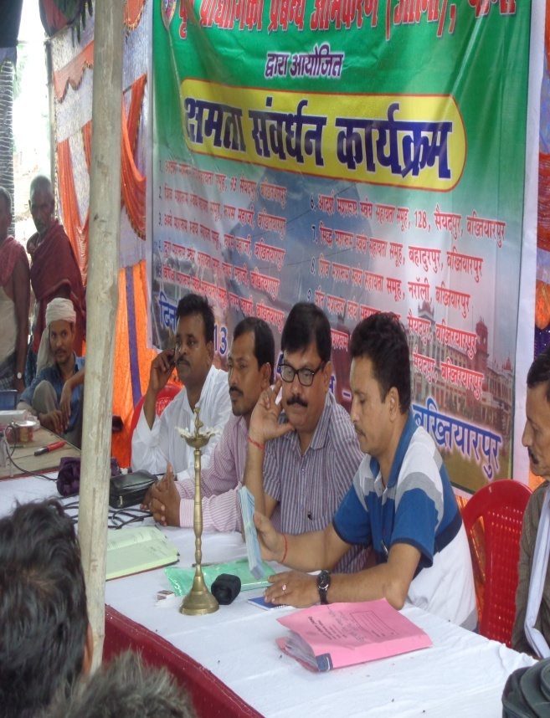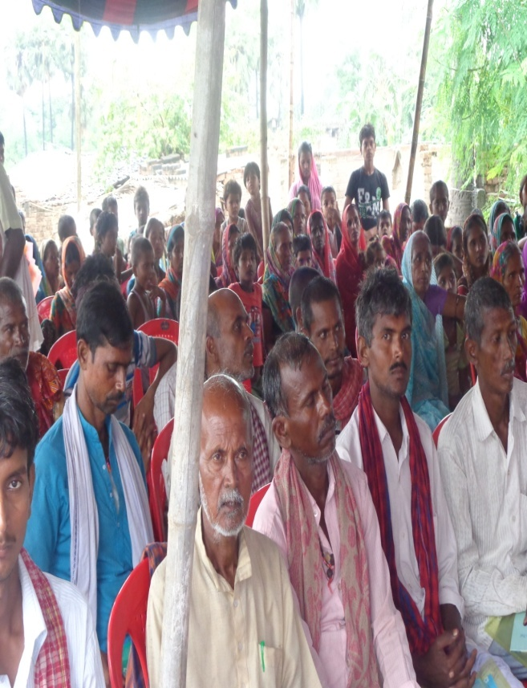
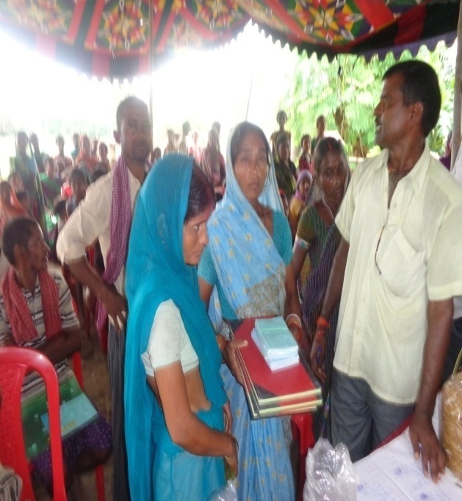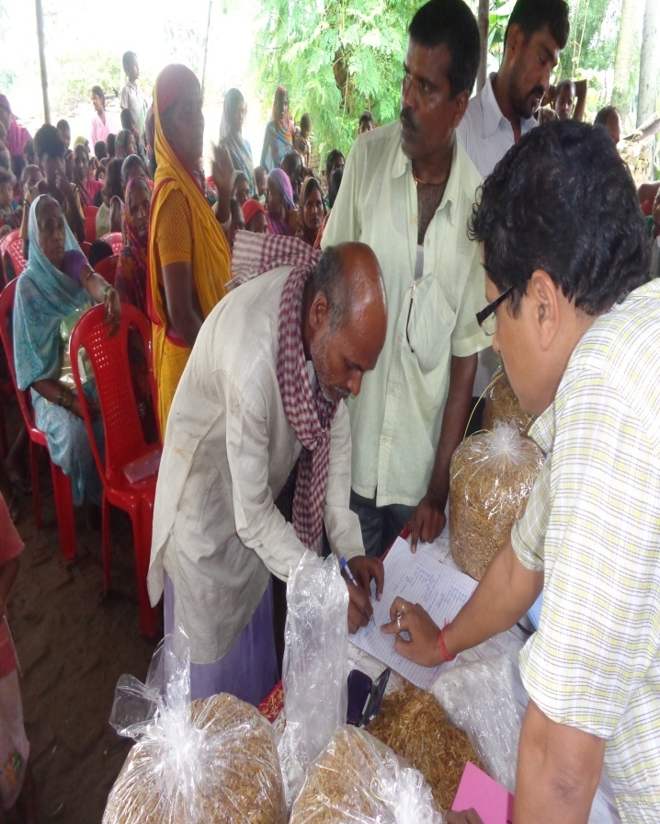
13- fnukad 20-08-2014 dsk /ku:vk iz[k.M vUrxZr vyhiqj xzke essa 10 fdlku fgr lewg@efgyk fgr lewg dk {kerk lao/kZu rFkk e'k:e mRiknu dk izf'k{k.k fn;k x;kA
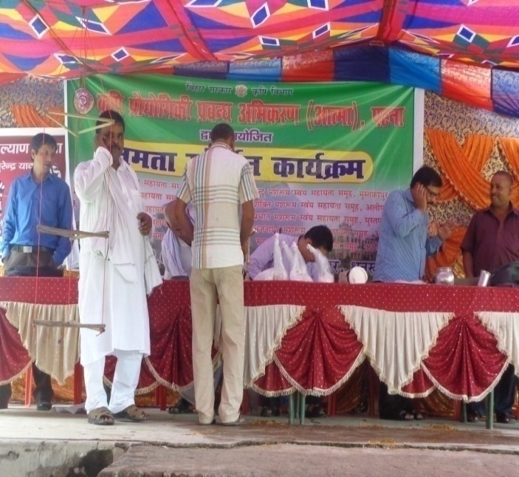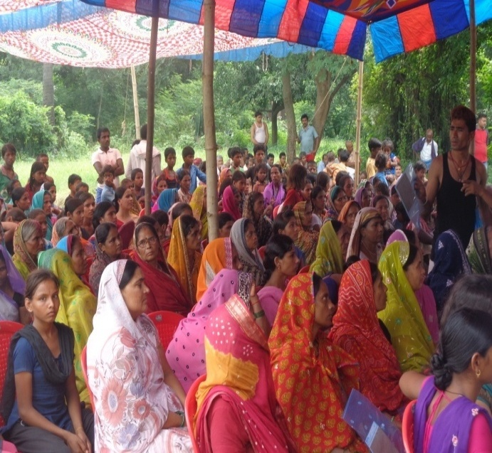
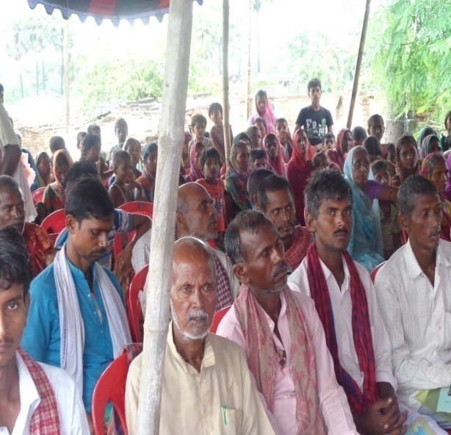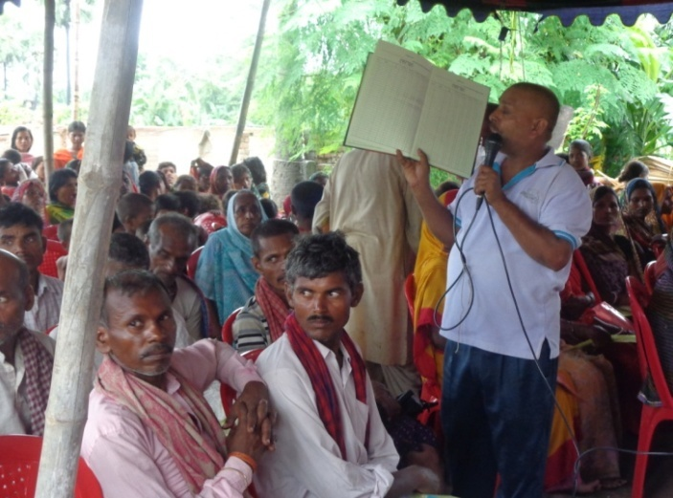
14- fnukad 20&25 vxLr 2014 rd fcgkj d`f"k fo'ofo|ky; lckSj] Hkkxyiqj essa jkT; ds vUnj fdlku izf'k{k.k vUrxZr 5% fdlku lykgdkj dk izf'k{k.k djk;k x;k tks fuEu gS %&
dze la0 | fdlku dk uke | Xkzke | Ikz[k.M
1 | Jh jke gjs | iaMkjd | iaMkjd
2 | Jh euksgj izlkn | csyNh | csyNh
3 | Jh la/kk’kqdqekj | Ckk<+ | Ckk<+
4 | Jh lq/khj dqekj xqy’ku | Cxk< | Cxk<
5 | Jh :is’kdqekj | Ckf[r;kjiqj | Ckf[r;kjiqj

15- fnukad 29&30 vxLr 2014 dks ftyk ds vUnj fdlku izf'k{k.k vUrxZr vk/kqfud eos'kh ikyu fo"k;d 40 fdlkuksa dk nks fnolh; vkoklh; izf'k{k.k fcgkj i'kq fpfdRlk egkfo|ky;] iVuk esa djk;k x;kA ftldh lwph fuEu gS %&
Øekad | uke | firk@ifr dk uke | irk | iz[k.M
1 | Jh dkes'oj ;kno | Jh jkejru ;kno | jkeiqjuxokW | ikyhxat
2 | Jh vjfoUn dqekj | Jh jkebZ'oj ;kno | ihijnkgk caxkyh Vksyk | ikyhxat
3 | Jh jkev;ks/;k flag | Jh jkethr flag | yk[kkij | ikyhxat
4 | Jh jkek/kkj flag | Jh xks/ku ;kno | jkeiqj uxokW | ikyhxat
5 | Jh jkds'k dqekj | Jh taxcgknqj flag | jkuhiqj | ikyhxat
6 | Jh uUnnso izlkn | Jh eqdlwnu izlkn | jkeiqj uxokW | ikyhxat
7 | Jh lrh'k dqekj | Jh cStw ;kno | vf[r;kjiqj | ikyhxat
8 | Jh t;izdk'k 'kekZ | Lo0 ;wxy flag | jkeiqj uxokW | ikyhxat
9 | Jh vt; dqekj | Jh Hkw"k.k 'kekZ | dkSjh | ikyhxat
10 | Jh jes'k dqekj | Jh jkekKk flag | bZtjrk | ikyhxat
11 | Jh fojsUnz 'kekZ | Lo0 dUgkbZ flag | btjrk | ikyhxat
12 | Jh /khjsUnz dqekj | Jh fl|ukFk flag | bZtjrk | ikyhxat
13 | Jh d`".k dqekj 'kekZ | Lo0 j.kthr flag | bZtjrk | ikyhxat
14 | Jh foey dqekj flag | Lo0 ijegal flag | bZtjrk | ikyhxat
15 | Jh foisUnz dqekj | Jh jkekuqt flag | bZtjrk | ikyhaxt
16 | Jh dfoUn dqekj | Jh fl|ukFk flag | bZtjrk | ikyhxat
17 | Jh jkeHkou 'kekZ | Lo0 ;qxy flag | dklhepd | nqfYgucktkj
18 | Jh jktfd'kksj jk; | uUn dqekj flag | gjiqjk | nqfYgucktkj
19 | Jh jkts'k dqekj falg | Jh tokgj izlkn | egkcyhiqj | nqfYgucktkj
20 | Jh jfodkUr flag | Jh egsUnz ;kno | egkcyhiqj | nqfYgucktkj
21 | Jh t;dqekj | Jh fouksn ikloku | gjiqjk | nqfYgucktkj
22 | Jh lqHkk"k dqekj | Jh jktuUnu falag | eksfdeiqj | nqfYgucktkj
23 | Jh vkseizdk'k ikloku | Jh gfjpj.k ikloku | eksfdeiqj | nqfYgucktkj
24 | Jh gfj'kadj mik/;k; | Jh jktsUnz mik/;k; | nksjokW | nqfYgucktkj
25 | Jh vatuh dqekj | Jh j?kqukFk 'kekZ | Hksjgfj;k | ikyhxat
26 | Jh vk'kqrks"k dqekj | Jh 'kSysUnz dqekj | Hksjgfj;k | ikyhxat
27 | Jh foosd dqekj | Jh d`".kUkUn 'kekZ | Hksjgfj;k | ikyhxat
28 | Jh vkfnR; dqekj | Jh lq/khj dqekj | Hksjgfj;k | ikyhxat
29 | Jh fou; 'kj.k | Jh Lokeh 'kj.k flUgk | lsYgkSjh | nqfYgucktkj
30 | Jh lqjsUnz 'kekZ | Jh Mkseu 'kekZ | dqjdqjh foxgk | nqfYgucktkj
31 | Jh ;ksfxUnz dqekj | Lo0 lkfgUnz dkUr | lsYgkSjh | nqfYgucktkj
32 | Jh vHk; dqekj | Jh jfoUnz dqekj oekZ | lsYgkSjh | nqfYgucktkj
33 | Jh vkuUn dqekj | Jh dk'kh izlkn | lsYgkSjh | nqfYgucktkj
34 | Jh jkedqekj oekZ | Lo0 [ksn: izlkn oekZ | dqdjh foxgk | nqfYgucktkj
35 | Jh /keZnkl izlkn | Jh d`".kk ;kno | uoknk | nqfYgucktkj
36 | Jh vthr dqekj | Jh jktsUnz ;kno | uoknk | nqfYgucktkj
37 | Jh fot; 'kadj | Lo0 d`".kfcgkj flag | lsYgkSjh | nqfYgucktkj
38 | Jh ftrsUnz dqekj | Jh lw;ZukFk flag | dqdjh foxgk | nqfYgucktkj
39 | Jh jfoUnz izlkn oekZ | Jh ykynso flag | dqdjh foxgk | nqfYgucktkj
40 | Jh pUnzs'oj flag | Lo0 xq:pj.k falg | dqdjh foxgk | nqfYgucktkj
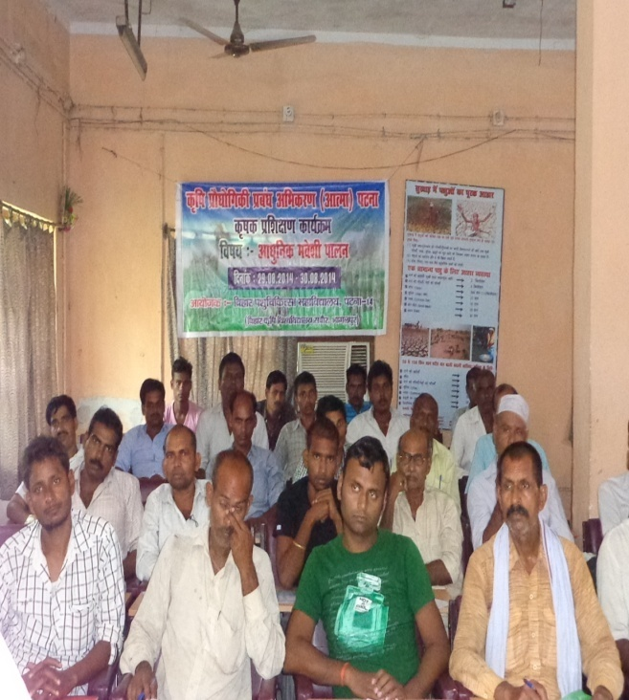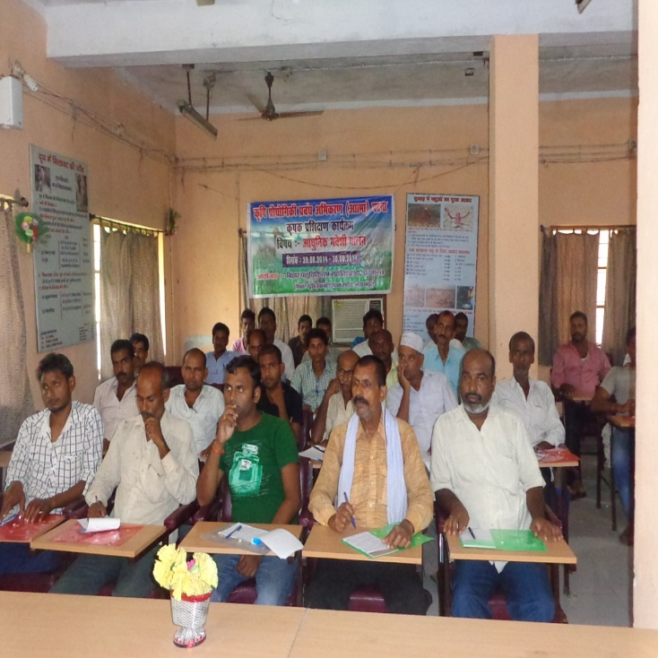
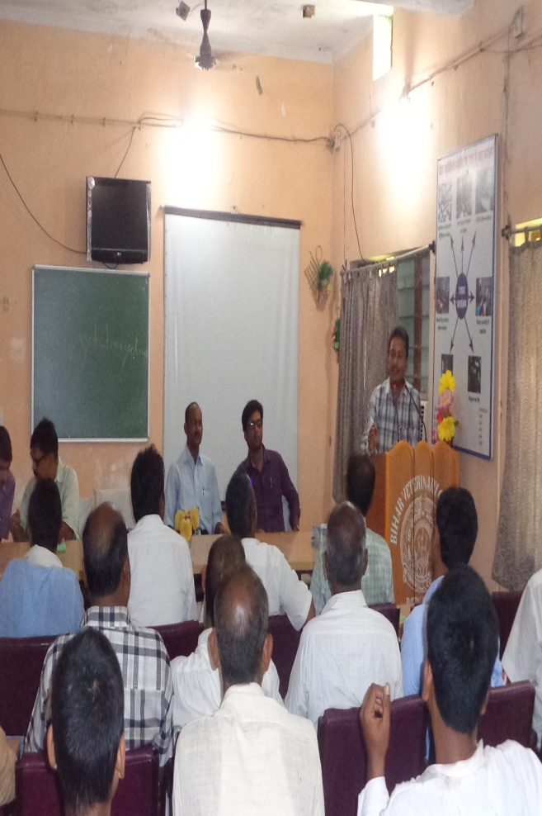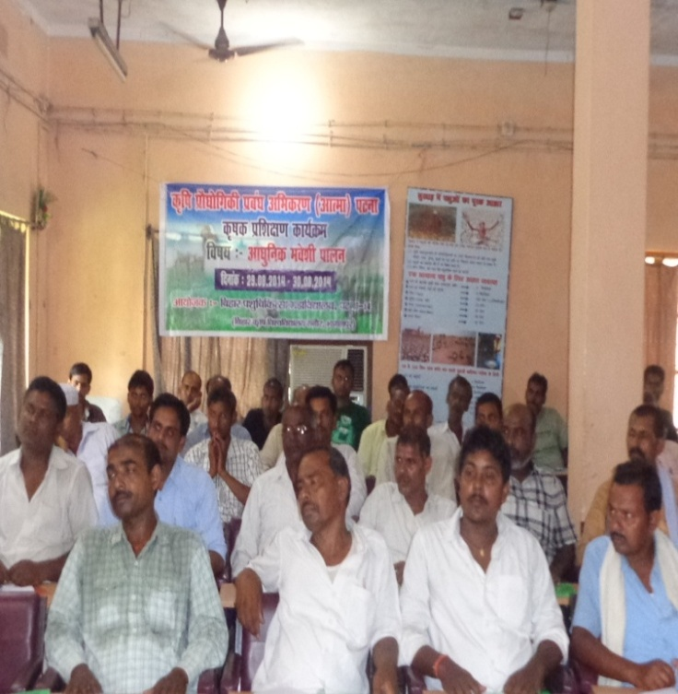
16- fnukad 03-09-2014 dsk eusj iz[k.M vUrxZr gYnh Nijk esa fdlku fgr lewg@efgyk fgr lewg dk {kerk lao/kZu dk;Zdze vk;ksftr fd;k x;k A
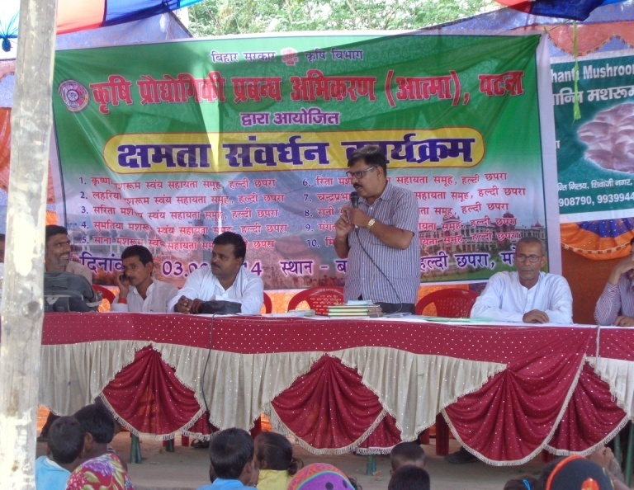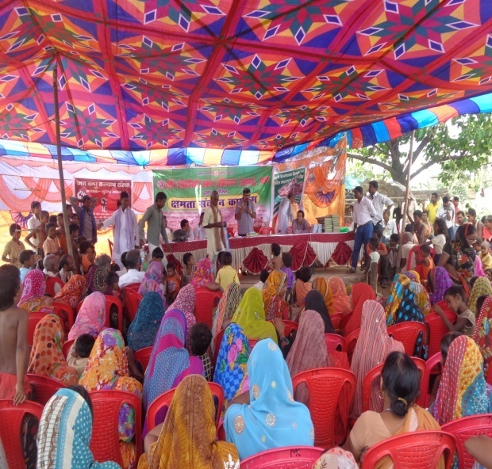
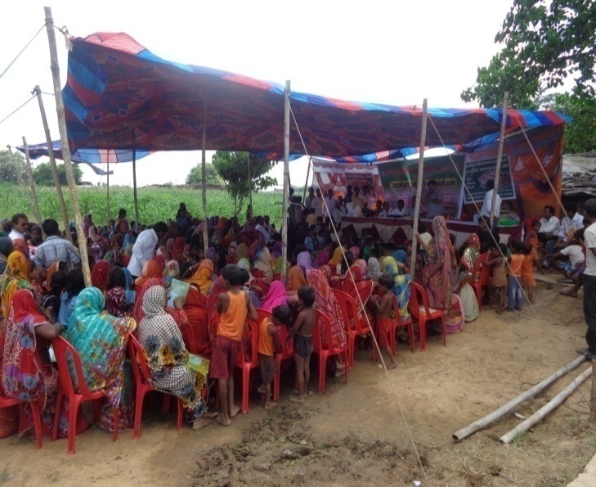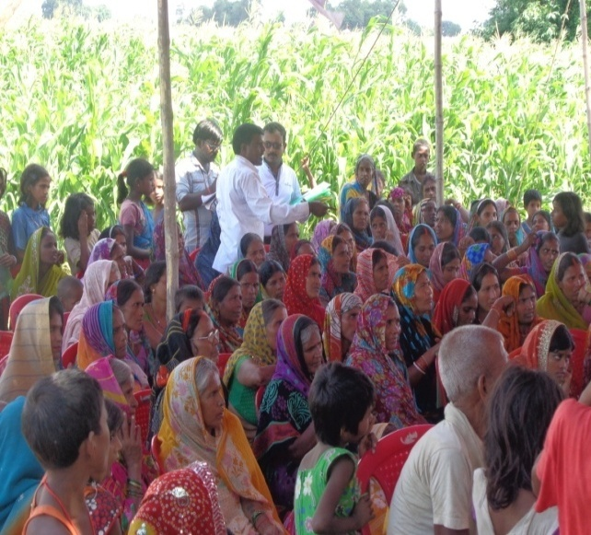
17- fnukad 04-09-2014 dsk fodze iz[k.M vUrxZr ck/kkdksy xzke essa 10&10 fdlku fgr lewg@efgyk fgr lewg dk {kerk lao/kZu rFkk e'k:e mRiknu] eos'kh ikyu ij izf'k{k.k fn;k x;kA
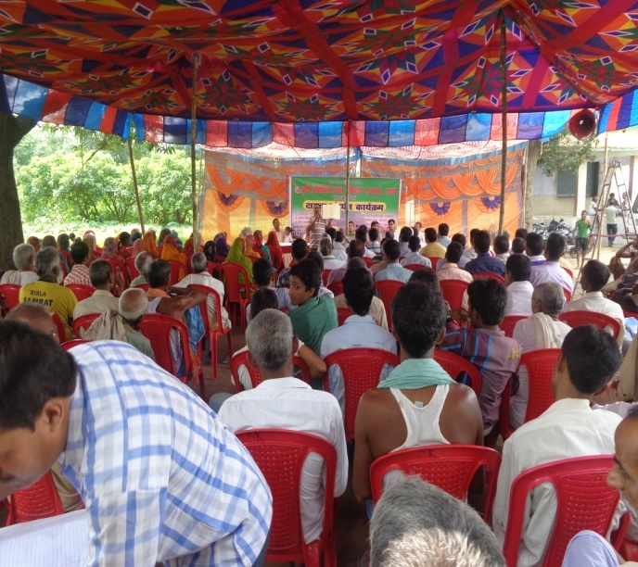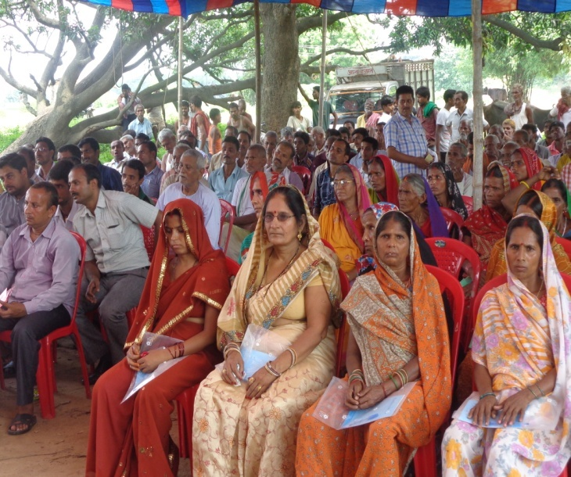
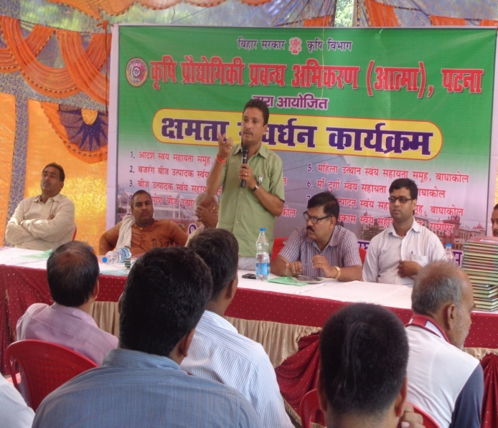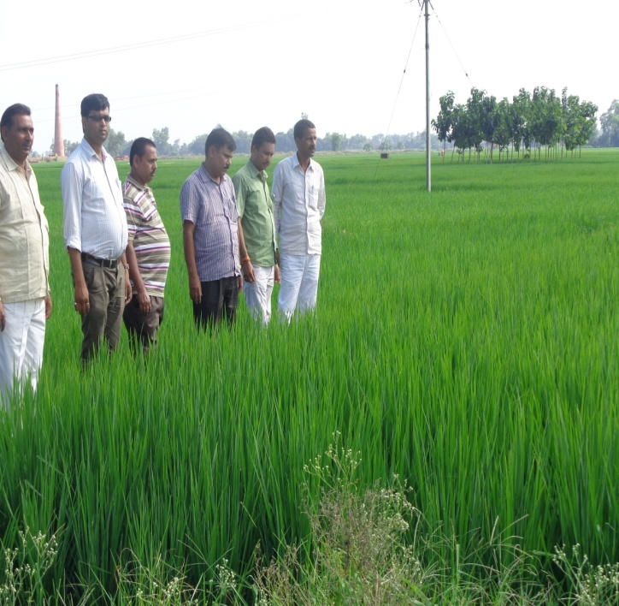
18-fnukad 06-09-2014 dsk eksdkek iz[k.M vUrxZr dUgkbZiqj essa 10&10 fdlku fgr lewg@efgyk fgr lewg dk {kerk lao/kZu rFkk e'k:e mRiknu] eos'kh ikyu ij izf'k{k.k fn;k x;kA
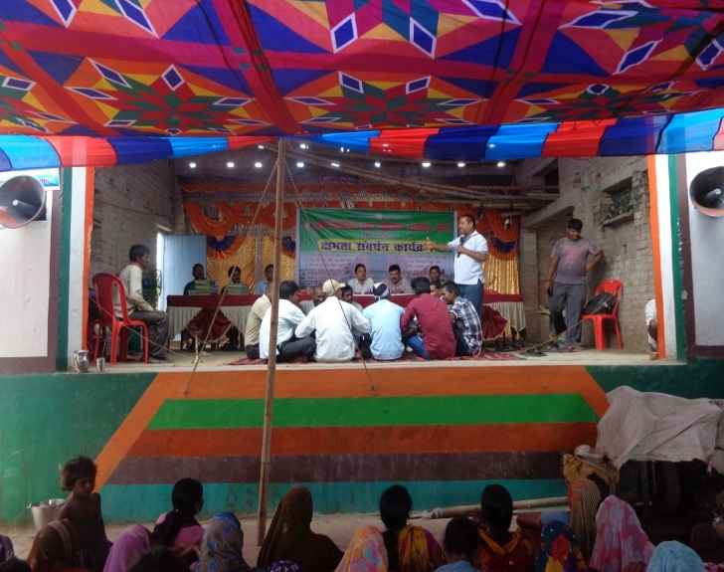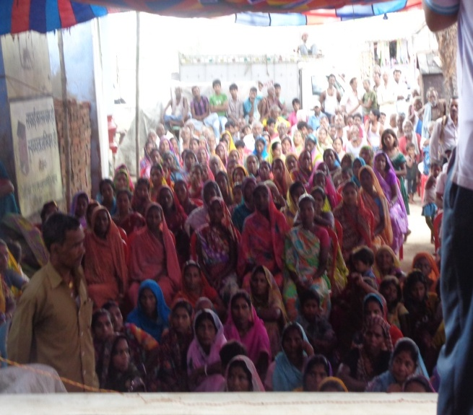
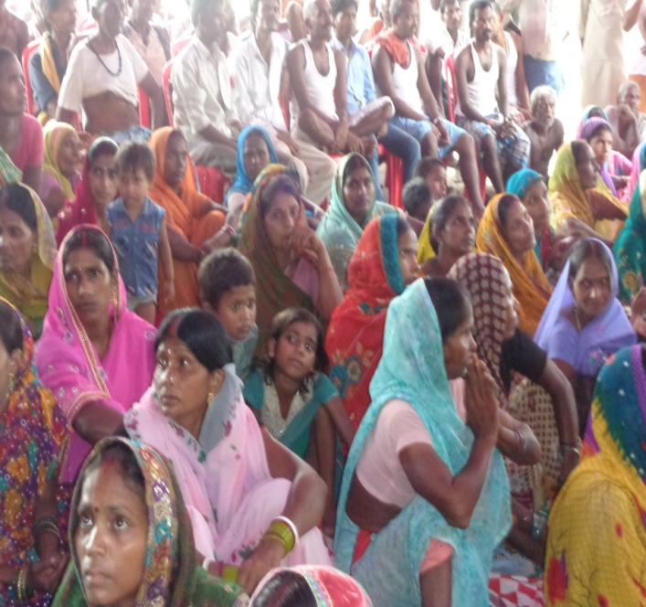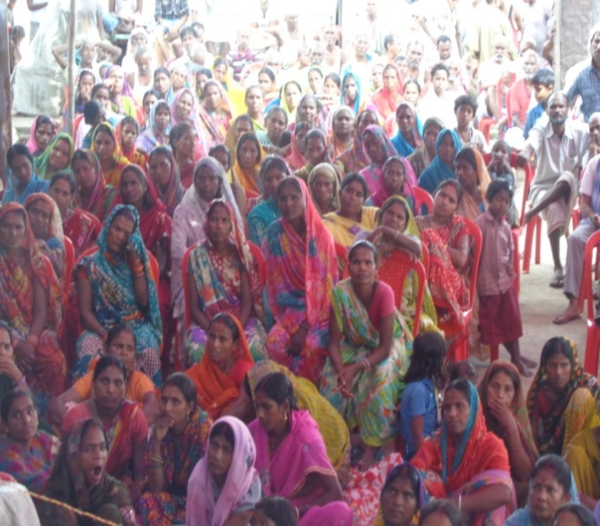
19- fnukad 11&12 flrEcj 2014 dks ftyk ds vUnj fdlku izf'k{k.k vUrxZr vk/kqfud eos'kh ikyu fo"k;d 47 fdlkuksa dk nks fnolh; vkoklh; izf'k{k.k fcgkj i'kq fpfdRlk egkfo|ky;] iVuk esa djk;k x;kA ftldh lwph fuEu gS %&
Øekad | uke | firk@ifr dk uke | irk | iz[k.M | nwjHkk"ka la[;k
1 | Jh nsodqekj | Jhjke izlkn fo'odekZ | ck/kkdksy | fodze | 9934265943
2 | Jh jkts'k dqekj | Jh nkeksnj falag | ck?kkdksy | fodze | 9801416509
3 | Jh jfojatu dqekj | Jh dkes'oj nqcs | ck?kkdksy | fodze | 9934204080
4 | Jh ccyw dqekj | Jh nsoh n;ky nqcasa | ck?kkdksy | fodze | 9162236214
5 | Jh fnus'k izlkn falg | Lo0 jktsUnz flag | vk'kksiqj | nkukiqj | 9570461720
6 | Jh jfo izdk'k | Jh vf[kys'oj izlkn falg | vk'kksiqj | nkukiqj | 9852630746
7 | Jh lat; dqekj 'kekZ | JhuUn yky 'kekZ | xaxgkjk | nkukiqj | 9631975096
8 | Jh e`R;at; 'kekZ | Jh lru 'kekZ | xaxgkjk | nkukiqj | 9931602965
9 | Jh lat; 'kekZ | Jh ctjaxh 'kekZ | fuljiqjk | fodze | 9939682010
10 | Jh v:.k dqekj | Jh lqn'kZu 'kekZ | xksj[kjh | fodze | 9801581044
11 | Jh gjsUnz dqekj | Lo0 f=Hkqou flag | nknqiqj | fodze | 9905950914
12 | Jh vthr dqekj | Lo0 y{e.k flag | djlk | fodze | 9136268560
13 | Jh n;kuUn flag | Lo0 jkeLo:i flag | yksnhiqj pkWnekjh | nkukiqj | 9801879877
14 | Jh fo|klkxj flag | Lo0 jkeflagklu flag | pekjhpd | nkukiqj | 9472891653
15 | Jh jke,dcky ;kno | Lo0 caxkyh ;kno | efB;kiqj | nkukiqj
16 | Jh t;izdk'k flag | Jh ujs'kuUnu flag | xksjxkWok | nkukiqj | 9334258366
17 | Jh vthr dqekj | Lo0 v:.k izlkn | xksjxkWoka | nkukiqj | 7277844280
18 | Jh jkethr 'kekZ | Jh foJke flag | Qjhniqj | fodze | 9931795982
19 | Jh eqdqUnz ukjk;.k | Jh lwjs'k flg | nfr;kuk | fodze | 9934198561
20 | Jh f'kodqekj flag | Lo0 cfyjke flag | nknqiqj | fodze | 9097428758
21 | Jh jkeukFk flag | Jh t;fd'kqu flag | xksjxkokW | nkukiqj | 9334508604
22 | Jh fd'kwu flag | Jh vkseizdk'k falg | xksjxkWOkk | nkukiqj | 9308274197
23 | Jh jktsUnz izlkn flag | Jh jkekorkj flag | xksjxkWok | nkukiqj | 9304787448
24 | Jh vthr dqekj | Jh jkekUkUnz izlkn | ;wlwQVksyk | nkukiqj | 9334712134
25 | Jh jktsUnz izlkn | Jh f'koukjk;.k ;kno | /kqlqdVksyk | nkukiqj
26 | Jh vejthr dqekj fflUgk | Lo0 dkerk izlkn flag | pkWnekjh] yksnhiqj | nkukiqj | 9934713788
27 | Jh lq/khj dqekj | Lo0 lqjkt flag | ck?kkdksy | fodze | 9162142823
28 | Jh fiUVw dqekj flag | Lo0 egsUnz falg | efB;kiqj | nkukiqj | 9709783722
29 | Jh larks"k dq0 flag | Jh jketh flag | efB;kiqj | nkukiqj | 9334707642
30 | Jh v'kksd dq0 flag | Lo0 o`tuUnu falg | efB;kiqj | nkukiqj | 9852186303
31 | Jh vejthr 'kekZ | Lo0 nsonkl falag | ck?kkdksy | fodze | 9905793522
32 | Jh uhjt dqekj | Jh nsonkl falg | ck?kkdsky | fodze | 9631852179
33 | Jh uUnfd'kksj dq0 | Jh ris'oj flag | nfr;kuk | fodze | 9973436951
34 | Jh euh"k dqekj | Jh feFkys'k flag | nfr;kuk | fodze | 9386108030
35 | Jh jktdqwekj | Jh jkeusj'k 'kekZ | Qjhniqj | fodze | 8651377724
36 | Jh fodkl dqekj | Jh mn; uk0 'kekZ | nfr;kuk | fodze | 8507111327
37 | Jh jtuh'k jatu dq0 | Jh misUnz 'kekZ | nfr;kuk | fodze | 7277748189
38 | Jh jkefd'kksj 'kekZ | Lo0 jkensou falg | nfr;kuk | fodze | 7277748189
39 | Jh NksVu izlkn | Lo0 'kfupj jk; | /klqdVksyk | nkukiqj | 9386508026
40 | Jh d`".kk jk; | Lo0 cqVkbZ jk; | ;wlwQVksyk | nkukiqj | 9608368992
41 | Jh gjsUnz dqekj | Lo0 jkenfgu flag | ;wlqQVksyk | nkukiqj | 9386508026
42 | Jh lxquh izlkn | Jh tVq jke | ;wlqQVksyk | nkukiqj | 7488324646
43 | Jh dkes'oj izlkn | Lo0 jkeldy jk; | ;wlqQVksyk | nkukiqj | 9308337139
44 | Jh ef.kdkUr flaUgk | Lo0 jk?kkdkUr flg | f'kox+<+ | fodze | 9973072548
45 | Jh uhjt dqekj | Lo0 efgekuUnu izlkn | duik | fodze | 9576332181
46 | Jh ftrsUnz dqekj | Lo0 txuUnu flag | efB;kiqj | nkukiqj | 7488376421
47 | Jh vfuy dqekj | Jh jkeyxu izlkn | efB;kiqj | nkukiqj | 8252979937

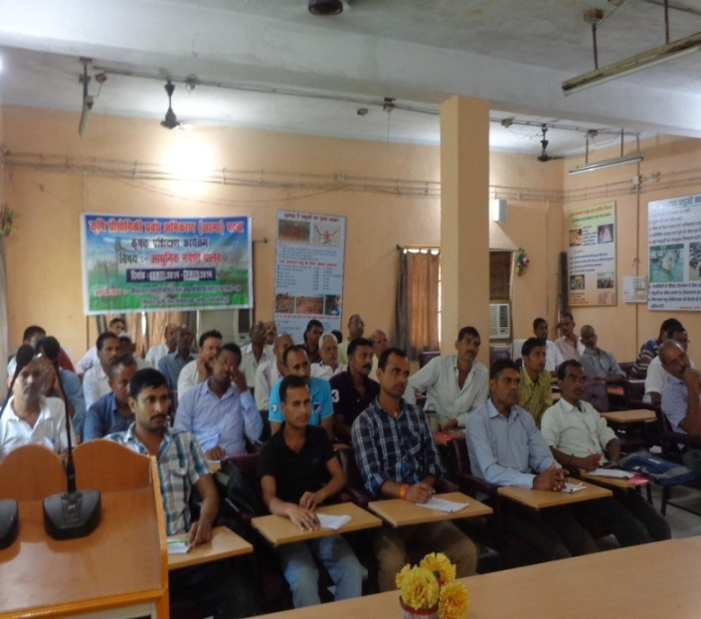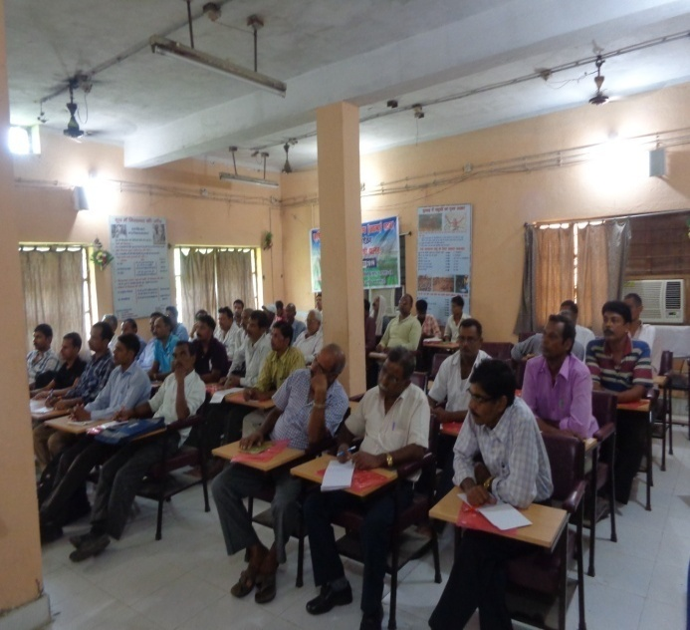
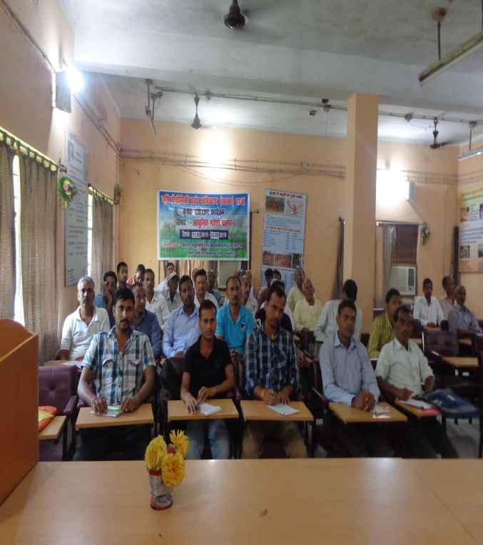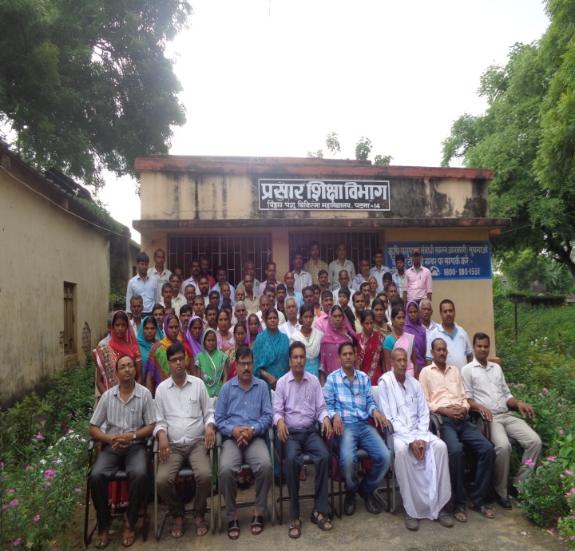
20- fnukad 13&14 flrEcj 2014 dks ftyk ds vUnj fdlku izf'k{k.k vUrxZr vk/kqfud eos'kh ikyu fo"k;d 75 fdlkuksa dk nks fnolh; vkoklh; izf'k{k.k fcgkj i'kq fpfdRlk egkfo|ky;] iVuk esa djk;k x;kA ftldh lwph fuEu gS %&
Øekad | uke | firk@ifr dk uke | irk | iz[k.M | nwjHkk"ka la[;k
1 | Jh lq'khy dqekj | Jh txnh'k izlkn | lk.Mk | /ku:vk | 9546669397
2 | Jh f'koizlkn | Jh jkenso egrks | lk.Mk | /ku:vk
3 | Jh izeksn dqekj | Jh jkekJ; izlk n | lk.Mk | /ku:vk | 9334870247
4 | Jh vej T;ksfr | Jh y{eh flag | gqyklhVksyk | eusj | 9693710112
5 | Jh fotsUnz flag | Jh jkek'kadj falg | jkeiqj fn;jk | eusj | 9798508577
6 | Jh egsUnz dqekj | Jh equs'oj falg | if'peh lqvjejok | eusj | 9852098573
7 | Jh vfouk'k dqekj | Jh ykyeksgu flag | jkeiqj fn;jk | eusj | 7677481390
8 | Jh vfuy flag | Lo0 lqdu flag | jkeiqj fn;jk | eusj
9 | Jh tUes'k dqekj flag | Jh 'kf'kHkw".k falg | jkeiqj fn;jk | eusj | 8539845013
10 | Jh v:.k flag | Jh jkek/khj falg | jkeiqj fn;jk | eusj | 8102940094
11 | Jh i'kqifr flag | Lo0 jkek/kj falg | jkeiqj fn;jk | eusj | 9504239797
12 | Jh enu dqekj falg | Lo0 jketru flag | jkeiqj fn;jk | eusj | 8804243582
13 | Jh jkeHkjkslk falg | Jh lq[kuUnu flag | jkeiqj fn;jk | eusj
14 | Jh fo'oukFk falg | Lo0 txnso flag | gkFkhVksyk | eusj
15 | Jh deys'k dqekj | Lk0 jken'kZu flag | jkeiqj fn;jk | eusj | 9097419806
16 | Jh mes'k dq0 flag | Lo0 'kadj falg | jkeiqjfn;jk | eusj | 7250090108
17 | Jh 'kSysUnz dqekj | Jh feFkys'k flag | jkeiqj fn;jk | eusj | 7488197609
18 | Jh dSyk'k ifr flg | Lo0 jke,dcky falag | gqyklhVksyk | eusj | 9334504771
19 | Jh oklqnso jk; | Lo0 xkW/kh jk; | jkeiqjfn;jk | eusj | 8603565170
20 | Jh nso'kj.k falg | Lo0 nsoeatu flag | gqyklhVksyk | eusj | 8083779528
21 | Jh ijes'oj jk; | Jh jkebZ'oj jk; | gqyklhVksyk | eusj | 8804292409
22 | Jh eqdqy dqekj | Jh pUnzdkar falg | jkeiqj fn;jk | eusj | 9661793815
23 | Jh xksiky dqekj oekZ Jh | Jh cztuUnu oekZ | eksguiqj | eusj | 9835630479
24 | Jh jkek/kkj falg | Jh nsoifr flag | eksguiqj | eusj | 9304332761
25 | Jh fots'k dqekjflag | Lo0 f=Hkqou flag | jkeiqj fn;jk | eusj | 8083220638
26 | Jh 'kSysUnz dqekj flag | Jh fnus'k izlkn flag | jkeiqj fn;jk | eusj | 9608023449
27 | Jh j.kthr dqekj | Jh mn; aflag | jkeiqj fn;jk | eusj | 9504835141
28 | Jh 'ks"kukFk flag | Jh jkefoyk'k flag | jkeiqj fn;jk | eusj | 9905736948
29 | Jh vfuy dqekj flag | Lo0 txnEck flag | jkeiqj fn;jk | eusj | 7765948554
30 | Jh jkek/kkj falg | Jh jkeHkjkslk aflag | jkeiqj fn;jk | eusj
31 | Jh lqHkk"k aflag | Lo0 nbZc flag | jkeiqj fn;jk | eusj
32 | Jh d`".kk falg | Lo0 nsoh izlkn falg | jkeiqj fn;jk | eusj | 7764099602
33 | Jh jfo jatu | Jh jkes'oj jk; | dsnyiqjk | nkukiqj | 9204437838
34 | Jh nhid dqekj | Lo0 egsUnz izlkn | lk.Mk | /ku:vk
35 | Jh jthr dqekj | Lo0 txnh'k izlkn | lk.Mk | /ku:vk | 9608789241
36 | Jh jkts'k dq0 oekZ | Jh vf[kys'k izlkn | lk.Mk | /ku:vk
37 | Jh vuqt dqekj | Jh egs'k izlkn | lk.Mk | /ku:vk | 9199184075
38 | Jh jkds'k izlkn | Jh jkekUn izlkn | lk.Mk | /ku:vk | 9631375279
39 | Jh cStw izlkn | Jh j?kqukFk egrks | lk.Mk | /ku:vk | 7765823174
40 | Jherh cSt;arh nsoh | Jh vjfoUn izlkn | lk.Mk | /ku:vk
41 | Jh vk'kk nsoh | Jh gjsUnz izlkn | lk.Mk | /ku:vk
42 | Jherh xhrk nsoh | Jh v:.k izlkn | lk.Mk | /ku:vk
43 | Jherh vk'kk nsoh | Jh eUuk yky izlkn | lk.Mk | /ku:vk
44 | Jherh lhek nsoh | Jh lqcks/k dwekj | lk.Mk | /ku:vk
45 | Jherh uhrw nsoh | Jh misUnz izlkn | lk.Mk | /ku:vk
46 | Jherh latw nsoh | Jh jktizlkn | lk.Mk | /ku:vk
47 | Jherh fpUrk nsoh | Jh vf[kys'k izlkn | lk.Mk | /ku:vk
48 | Jherh vfurk nsoh | Jh lR;sUnz izlkn | lk.Mk | /ku:vk
49 | Jh larks"k lkfgy | Jh rkj.khdkUR lkfgy | lk.Mk | /ku:vk
50 | Jherh vuq nsoh | Jh lquhy dqekj | lk.Mk | /ku:vk
51 | Jherh jhuk nsoh | Jh ikjljk; | lk.Mk | /ku:vk
52 | Jhizhfr dqekjh | Jh gjsUnz dqekj falg | lk.Mk | /ku:vk
53 | Jherh js'ke dqekjh | Jha jathr dqekj | lk.Mk | /ku:vk
54 | Jherh laxhrk nsoh | Jh 'kf'kHkw"k.k izlkn flUgk | lk.Mk | /ku:vk
55 | Jherh lkfo=h nsoh | Jh Qqyu jke | lk.Mk | /ku:vk
56 | Jh eukst pkS/kjh | Jh jkey[ku pkS/kjh | lk.Mk | /ku:vk
57 | Jh 'kf'kdkUr izlkn | Jh ykyth izlkn | lk.Mk | /ku:vk
58 | Jh lqcks/k dqekj | Jh jkeLo:i izlkn | lk.Mk | /ku:vk
59 | Jh vejs'k dqekj | Jh jkes'oj izlkn | lk.Mk | /ku:vk | 8294121754
60 | Jh vf[kys'k izlkn | Jh pUnznhi izlkn | lk.Mk | /ku:vk
61 | Jh vo/ks'k izlkn | Jh ykyth izlkn | lk.Mk | /ku:vk | 9199158981
62 | Jh lqHkk"k izlkn | Jh lhrk jke izlkn | lk.Mk | /ku:vk | 8002158730
63 | Jh vfHk"ksd vkUkUn | Jh vthr dq0 flUgk | rktiqj | eusj | 9304085641
64 | Jh foey izlkn | Jh pUns'oj egrks | lk.Mk | /ku:vk | 7759928243
65 | Jh fouksn dqekj | Jh jkecyh flag | ekSyhuxj | eusj | 7488402197
66 | JhdkUr flag | Jh cStw jke | ekSyhuxj | eusj | 8579898950
67 | Jh v'kksd izlkn | Jh txnh'k izlkn | lk.Mk | /ku:vk | 7677261310
68 | Jh jes’k dqekj | Jh jktsUnz izlkn | Lk.Mk | /ku:vk | 9576506211
69 | Jh vthr jk; | Jh xjh jk; | Lk.Mk | /ku:vk | 9304085641
70 | Jh lqnkek lko | Jh x.ks’k lko | gYnhNijk | Ekusj | 8083267049
71 | Jh lqHkk"k flag | Jh tukZnu falg | gYnhNijk | Ekusj | 9576516986
72 | Jh dkes’oj jk; | Jh jkts’oj jk; | gYnhNijk | Ekusj | 9097231133
73 | Jh fotyh jk; | Jh enu jk; | gYnhNijk | Ekusj
74 | Jh yyu egrks | Jh lqfpr egrks | gYnhNijk | Ekusj | 8804875081
75 | Jh nsojkt jk; | Jh dqWoj jk; | gYnhNijk | Ekusj | 9631578029
76 | Jh gjsUnz flag | Jh fl+)ukFk flag | jkeiqj fn;jk | Ekusj
78 | Jh vfer dqekj | Jh lqn’kZu flag | Jkeiqj fn;jk | Eusj | 9304804274

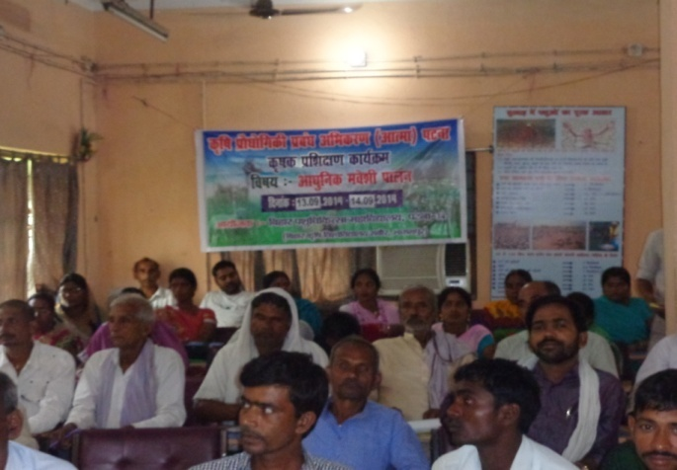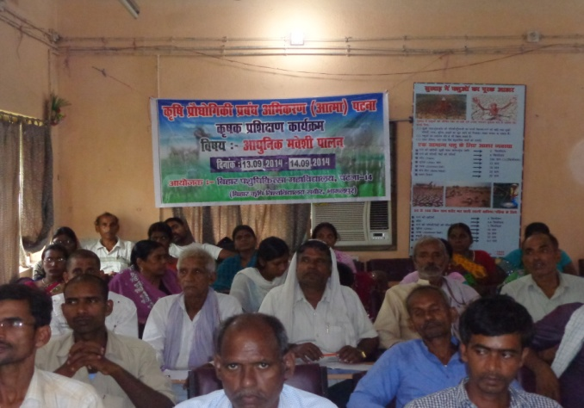
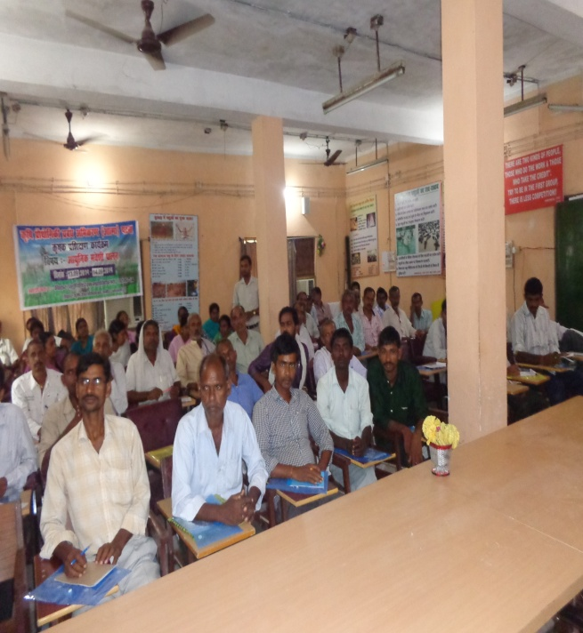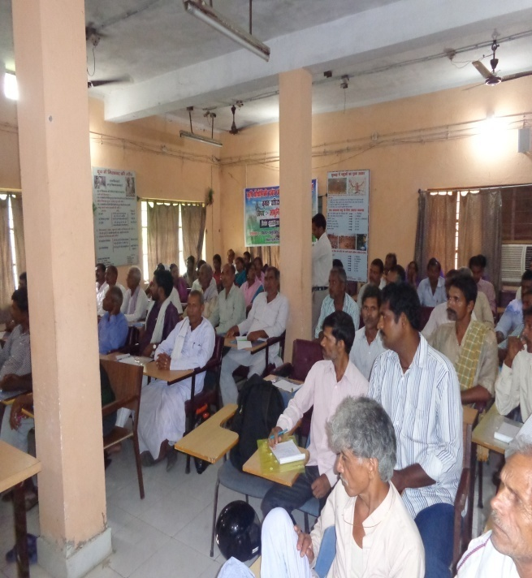
21- jkT; ds ckgj fdlku izf'k{k.k dk;Zdze vUrxZr fnukad 13-09-2014 ls 20-09-2014 rd vkRek] iVuk ls izf'k{k.k dk;Zdze gsrq gSd e'k:e izf'k{k.k laLFkku] eqjFkkSy lksuhir]gfj;k.kk esa 22 ¼ckbl½ efgykvksa ,oa 3 ¼rhu½ iq:"k dqy 25 ¼iPPkhl ½ fdlkuksa dks e’k:e mRiknu ij o`gr :Ik ls izf’k{k.k fn;k x;kA
dze la0 | fdlku dk uke | firk dk uke | Xkzke | Ikz[k.M
1 | Jh vjfoUn ‘’kekZ | Jh jktkjke flag | vyhiqj | /ku:vk
2 | Jherh jatw nsoh | Jh tSusUnz dqekj | Ukniqjk | /ku:vk
3 | Jherh ekuks nsoh | Jh x.ks’k jke | vyhiqj | /ku:vk
4 | Jherh feUrk nsoh | Jh jes’k ikloku | uniqjk | /ku:vk
5 | Jherh efurk nsoh | Jh vjfoUn ‘’kekZ | vyhiqj | /ku:vk
6 | Jherh jkf/kdk nsoh | Jh dqUrh egrks | cgknqjiqj | Ckf[r;kjiqj
7 | Jh erh lqfe=k nsoh | Jh y[ku eksph | lSniqj | Ckf[r;kjiqj
8 | Jherh js[kk nsoh | Jh Mkseu egrks | Ckf[r;kjiqj | cf[r;kjiqj
9 | Jherh fueZyk nsoh | Jh izos’k lko | Ckgknqjiqj | cf[r;kjiqj
10 | Jherh lq’khyk nsoh | Jh d`".kk lko | Ckgknqjiqj | cf[r;kjiqj
11 | Jherh lwuSuk nsoh | Jh ds’ko eksph | cgknqjiqj | Ckf[r;kjiqj
12 | Jherh ’;kek nsoh | Jh jkekuUn ikloku | lSniqj | Ckf[r;kjiqj
13 | Jherh lksue nsoh | Jh Hkw"k.k lko | ujkSyh | cf[r;kjiqj
14 | Jherh nq[kuh nsoh | Jh fl;kjke ikloku | lSniqj | cf[r;kjiqj
15 | Jherh lfjrk nsoh | Jh jes’k eksph | lSniqj | cf[r;kjiqj
16 | Jherh ‘’kkafr nsoh | Jh disUnz ikloku | lSniqj | cf[r;kjiqj
17 | Jherh jkelf[k;k nsoh | Jh jkepUnz eksph | ujkSyh | cf[r;kjiqj
18 | Jherh fjadw nsoh | Jh lnu lkg | lSniqj | cf[r;kjiqj
19 | Jherh ehuk nsoh | Jh pfUnzdk ikloku | lSniqj | cf[r;kjiqj
20 | Jherh /kjeh nsoh | Jh nsoUnz lko | ujkSyh | cf[r;kjiqj
21 | Jherh laxhrk nsoh | Jh fo’oukFk jk; | ujkSyh | cf[r;kjiqj
22 | Jh fl}s’oj eksph | Jh c[kkSjh eksph | Ckgknqjiqj | cf[r;kjiqj
23 | Jerh viZuk ckyk | Jh jkeujs’k dqekj vEc"V | Ekk/kksiqj | cf[r;kjiqj
24 | :ik T;ksfr | Jh iou dqekj oekZ | Ekk/kksiqj | cf[r;kjiqj
25 | Jh vt; izlkn flag | egsUnz flag | Ckgknqjiqj | cf[r;kjiqj

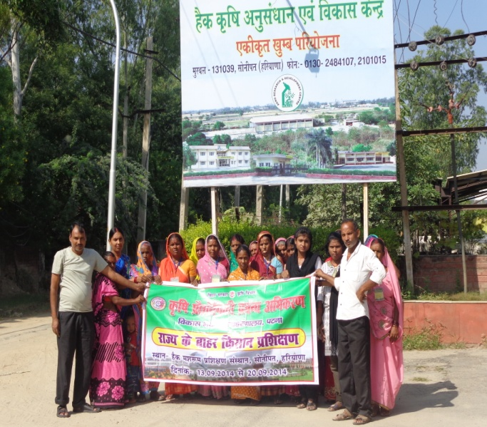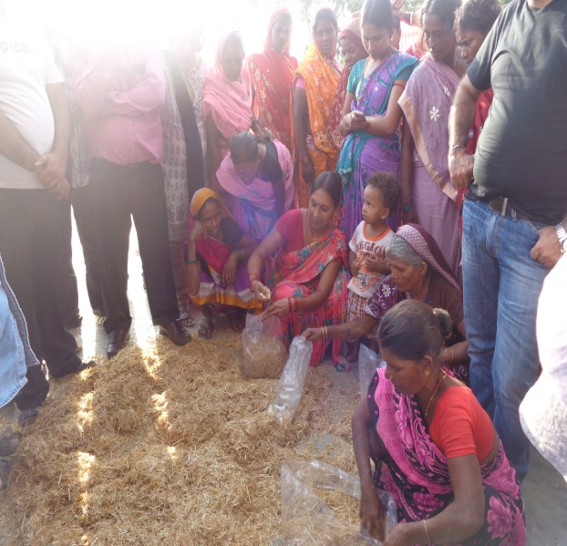
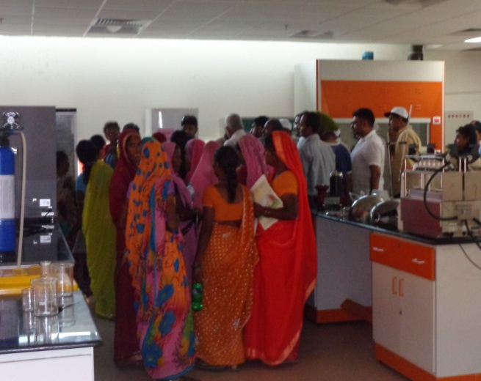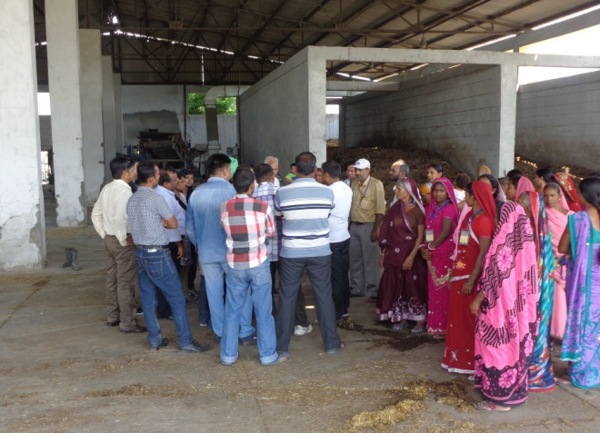
22- jkT; ds vUnj fdlku ifjHkze.k vUrxZr fnukad 20-09-2014 dks vkRek] iVuk }kjk efgykvksa dk es0 cq)k e'k:e LikWy ySc iafMriqj] jktxhj ukyUnk esa ifjHkze.k djk;k x;k A
dze la0 | fdlku dk uke | firk dk uke | Xkzke | nwjHkk"k la0
1 | Jherh ek/kqjh nsoh | Jh tksxsUnz izlkn | dUgkbZiqj
2 | Jherh uhye nsoh | Jh lqjsUnz izlk n | dUgkbZiqj
3 | Jherh m"kk nsoh | Jh ewUuk dqekj | dUgkbZiqj
4 | Jherh foeyk nsoh | Jh /kesZUnz dqekj | dUgkbZiqj
5 | Jherh dsoyh nsoh | Jh nklks egrks | dUgkbZiqj
6 | Jherh eatw nsoh | Jh veys’k dqekj | dUgkbZiqj
7 | Jherh paik nsoh | Jh ;nquUnu egrks | dUgkbZiqj
8 | Jherh vfurk nsoh | Jh jfoUnz egrks | dUgkbZiqj
9 | Jh erh ls[kk nsoh | Jh jkts’k dqekj | dUgkbZiqj
10 | Jherh lhek nsoh | Jh ‘’kSysUnz dqekj | dUgkbZiqj
11 | Jherh xhrk nsoh | Jh lat; egrks | dUgkbZiqj
12 | Jherh ehuk nsoh | Jh v’kksd izlkn | dUgkbZiqj
13 | Jherh bUnq nsoh | Jh jkepfj= egrks | dUgkbZiqj
14 | Jherh csch nsoh | Jh pUnznhi egrks | dUgkbZiqj | 9006722808
15 | Jherh ikoZrh nsoh | Jh Hkksyk izlkn | dUgkbZiqj | 9097725591
16 | Jherh :ch nsoh | Jh jkts’k dqekj | dUgkbZiqj | 7870492563
17 | Jherh eatw nsoh | Jh lnhy jtd | dUgkbZiqj
18 | Jh ‘’kSysUnz dqekj | Jh o`tuUnu izlkn | dUgkbZiqj | 9431662034
19 | Jh larks"k dqekj dq’kokgk | Jh lj;qx izlkn | dUgkbZiqj | 9608237017
20 | Jh ‘’kSysUnz izlkn | Jh ukjk;.k egrks | dUgkbZiqj | 8083844989
21 | Jh /kesZUnz dqekj | Lo0 xukSjh egrksa | dUgkbZiqj | 7277937244
22 | Jh jkds’k dqekj jtd | Jh eYyw jtd | dUgkbZiqj | 9608788120
23 | Jh vuqt dqekj iafMr | Jh jke’kj.k iafMr | dUgkbZiqj | 9504137737
24 | Jh f’ko’kadj egrks | Jh ckys’oj egrks | dUgkbZiqj | 7870490311
25 | Jherh f’kodqekjh nsoh |  | dUgkbZiqj
26 | Jherh dapu nsoh | Jh f’ko’kadj egrksa | dUgkbZiqj | 7870490311
27 | Jherh dkty nsoh | Jh jktdqekj egrks | dUgkbZiqj
28 | Jherh eatw nsoh | Jh Jo.k egrks | dUgkbZiqj | 9504023910
29 | Jherh eerk nsoh | Jh vuqt dqekj iafMr | dUgkbZiqj | 9504137737
30 | Jherh ltuk nsoh | Jh jkeizos’k ikloku | dUgkbZiqj
31 | Jherh /kfu;k nsoh | Jh uUns ;kno | dUgkbZiqj
32 | Jherh ‘’kkfr nsoh | Jh vfer izlkn | dUgkbZiqj | 8507224746
33 | Jherh lwuSuk nsoh | Jh jfoUnz izlkn | dUgkbZiqj | 8092709757
34 | Jherh ‘’khyk nsoh | Jh fous’oj egrks | dUgkbZiqj
35 | Jherh ekuks nsoh | Jh fnyhi egrks | dUgkbZiqj
36 | Jhehr yhyk nsoh | Jh Hksksey egrks | dUgkbZiqj
37 | Jherh lfjrk dekjh | Jh jkds’k dqekj jtd | dUgkbZiqj | 8271847729
38 | Jherh bUnq nsoh | Jh lathr egrks | dUgkbZiqj
39 | Jherh :.kk nsoh | Jh jkeo`t egrks | dUgkbZiqj
40 | Jherh ‘’;kek nsoh | Jh fot; jtd | dUgkbZiqj | 7870490311
41 | Jherh Qqys’ojh nsoh | Jh lat; dqekj | dUgkbZiqj
42 | Jherh lksuk nsoh | Jh vjfoUn dqekj | dUgkbZiqj
43 | Jherh lksuk eq[kh nsoh | Jh lat; egrks | dUgkbZiqj

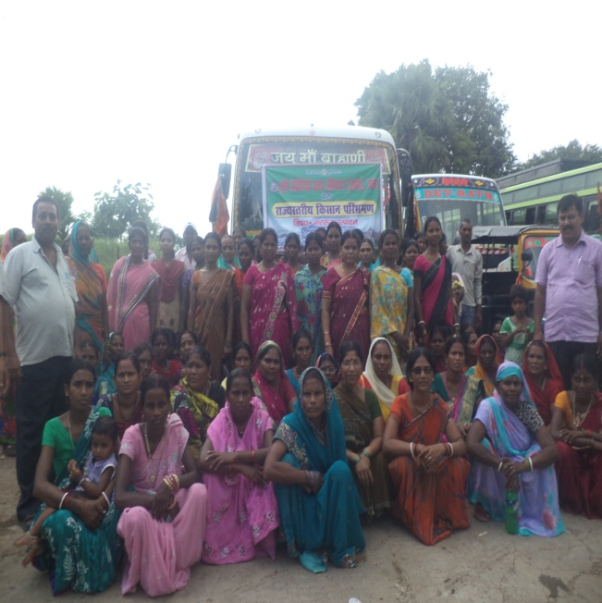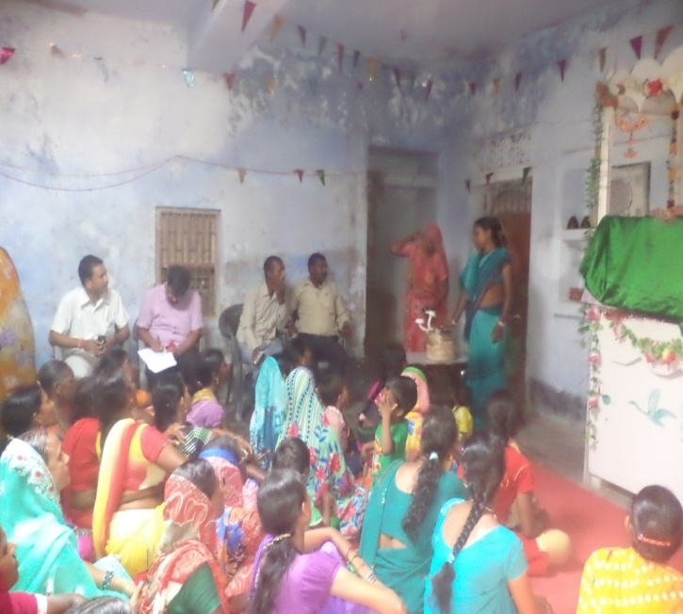

23- jkT; ds ckgj fdlku izf'k{k.k vUrxZr fnukad 23-09-2014 ls 28-09-2014 rd vkRek] iVuk ls 30 fdlkuksa ,oa 1 vkRek dehZ dqy &31 O;fDr;ksa dk bfUnjk xkW/kh lgdkjh izcU/ku laLFkku] y[kum esa ikWp fnolh; izf'k{k.k djk;k x;k ftldh lwph fuaEu gS %&
dze la0 | fdlku dk uke | firk dk uke | Xkzke | Izk[k.M
1 | Jh n;kuUn izlkn | Jh jkeinkjFk jke | Lkcuhek | vFkeyxskyk
2 | Jh ijekuUn jk; |  | Ekdnqeiqj | vFkeyxskyk
3 | Jh panu dqekj | Jh fouksn dqekj ‘’kekZ | Lkcuhek | vFkeyxskyk
4 | Jh mes’k izlkn falg | Lo0 jkes’oj flag | Lqkyrkuiqj | Qrqgk
5 | Jh larks"k ;kno |  | dksYgkj | Qrqgk
6 | Jh czgnso ukjk;.k | Lo0 lw;Znso ukjk;.k | lqyrkuiqj | Qrqgk
7 | Jh vktkn dqekj | Jh jketh izlkn | Lksuk: | Qrqgk
8 | Jh lrh’k dqekj | Lo0 dkerk izlkn flag | cM+dh dksik | ukScriqj
9 | Jh /kus’k dqekj | Lo0 ctjax flag | pspkSy | ukScriqj
10 | Jh fnus’k dqekj | Jh ‘’k=q/ku izlkn | cMh dsobZ | nfu;kaoka
11 | Jh euq ikloku | Jh ckcq yky ikloku | cMh dsobZ | nfu;kaoka
12 | Jh ‘’kaHkw ikloku | Jh vtqZu feL=h | cMh dsobZ | nfu;kaoka
13 | Jh jktukFk flag | Lo0 f’ko/kj flag | fpyfcYyh | Qqyokjh’kjhQ
14 | Jh f’kolaqnj flag | Lo0 eqDdk flag | fpyfcYyh | Qqyokjh’kjhQ
15 | Jh nsosUnz flag | Lo0 cynso flag | fpyfcYyh | Qqyokjh’kjhQ
16 | Jh dkes’oj ;kno | Jh jkejru ;kno | jkeiqj uxokW | Ikkyhxat
17 | Jh lrh’k dqekj | Jh cStw ;kno | vf[r;kjiqj | Ikkyhxat
18 | Jh t;izdk’k ‘’kekZ | Jh ;qxy ‘’kekZ | jkeiqj uxokW | Ikkyhxat
19 | Jh f’ko’kadj egrks | Lo0 ckys egrks | dUgkbZiqj | Ekskdkek
20 | Jh vuqt dqekj iafMr | Jh jke’kj.k iafMr | dUgkbZiqj | Ekksdkek
21 | Jh vkyksd dqekj | Jh NksVu flag | Eksyfn;kjVksyk | Ekskdkek
22 | Jh t;izdk’k flag | Jh vf[kykuUn flag | iFkjgV | /ku:vk
23 | Jh lqjsUnz izlkn flag | Jh jkepUnz flag | iFkjgV | /ku:vk
24 | Jh ftrsUnz dqekj | Jh ukxs’oj flag | ykykHknlkjk | nqfYgucktkj
25 | Jh jk/ks’;ke ‘’kekZ | Jh jktkjke flag | ykykHknlkjk | nqfYgucktkj
26 | Jh jkeukFk flag | Lo0 t;fd’kqu flag | xksjxkokW | nkukiqj
27 | Jh lfPPknkuan izlkn | Lo0 jkeizlkn falg | xksjxkokW | nkukiqj
28 | Jh yfyr dqekj | Lo0 uUndsljh | xksjxkokW | nkukiqj
29 | Jh fot; ukjk;.k flag | Jh Hkkxor ukjk;.k flag | Dkkerkpd | Lakirpd
30 | Jh t;izdk’k flag | Jh ujs’k uUnu flag | xksjxkWOkk | nkukiqj
24- ftyk ds vUnj fdlku izf'k{k.k@uokpkj vUrxZr fnukad 22-09-2014 ls 23-09-2014 rd iVuk Vszfuax dkWyst] iVuk esa dqy 90 O;fDr;ksa dk izf'k{k.k fnyk;k x;k A ftldk mn?kkVu Mk0 okbZ lh0 fleknzh]dqyifr iVuk fo’ofo|ky;]iVuk }kjk fd;k x;kA
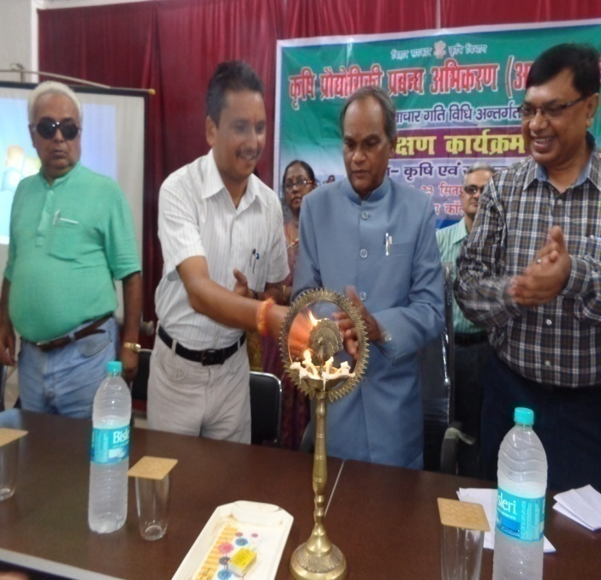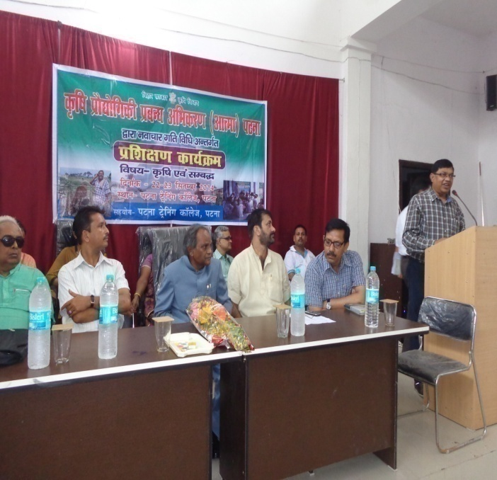
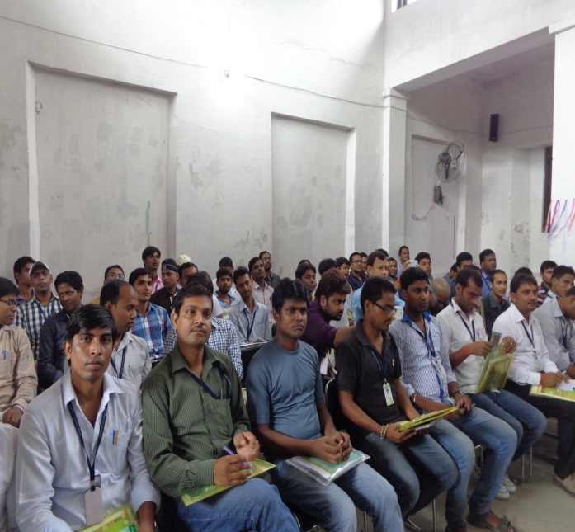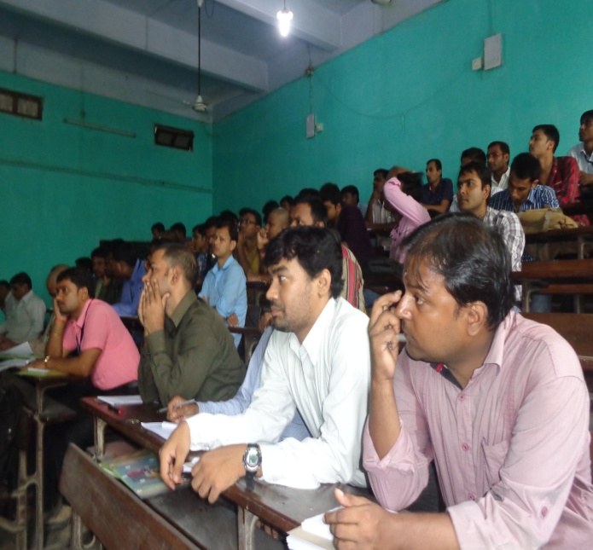

25- fnukad 25-09-2014 dks iquiqu iz[k.M vUrxZr xatij esa a{kerk lao/kZu dk;Zdze vUrxZr izf'k{k.k fn;k x;k ftlesa yxHkx 170 ¼,d lkS lRrj½ fdlkuksa us mDr izf'k{k.k dk;Zdze esa Hkkx fy;kA

26- fnukad 26-09-2014 dsk nkukiqj iz[k.M vUrxZr ujxnk esa {kerk lao/kZu dk;Zdze vUrxZr izf'k{k.k fn;k x;k ftlesa yxHkx 160 ¼,d lkS lkB½ fdlkuksa us mDr izf'k{k.k dk;Zdze esas Hkkx fy;kA
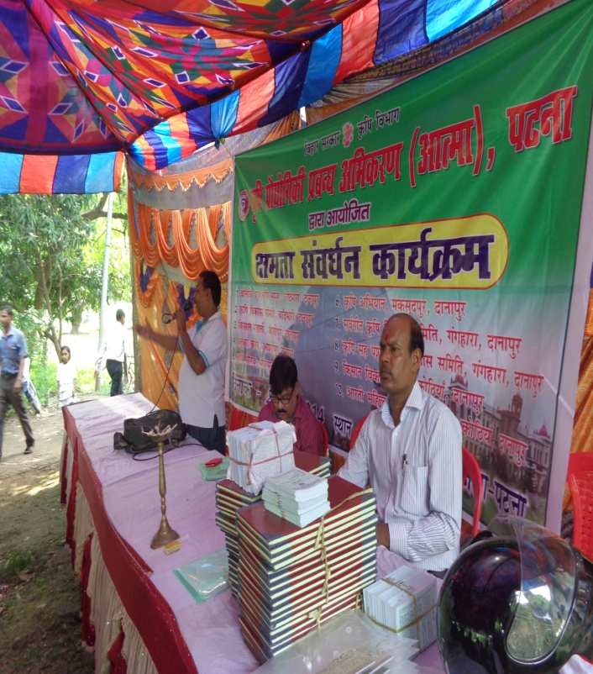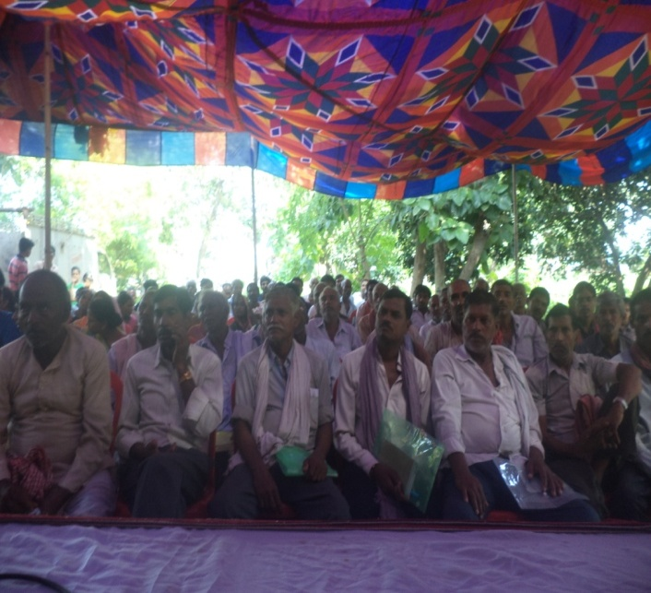
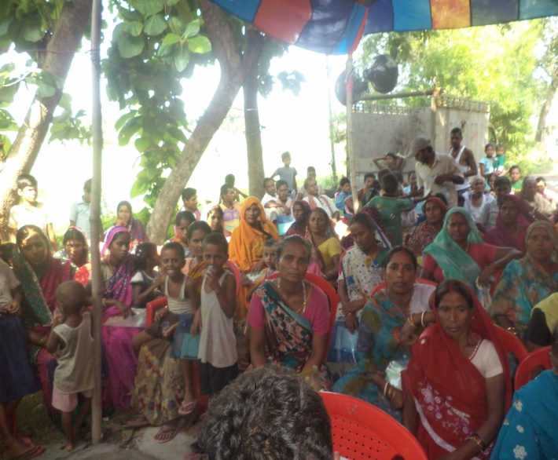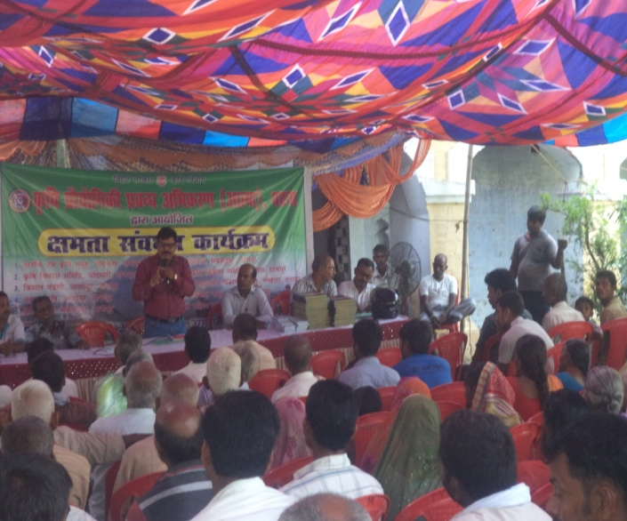
27- fnukad 23&25 flrEcj 2014 dks jkT; ds vUnj fdlku izf'k{k.k dk;Zdze vUrxZr d`f"k foKku dsUnz teqbZ esa dqy 54 fdlkuksa dk rhu fnolh; izf'k{k.k dk;Zdze vk;ksftr fd;k x;kA
dze la0 | fdlku dk uke | firk dk uke | Xkzke | Izk[k.M
1 | jfo dqekj | Jh jkts’oj izlkn | Tkequhpd | Ckk<+
2 | Jh egs’oj flag | Jhjketh flag | Ikjlkaoka | iaMkjd
3 | Jh x.ks’k jke | Jh jke’kj.k jke | f=eksgku | ?kkslojh
4 | Jh eqds’k dqekj | Jh jkey[ku iz0 ;kno | Ckklksckxh | Ckk<+
5 | Jh dqUnu dqekj | Jh lqjs’k egrks | dUgkbZiqj | Ekksdkek
6 | Jh eqUuk dqekj izlkn | Jh usj’k egrks | dUgkbZiqj | Ekksdkek
7 | Jh dqekj vuqjkx | Lo0 tnquUnu izlkn | vankSyh | csyNh
8 | Jh firEcj ;kno | Lo0 txnso ;kno | Ekksfdeiqj | Ckk<+
9 | Jh jkto/kZUk izlkn | Jh jkenqykj ;kno | lksbZek | Ckk<+
10 | Jh jes’k dqekj | Lo0 egsUnz ;kno | lksbZek | Ckk<+
11 | Jh jkts’k dqekj | Lo0 egsUnz ;kno | lksbZek | Ckk<+
12 | Jh lat; dqekj | Jh ckfYehdh izlkn | cklksokM+h | Ckk<
13 | Jh xksiky f=osnh | Lo0 jkeuUnu f=osnh | Lqkyrkuiqj | Ekksdkek
14 | Jh fo’okl dqekj | Jh jkemfpr ikloku | dUgkbZiqj | Ekskdkek
15 | Jh jkts’k ikloku | Jh ykyks ikloku | dUgkbZiqj | Ekskdkek
16 | Jh larks"k dqekj dq’kokgk | Jh lj;qx izlkn | dUgkbZiqj | Ekksdkek
17 | Jh lat; dqekj flag | Jh vafedk flag | lgukSjk | iaMkjd
18 | Jh ijekuUn flag | Lo0 mfpr flag | ,dMaxk | Ckk<+
19 | Jh izeksn izlkn | Lo0 ukjk;.k egrks | dUgkbZiqj | Eksakdkek
20 | Jh fd’kksjh ikloku | JhdkUr ikloku | dUgkbZiqj | Ekksdkek
21 | Jh jkds’k dqekj | Jh eYyw jtd | dUgkbZiqj | Ekksdkek
22 | Jh vfHkeU;q dqekj | Jh Jo.k dqekj | dUgkbZiqj | Ekksdkek
23 | Jh jkefuokl | Jh ujs’k izlkn ‘’kekZ | Lkqyrkuiqj | Ekskdkek
24 | Jh vkfnR;k jkt | Jh jktdqekj | CkklksokMh | Ckk<+
25 | Jh lksuk egrks | Jh rfud egrks | Xkksoklk ‘’ks[kiqjk | iaMkjd
26 | Jh jfodkar dqekj | Jh jktkjke egrks | dksUnh | iMkjd
27 | Jh ‘’kSysUnz izlkn | Jh ukjk;.k egrks | dUgkbZiqj | Ekskdkek
28 | Jh fojsUnz dqekj | Jh izgykn uk0 | ?kudMkse | ?kkslojh
29 | Jh ?kesZUnz dqekj | Lo0 lkxj egrks | ?kudMkse | ?kkslojh
30 | Jh lqjs’k izlkn | Lo0 ijes’oj egrks | /kudMkse | ?kkslojh
31 | Jh LokjFk eka>h | Jh uanyky eka>h | ?kudMkse | ?kkslojh
32 | Jh vf[kys’k dqekj | Jh uanfd’kksj izlkn | CkgjkWOkak | Ckk<
33 | Jh fouksn dqekj | Jh jkepUnz izlkn | gklupd | Ckk<
34 | Jh dey fd’kskj | Jh t;izdk’k falag | Ek>kSyh | Cfk[r;kjiqj
35 | Jh jfoUnzj flag | Jh laqjs’k flag | E`knkgkpd | Ckf[r;kjiqj
36 | Jh jkekJ; ;kno | Jh jketh ;kno | Ekskfdeiqj | Ckk<+
37 | Jh fnus’k dqekj flag | Jh lqjs’k falg | Pkdehnkn | iaMkjd
38 | Jh jkgqy dqekj | Jh lqHkk"k flag | lgukSjk | iaMkjd
39 | Jh fiaVw dqekj | Jh feFkys’k dqekj flag | lgukSjk | iaMkjd
40 | Jh ouokjh ikloku | Lo0 gtkjh ikloku | ‘’kgjh | Ckk<+
41 | Jh ‘’;kelqUnj izlkn | Jh uoy izlkn | Dsoy foxgk | Ckf[r;kjiqj
42 | Jh fnus’k egrks | Lo0 f’kcq egrks | dUgkbZiqj | Ekksdkek
43 | Jh xtkauan | Jh izeksn ;kno | lksbZek | Ckk<+
44 | Jh jkds’k jkS’ku | Jh nsoohj flag ;kno | lksbZek | Ckk<
45 | Jh jkts’k dqekj | Jh eYyq jtd | dUgkbZiqj | Ekskdkek
46 | Jh lqjsUnz izlkn | Lo0 ckys’oj lkko | dUgkbZiqj | Ekskdkek
47 | Jh nkzsukpk;Z | Jh vtqZu izlkn | lksbZek | Ckk<+
48 | Jh fnus’k dqekj | Jh Hkjr ;kno | lksbZek | Ckk<
49 | Jh fiaVw dqekj | Jh jktu ;kno | lksbZek | Ckk<+
50 | Jh jkS’ku dwekj | Lo0 lrsUnz flag | ,dMaxk | Ckk<+
51 | Jh vt; dqekj | Lo0 ckcw yky egrks | ?kudMkse | ?kkslojh
52 | Jh ykyks izlkn | Jh jkepfj= egrks | ?kudMkse | ?kkslojh
53 | Jh vfuy dqekj flag | Lo0 ;ksxsUnz flag | ‘’kgjh | Ckk<
54 | Jh larks"k dqekj | Jh jkeizlkn lkg | Ckq<+uhpd | Ckk<

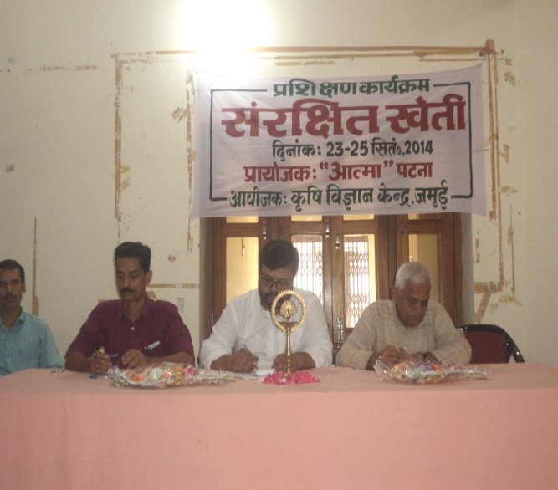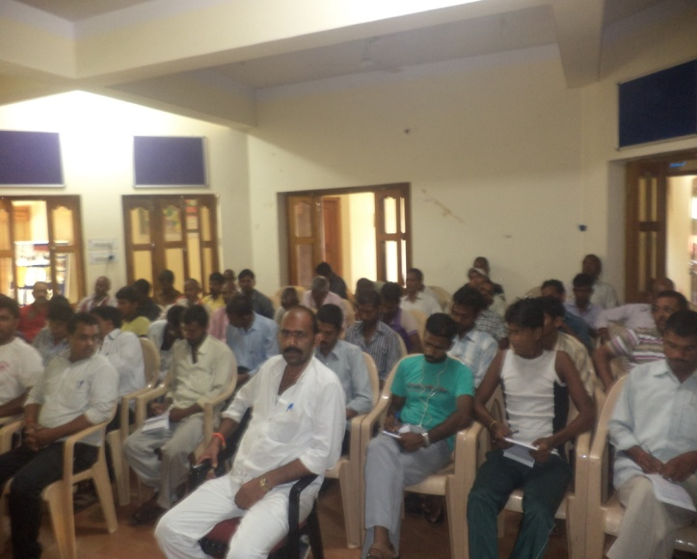
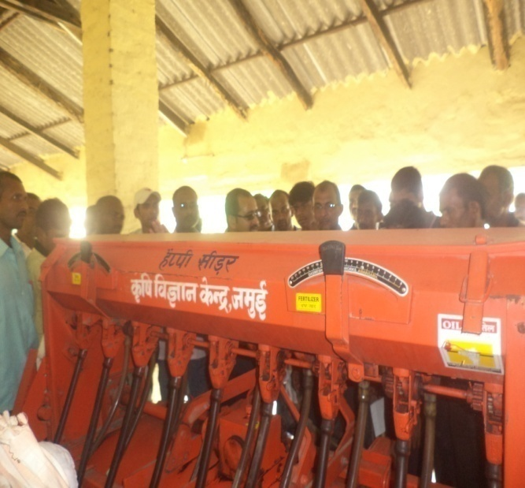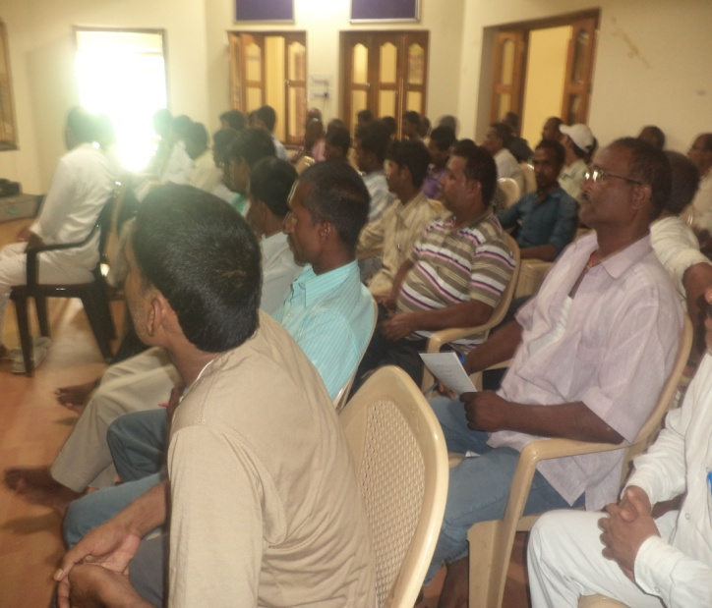
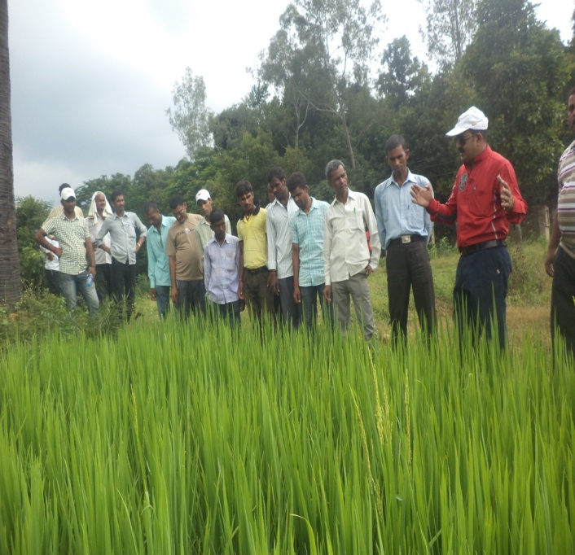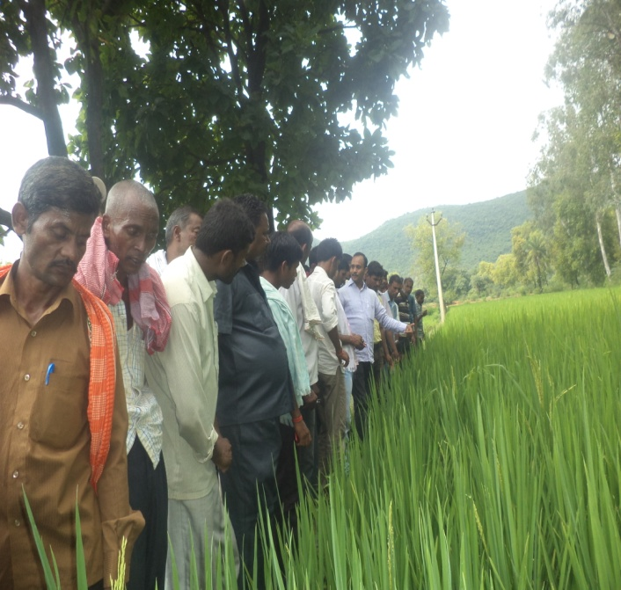
28- fnukad 26&29 flrEcj 2014 dks ftyk LRkjh; fdlku esyk vUrxZr d`f"k ;kaf=dj.k esyk dk vk;kstu ehBkiqj d`f"k iz{ks=] iVuk esa fd;k x;kA
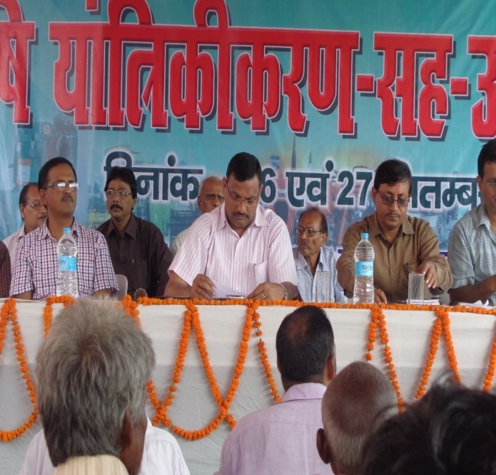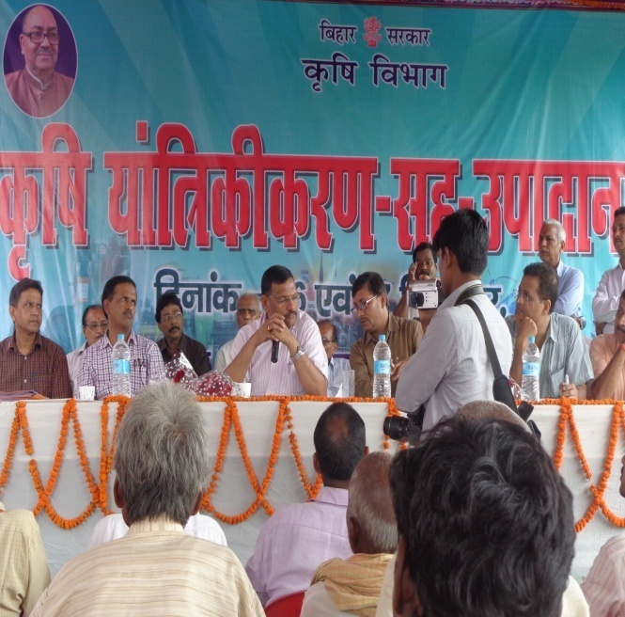
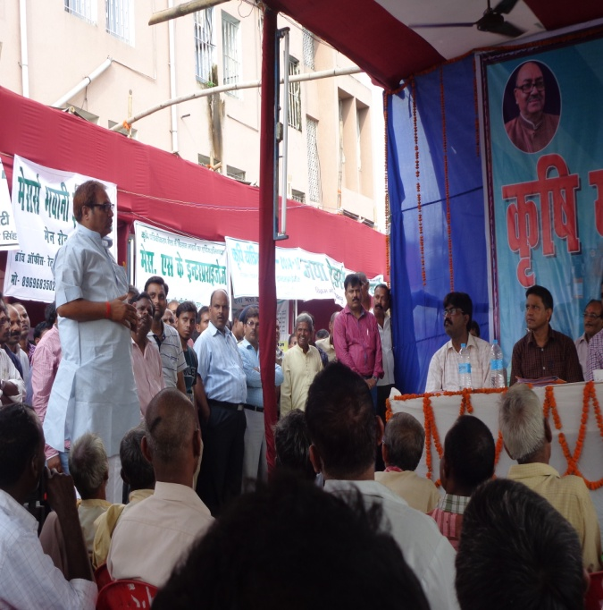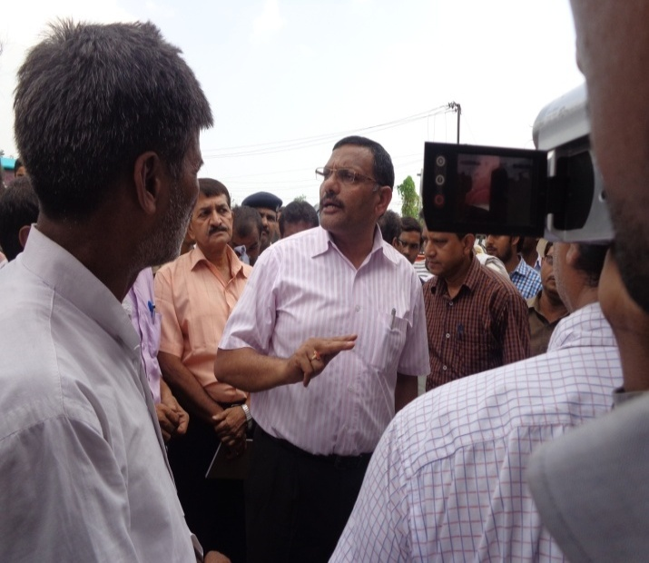
29- fnukad 09-10-2014 dks vFkeyxksyk iz[k.M ds mlekuiqj xzke esa fdlku fgr lewg@efgyk fgr lewg dk {kerk lao/kZu dk;Zde vk;ksftr fd;k x;k ftlesa 14 lewg ds 209 fdlkuksa us Hkkx fy;kA
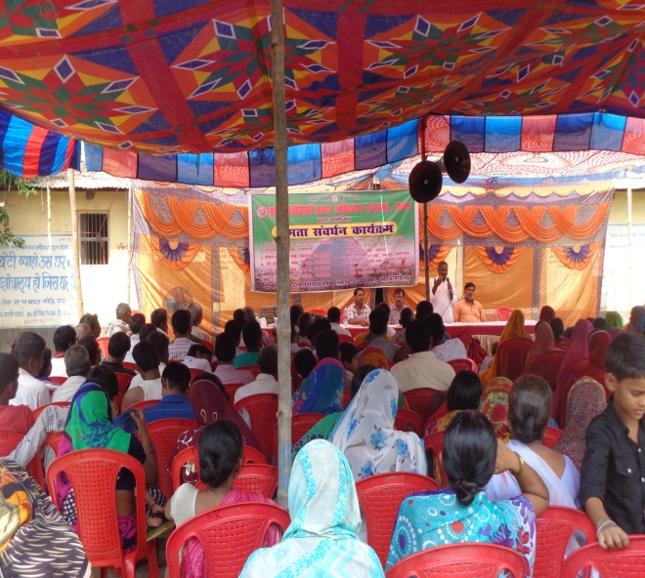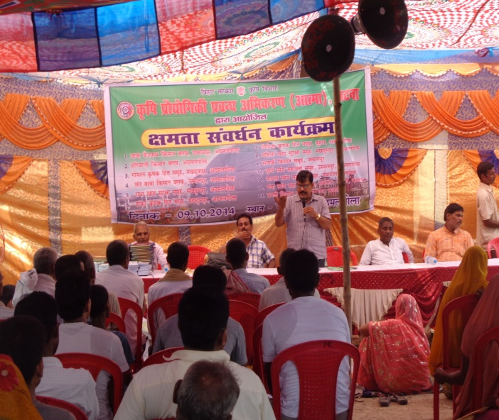
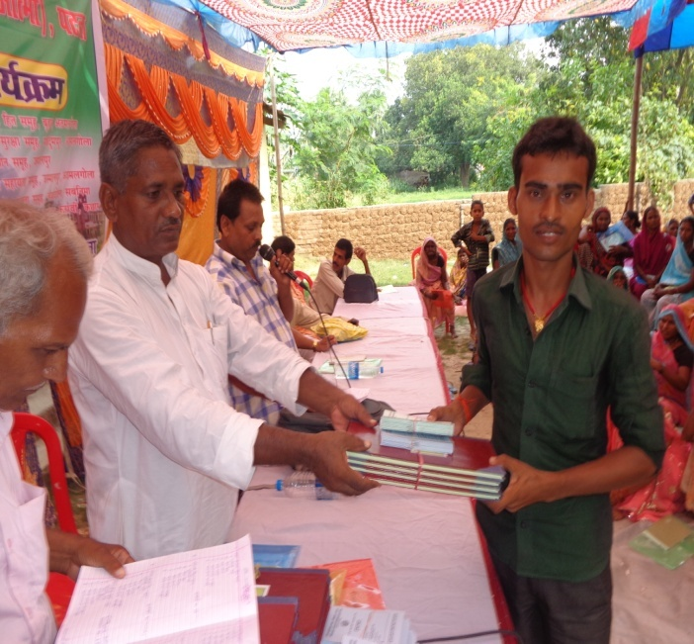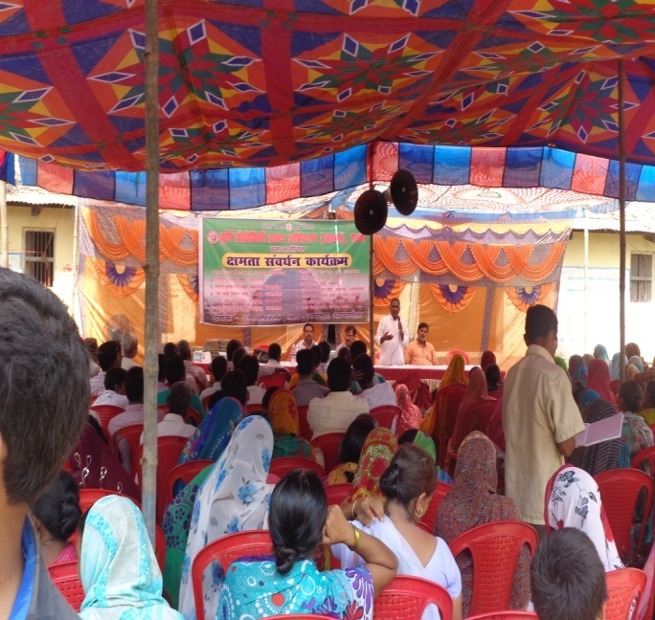
30- fnukad 11-10-2014 dks fdlku tkx:drk egkvfHk;ku &lg&jch egksRlo 2014 vUrxZr fdlku tkx:drk jFk dk ekuuh; eq[;ea=h] fcgkj ,oa ekuuh; d`f"k ea=h fcgkj ljdkj }kjk ?ot fn[kkdj ftyk esa jch egksRlo ds izpkj&izlkj gsrq jokuk fd;k x;kA

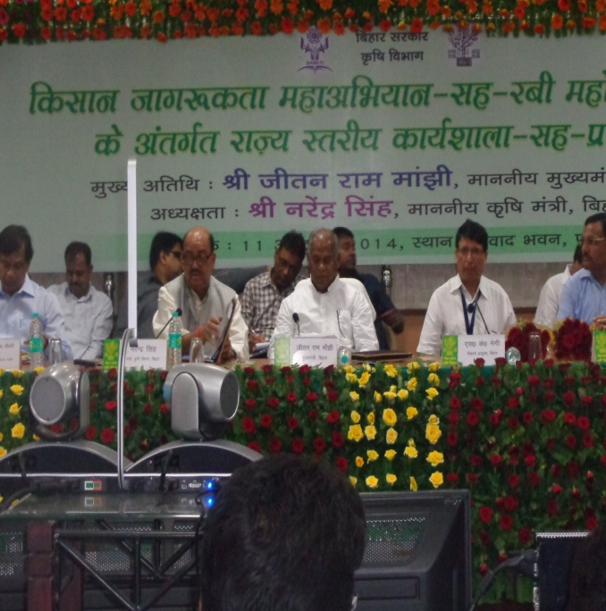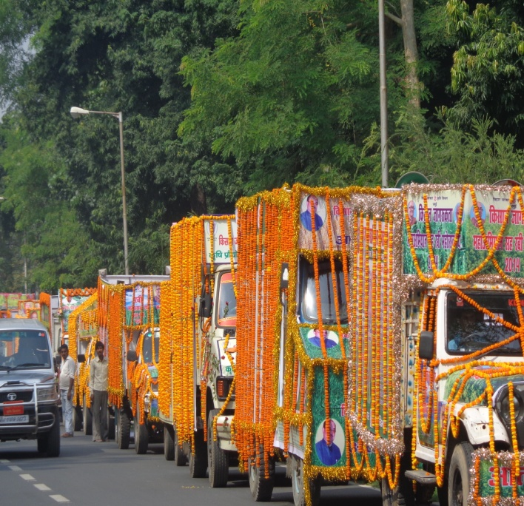
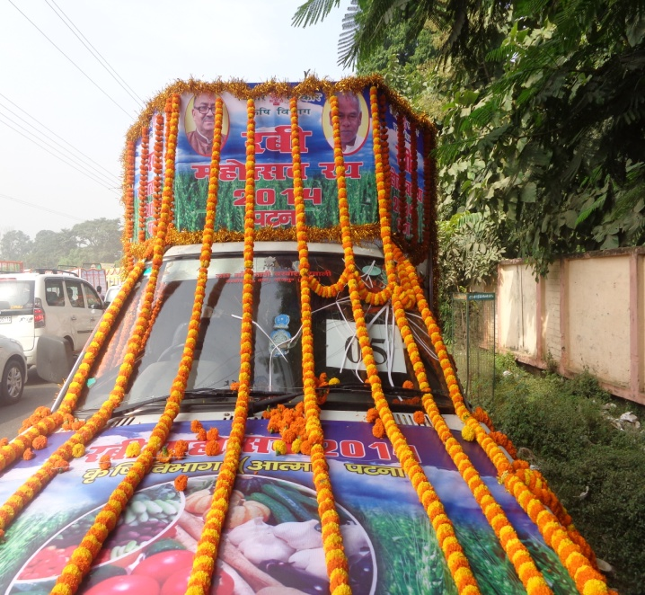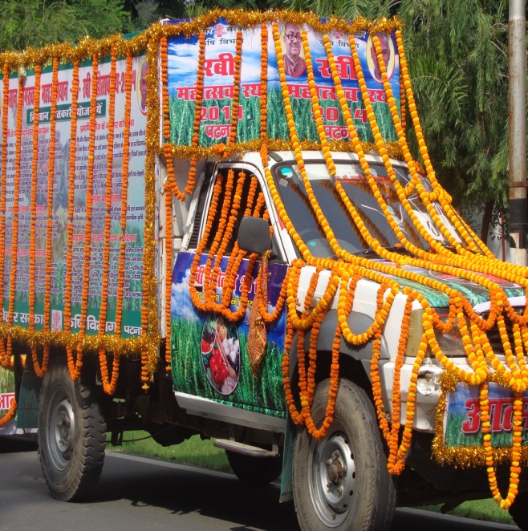
31- fnukad 13-10-2014 dks ftyk Lrjh; izf'k{k.k&^lg& jch deZ'kkyk dk vk;kstu nhi ukjk;.k flag {ks=h; lgdkjh izcU/k laLFkku 'kkL=huxj]iVuk es fd;k x;k ftlesa d`f"k foHkkx ds ftyk LRkj ds inkf/kdkjh x.k vuqeaMy d`f"k inkf/kdkjh] iz[kaM d`f"k inkf/kdkjh] d`f"k leUo;d fdlku lykgdkj ,oa v/;{k] fdlku lykgdkj lfefr us Hkkx fy;kA
32- fnukad 16&17 vDVwcj 2014 dsk cq)k e'k:e LikWy ySc] iafMriqj jktxhj ukyUnk esa dqy 50 efgyk@iq:"k fdlkuksa jkT; ds vUnj fdlku izf'k{k.k vUrxZr e'k:e mRiknu fo"k;d izf'k{k.k dk vk;kstu fd;k x;kA ftlesa fuEu fdlkuksa us Hkkx fy;kA
dze la0 | fdlku dk uke | firk dk uke | Xkzke | Izk[k.M
1 | Jherh Qqys’ojh nsoh | Jh lat; dqekj | dUgkbZiqj | Ekksdkek
2 | Jherh :uk nsoh | Jh jkeo`{k egrks | dUgkbZiqj | Ekksdkek
3 | Jherh /kfu;k nsoh | Lo0 uUnyky xksi | dUgkbZiqj | Ekksdkek
4 | Jherh ekuksa nsoh | Jh fnyhi dqekj ‘’kekZ | dUgkbZiqj | Ekksdkek
5 | Jherh foeyk nsoh | Jh /kesZUnz dqekj | dUgkbZiqj | Ekksdkek
6 | Jherh xhrk nsoh | Lo0 lat; izlkn | dUgkbZiqj | Ekksdkek
7 | Jherh lquSuk nsoh | Jh jfoUnz izlkn | dUgkbZiqj | Ekksdkek
8 | Jherh vfurk nsoh | Jh jfoUnz egrks | dUgkbZiqj | Ekksdkek
9 | Jherh lhek nsoh | Jh ‘’kSysUnz dq0 dq’kokgk | dUgkbZiqj | Ekksdkek
10 | Jherh ‘’kkafr nsoh | Jh vfer izlkn | dUgkbZiqj | Ekksdkek
11 | Jherh izfrek nsoh | Jh vej izlkn | dUgkbZiqj | Ekksdkek
12 | Jherh equjh nsoh | Jh xaxk o’kqu egrks | dUgkbZiqj | Ekksdkek
13 | Jh jkevuqt flag | Jh esnuh flag | vVukeka | Ckk<+
14 | Jh vuqt dqekj | Lo0 jktsUnz izlkn | iwohZ elkgh
15 | Jh jkepUnz lko | Lo0 f’ko’kadj lko | Ckk<+
16 | Jherh eatw nsoh | Jh lqnhy jtd | dUgkbZiqj | Ekksdkke
17 | Jherh bUnq nsaoh | Jh jkepfjr izlkn | dUgkbZiqj | Ekskdkek
18 | Jherh ikoZrh nsoh | Jh Hkksyk izlkn | dUgkbZiqj | Ekskdkek
19 | Jherh pEik nsoh | Jh ;nquUnu egrks | dUgkbZiqj | Ekskdkek
20 | Jh izselq/kk nsoh | Jh iznhi izlkn | dUgkbZiqj | Ekskdkek
21 | Jherh ‘’khyk nsoh | Jh foUns’oj egrks | dUgkbZiqj | Ekskdkek
22 | Jherh eerk nsoh | Jh izeksn izlkn | dUgkbZiqj | Ekskdkek
23 | Jherh dsoyk nsoh | Jh nklks egrks | dUgkbZiqj | Ekskdkek
24 | Jherh yhyk nsoh | Jh Hkhey egrks | dUgkbZiqj | Ekskdkek
25 | Jherh f’kodwekjh nsoh | Jh v;ks/;k egrks | dUgkbZiqj | Ekskdkek
26 | Jherh :ch nsoh | Jh jkts’k jtd | dUgkbZiqj | Ekskdkek
27 | Jherh ‘’;kek nsoh | Jh fot; jtd | dUgkbZiqj | Ekskdkek
28 | Jherh fouhrk nsoh | Jh ftrsUnz egrks | dUgkbZiqj | Ekskdkek
29 | Jherh vkjrh nsoh | Jh fo’ks’oj egrks | dUgkbZiqj | Ekskdkek
30 | Jherh lquSuk nsoh | Jh pUnsa’oj egrks | dUgkbZiqj | Ekskdkek
31 | Jherh lksuh nsoh | Jh ghjk jtd | dUgkbZiqj | Ekskdkek
32 | Jherh csch nsoh | Jh pUnznhi egrks | dUgkbZiqj | Ekskdkek
33 | Jherh js[kk nsoh | Jh jkeizos’k izlkn | dUgkbZiqj | Ekskdkek
34 | Jherh eatw nsoh | Jh deys’k egrks | dUgkbZiqj | Ekskdkek
35 | Jherh ehuk nsoh | Jh v’kksd izlkn | dUgkbZiqj | Ekskdkek
36 | Jherh ek/kqjh nsoh | Jh ;ksxsUnz izlkn | dUgkbZiqj | Ekskdkek
37 | Jh vuqt dqekj iafmr | Jh jke’kj.k iafMRk | dUgkbZiqj | Ekskdkek
38 | Jh ‘’kSysUnz izlkn | Lo0 ukjk;.k egrks | dUgkbZiqj | Ekskdkek
39 | Jh jkts’k ikloku | Jhykyks ikloku | dUgkbZiqj | Ekskdkek
40 | Jh lquhy dqekj flag | Lo0 ;ksxsUnz flag | Lkgjh | Ckk<
41 | Jh ’kSysUnz dqekj | Jh o`tuUnu izlkn | dUgkbZiqj | Ekskdkek
42 | Jherh izhrh dwekjh | Jh pUnznhi egrks | dUgkbZiqj | Ekskdkek
43 | Jh larks"k dq0 dq’kokgk | Jh lj;qx izlkn | dUgkbZiqj | Ekskdkek
44 | Jh jkds’k dqekj | Jh eYyw jtd | dUgkbZiqj | Ekksdkek
45 | f’ko’kadj egrks | Jh ckys egrks | dUgkbZiqj | Ekksdkek
46 | Jh vfuy dqekj flg | Lo0 ;ksxsUnz flg | Lkgjh | Ckk<+
47 | Jherh dapu nsoh | Jh f’ko’kadj egrks | dUgkbZiqj | Ekskdkek
48 | Jherh m"kk nsoh | Jh eqUUkk izlkn | dUgkbZiqj | Ekskdkek
49 | Jh veu dqekj | Jh vuqt iafMr | dUgkbZiqj | Ekksdkek
50 | Jherh eatw nsoh | Deys’k egrks | dUgkbZiqj | Ekksdkek

33- fnukad 05-11-2014 ls 22-11-2014 rd fdlku tkx:drk vfHk;ku varxZr iVuk ftyk ds izR;sd iz[kaM esa jCkh egksRlo dk vk;kstu fd;k x;k ftlesa fdlkuksa dks fofHkUu fo"k;ksa ij izf’k{k.k fn;k x;k ftldh iz[k.M okj izf’k{k.k ,oa miknku forj.k dh frfFk fuEuor gS %&
dze la0 | Ikz[k.M dk uke | Ikzf’k{k.k dk;dze dh frfFk | miknku forj.k dh frfFk
1 | iVuk lnj | 05.11.14 | 06-08, Nov. 2014
2. | cf[r;kjiqj | 05.11.14 | 06-08, Nov. 2014
3. | [kqLk:iqj | 06.11.14 | 07-09, Nov. 2014
4. | Qrqgk | 06.11.14 | 07-09, Nov. 2014
5. | nfu;kaoka | 07.11.14 | 08-10, Nov. 2014
6. | ck<+ | 07.11.14 | 08-10, Nov. 2014
7. | vFkeyxksyk | 08.11.14 | 09-11, Nov. 2014
8. | eksdkek | 08.11.14 | 09-11, Nov. 2014
9. | ?kkslojh | 10.11.14 | 11-13, Nov. 2014
10. | iaMkjd | 10.11.14 | 11-13, Nov. 2014
11 | csyNh | 11.11.14 | 12-14, Nov. 2014
12. | elkS<+h | 11.11.14 | 12-14, Nov. 2014
13. | /ku:vk | 12.11.14 | 13-15, Nov. 2014
14. | iquiqu | 12.11.14 | 13-15, Nov. 2014
15. | lairpd | 13.11.14 | 14-16, Nov. 2014
16. | nkukiqj | 14.11.14 | 15-17, Nov. 2014
17. | Qqyokjh'kjhQ | 15.11.14 | 16-18, Nov. 2014
18. | ikyhxat | 17.11.14 | 18-20, Nov. 2014
19. | nqfYgucktkj | 18.11.14 | 19-21, Nov. 2014
20. | foØe | 19.11.14 | 20-22, Nov. 2014
21. | fcgVk | 20.11.14 | 21-23, Nov. 2014
22. | eusj | 21.11.14 | 22-24, Nov. 2014
23. | ukScriqj | 22.11.14 | 23-25, Nov. 2014
34- fnukad 09-11-2014 ls 14-11-2014 rd jkT; ds ckgj fdlku izf'k{k.k gsrq th0 ch0 iUr uxj mRRkjk[k.M esa 28 fdlkuksa dk izf'k{k.k gsrq Hkstk x;k FkkA
dze la0 | fdlku dk uke | firk dk uke | Xkzke | Ikz[k.M
1 | Jh panu dqekj | Jh f’komn; ‘’kekZ | Egqvjh | Ikkyhxat
2 | Jh jfojatu dqekj | Jh jk?ksoUnz dqekj | Egqvjh | Ikkyhxat
3 | Jh lk/kq egrks | Loo0 ‘’;keuanu egrks | Mhgikyh | Ikkyhxat
4 | Jh v’kksd dqekj | Jh jkeiqdkj flag | Mhgikyh | Ikkyhxat
5 | Jh /ku’;ke dqekj | Jh jkeinkjFk falg | Cks<uk | Ckk<
6 | Jh vfuy dqekj | Jh txnh’k falg | nkgkSj | Ckk<+
7 | Jh /keZthr dqekj | Jh vejthr dqekkj flUgk | Yksknhiqj | nkukiqj
8 | Jh fizal dqekj | Jh lquhy dqekj | Yksknhiqj | nkukiqj
9 | Jh mess’k falg | Lo0 dqynhi falg | Yksknhiqj | nkukiqj
10 | Jh fo|klkxj flag | Lo0 jkeflagklu flag | Pkekjhpd | nkukiqj
11 | Jh jktuUnu falg | Lo0 iquhr flag | efB;kiqj | nkukiqj
12 | Jh foosd dqekj | Jh lqiu falg | Ukjxnk | nkukiqj
13 | Jh izeksn dqekj falg | Jh jkelsod flag | Yksknhiqj | nkukiqj
14 | Jh fotsUnz flag | Jh jke’kadj flag | jkeiqj fn;jk | Ekusj
15 | Jh fots’k dqekj flag | Jh f=Hkwou flag | jkeiqj fn;jk | Ekusj
16 | Jh lfPpnkuan flag | Jh Hkqous’oj flag | fc".kqiqjk | fcgVk
17 | Jh lquhy dqekj | Lo0 ukxsUnz flag | fc".kqiqjk | fcgVk
18 | Jh lat; uk0 ‘’kekZ | Lo0 f’kojke ‘’kekZ | Lqkyrkuiqj | Qrqgk
19 | JhdkUr uk0 ‘’kekZ | Lo0 f’kodqekj ‘’kekZ | Lqkyrkuiqj | Qrqgk
20 | Jh thrukjk;.k ‘’kekZ | Jh jkey{ke.k flag | Lqkyrkuiqj | Qrqgk
21 | Jh ’kadj n;ky ‘’kekZ | Jh mes’k izlkn falg | Lqkyrkuiqj | Qrqgk
22 | Jh lwjt ikloku | Lo0 cspu ikloku | uRFkqiqj | Qrqgk
23 | Jh fouksn dqekj | Jh jkeckcw izlkn | pikSj | elkS<h
24 | Jh t;izdk’k falg | Jh txnh’k iz0 flag | Hkyqvk | Ekusj
25 | Jh vejukFk | Lo0 jktsUnz izlkn | pikSj | elkS<h
26 | Jh cyjke iafMr | Lo0 ijek iafMRk | pikSj | elkS<h
27 | Jh vt; flag | Jh txnhi flag | pikSj | elkS<h
28 | Jh dSyk’k izlkn flag | Lo0 lq[knso flag | Qrsgiqj | ukScriqj
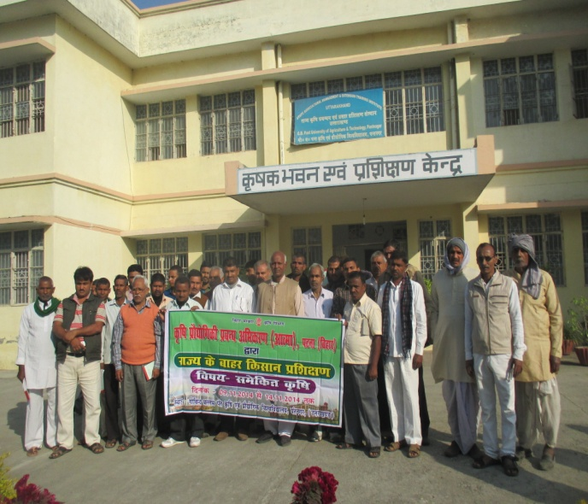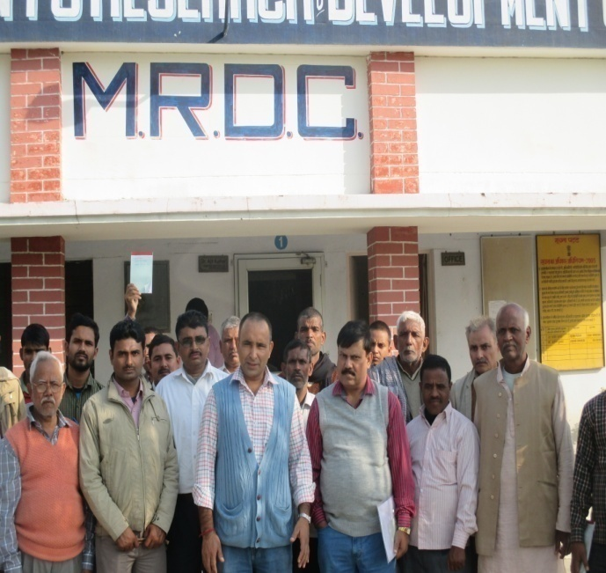
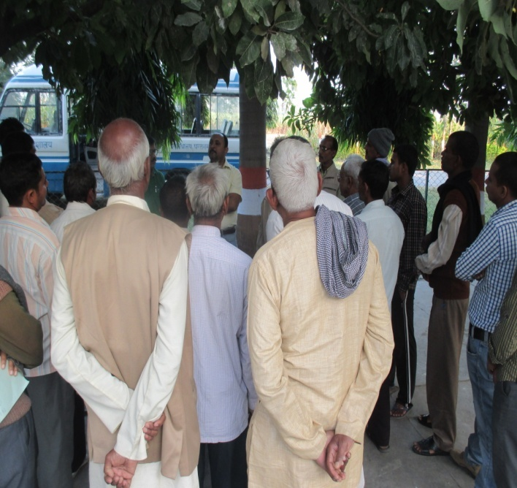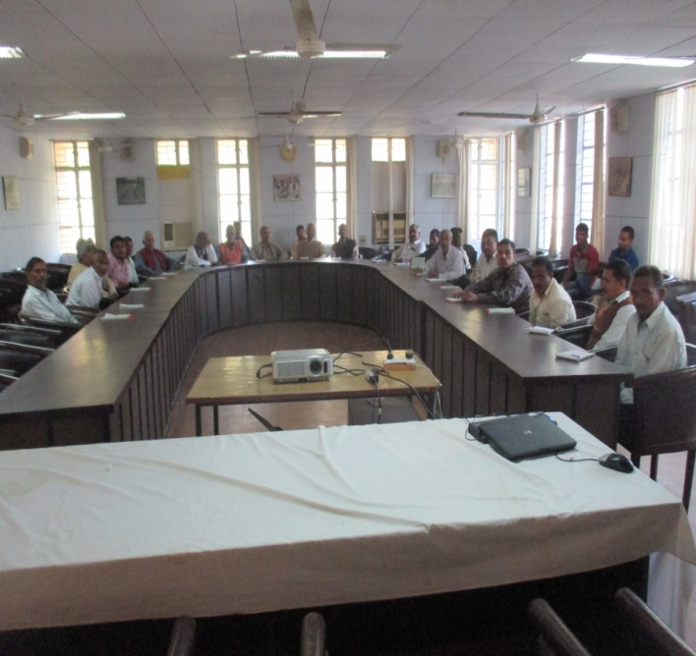
35- jkT; ds ckgj fdlku izf'k{k.k vUrxZr fnukad 11-11-2014 ls 18-11-2014 rd tSu bfjxs'ku flLVe fy0 tyxkWo egkjk"V esa 30 fdlkuksa dks izf'k{k.k gsrq Hkstk x;k A
dze la0 | fdlku dk uke | firk dk uke | Xkzke | Ikz[k.M
1 | Jh vfuy dqekj falg | Lo0 lqnjh flag | Ckkdhiqj | nfu;kaok
2 | Jh lquhy dqekj flag | Lo0 jkeo`{k flag | Pkdjtk | nfu;kaok
3 | Jh vHkhthr dqekj flag | Jh fl;kjke flag | fc’kquiqjk | fcgVk
4 | Jh xtsUnz flag | Jh jkeldy flag | fc’kquiqjk | fcgVk
5 | Jh egewn vkye | Lo0 eks0 gqlSu | jlqyiqj | Qrqgk
6 | Jh fouksn dqekj | Jh cuokjh flag | [kks[kquk | Qrqgk
7 | Jh meka’kdj dqekj | Jh txnh’k flag | fijgh | nqfYgucktkj
8 | Jh thoks/ku yky ikloku | Jh ukFkqu ikloku | Ikhjgh | nqfYgucktkj
9 | Jh jktfd’kksj jke | Jh txnh’k flg | fijgh | nqfYgucktkj
10 | Jh xksiky ‘’kekZ | Jh jkekuUn ‘’kekZ | ujSuk | Qrqgk
11 | Jh dey ukjk;.k ‘’kekZ | Lo0 jkekKk flag | ukScriqj | ukScriqj
12 | Jh dkes’oj ikloku | Jh jke;ru ;kno | jkeiqj ujxnk | Ikkyhxat
13 | Jh enu eksgu | Jh ckys’oj flag | fpjkSjk | ukScriqj
14 | Jh vfu:) dqekj | Jh lhrk jke izlkn | dM+jk | ?kkslojh
15 | Jh j/kqukFk izlkn | Jh jke[ksykou egrks | /koyiqjk | iVuk lnj
16 | Jh vthr dqekj | Lo0 jkeuUnu izlkn | /kqlqdVksyk | nkukiqj
17 | Jh iIiq dqekj | Jh jkeukjk;.k flag | Yksknhiqj | nkukiqj
18 | Jh enu eksgu izlkn | Jh lqjs’k izlkn | dM+jk | ?kkslojh
19 | Jh lrh’k dqekj | Lo0 cStw izlkn | vf[r;kjiqj | Ikkyhxat
20 | Jh d`".kk izlkn | Lo0 nsoh izlkn flag | jkeiqj fn;jk | Ekusj
21 | Jh ykyeksgu flg | Lo0 dkyh flag | jkeiqj fn;jk | Ekusj
22 | Jh odhy flag | Lo0 jked`iky flag | jkeiqj fn;jk | Ekusj
23 | Jh jes’k pUnz feJk | Lo0 ckcq uan feJk | jkeiqj fn;jk | Ekusj
24 | Jh lqHkk"k jk; | Jh eksgu jk; | gYnh Nijk | Ekusj
25 | Jh t;izdk’k flag | Lo0 jkevo/k flag | fijdh | nqfYgucktkj
26 | Jh jkek’kadj dqWvj | Lo0 oStukFk dqWoj | fetkZiqj | iVuk lnj
27 | Jh bUnzthr flag | Jh Hkjr falg | /koyiqjk | iVuk lnj

36- jkT; ds ckgj fdlku ifjHkze.k vUrxZr fnukad 17-11-2014 ls 24-11-2014 rd tSu bfjxs'ku flLVe fy0] tyxkWo egkjk"Vz esa 30 fdlkuksa dks Hkstk x;k A
dze la0 | fdlku dk uke | firk dk uke | Xkzke | Ikz[k.M
1 | Jh gfj’kadj mik/;k; | Jh jktsUnz mik/;k; | <ksjokW | nqfYgucktkj
2 | Jh izoh.k dqekj | Jh f’koPkUnz jtd | f=eqgku | ?kkslojh
3 | Jh jktsUnz izlkn falg | Jh ijekuUn flag | dkerkpd hh | Lakirpd
4 | Jh jkeukFk flag | Lo0 f’konkl falg | fpyfcYyh | Qqyokjh’kjhQ
5 | Jh lat; dqekj oekZ | Jhjkeckcq ‘’kekZ | fpyfcYyh | Qqyokjh’kjhQ
6 | Jh dkSys’oj izlkn flag | Lo0 lR;ukjk;.k flag | Tkykyiqj | Iqkuiqu
7 | Jh misUnz flag | Lo0 jkepUnz flag | Xkatij | vFkeyxksyk
8 | Jh vjfoUn dqekj esgrk | Jh eqa’kh izlkn | Tkks/ku foxgk | csyNh
9 | Jh ek/kks izlkn | Lo rstukjk;.k izlkn | fVYgkj | csyNh
10 | Jh c`txksiky flag | Jh txnh’k flag | ckSjgh | /ku:vk
11 | Jh jkds’k dqekj | Jh jkeukjk;.k flag | nknqiqj | fodze
12 | Jh lq/khj dqekj | Jh cklqnso flag | nknqiqj | fodze
13 | Jh ohjcgknqj flag | Jh QkStnkjh flag | eqLrkQkiqj | Iqkuiqu
14 | Jh iou dqekj | JhdkUr izlkn ‘’kekZ | <hcj | iaMkjd
15 | Jh jkds’k dqekj | Jh eYyq jtd | dUgkbZiqj | Ekksdkek
16 | Jh vt; dqekj | Jh lq/khj flag | Xkksoklk ‘’ks[kiqjk | iaMkjd
17 | Jh lrh’k dqekj flag | Jh jkeoj.k flag | ugoWk | elkS<+h
18 | Jh vfuy dqekj flag | Jh ;ksxsUnz falg | Lkgjh]ck<+ | Ckk<+
19 | Jh egsUnzdqekj | Jh xjHkw flag | dksYgj | Qrqgk
20 | Jh gfjdkUr uk0 ‘’kekZ | Jh fot; ‘’kekZ | Lqkyrkuiqj | Qrqgk
21 | Jh thruk0 ‘’kekZ | Jh jkey{k.k ‘’kekZ | Lqkyrkuiqj | Qrqgk
22 | Jh deys’oj ‘’kekZ | Jh foUns’ojh ‘’kekZ | Lqkyrkuiqj | Qrqgk
23 | Jh vejthr dq0 flUgk | Lo0 dkerk izlkn flUgk | Yksknhiqj | nkukqij
24 | Jh iou dqekj | Jh d`".kk dq0 lkg | Yksknhiqj | nkukqij
25 | Jh fiadw dqekj | Jh jkeckcq flag | Yksknhiqj | nkukqij
26 | Jh jfo dSyk’k | Jh nsoukjk;.k flag | Yksknhiqj | nkukqij
27 | Jh gseUr dqekj | Jh fo|k lkxj flag | Pkekjhpd | nkukqij
28 | ‘’kf’kdkUr ‘’kekZ | Jh fot; ‘’kekZ | Lqkyrkuiqj | Qrqgk
29 | JhdkUr uk0 ‘’kekZ | Jh f’kodqekj ‘’kekZ | Lqkyrkuiqj | Qrqgk
30 | Jh vf[kys’k dqekj | Jh foUns’ojh izlkn flag | xnZuhckx | iVuk lnj

37- jkT; ds vUnj fdlku izf'k{k.k vUrxZr fnukad 04-11-2014 ls 06-11-2014 rd d`f"k foKku dsUnz vkjk esa 52 fdlkuksa dk izf'k{k.k fnyk;k x;k A
dze la0 | fdlku dk uke | firk dk uke | Xkzke | Ikz[k.M
1 | Jh dfoUn dqekj | Lo0 fl}ukFk flag | iSiqjk dyk | Ikkyhxat
2 | Jh mes’k falg | Lo0 f’ko flag | jkuhiqj | Ikkyhxat
3 | Jh Hkw"k.k ‘’kekZ | Jh dapu ‘’kekZ | dkSjh | Ikkyhxat
4 | Jh lfoUnz dqekj | Jh dSyk’k falg | Ekgqvjh | Ikkyhxat
5 | Jh jk?kosUnz ‘’kekZ | Jh dk’kh ‘’kekZ | Ekgqvjh | Ikkyhxat
6 | Jh misUnz ‘’kekZ | Jh Hkqous’oj ‘’kekZ | Ekgqvjh | Ikkyhxat
7 | Jh pUnu dqekj | Jh f’koizlkn ‘’kekZ | egqvjh | Ikkyhxat
8 | Jh vftr dqekj | Jh jkelkxj ‘’kekZ | egqvjh | Ikkyhxat
9 | Jh fodkl dq0 ‘’kekZ | Jh jkemn; ‘’kekZ | egqvjh | Ikkyhxat
10 | Jh fizl dqekj | Lo0 cyh flg | egqvjh | Ikkyhxat
11 | Jh pUnzs’oj falg | Jh cyh flag | Cksyk | Ikkyhxat
12 | Jh fl;kjke ‘’kekZ | Lo0 pUns’oj ‘’kek | Egqvjh | Ikkyhxat
13 | Jh yodq’k mik/;k; | Jh cqysUnz mik/;k; | elkS<+k | Ikkyhxat
14 | Jh dkS’ky dqekj | Jh f’kolkxj ‘’kekZ | Ekgqvjh | Ikkyhxat
15 | Jh f’koizlkn falg | Jh jkekJ; flag | Cksyk | Ikkyhxat
16 | Jh ftrsUnz dqekj | Jh t;jke flag | Ekgqvjh | Ikkyhxat
17 | Jh jes’k dqekj | Jh jkekKk falg | btjrk | Ikkyhxat
18 | Jh jk?kosUnz dqekj | Jh fl}ukFk flag | bZtjrk | Ikkyhxat
19 | Jh lquhy dqekj | Lo0 jkepUnz egrsk | Mhgikyh | Ikkyhxat
20 | Jh vkyksd dqekj | Lo0 jkev/kkj flag | nfj;kiqj | Ikkyhxat
21 | Jh VaVh dqekj | Jh jkek/kkj flag | nfj;kiqj | Ikkyhxat
22 | Jh jktukFk jk; | Jh ghjk lko | Mhgikyh | Ikkyhxat
23 | Jh eukst dqekj | Jh ;equk flag | Mhgikyh | Ikkyhxat
24 | Jh eqUuk falg | Jh e/ks’oj flag | Cksyk | Ikkyhxat
25 | Jh uoy fd’kksj flag | Jh jkepUnz falg | Xaktij | Ikquiqu
26 | Jh jk/ks’;ke flag | Jh nqykj flag | tykyiqj | Ikquiqu
27 | Jh lat; dqekj flag | Jh ykyfcgkjh flag | xatij | Ikquiqu
28 | Jh lqjsUnz dqekj | Jh ujflag ikloku | Tkykyiqj | Ikquiqu
29 | ‘’kf’kdkUr dqekj | Jh jkenso ikloku |  | Ikquiqu
30 | Jh bUnznso ikloku | Jh vtqZu ikloku |  | Ikquiqu
31 | Jh e/ks’k ikloku | Jh v’kksd ikloku |  | Ikquiqu
32 | Jh lgtkuan flag | Jh f’kykthr flag | ikjFkq | Ikquiqu
33 | Jh pUnu dqekj falg | Lo0 v:.k falg | Ykglwuk | Ikquiqu
34 | Eksk0 vdcj vyh | Lo0 vCnqy djhe | tVMqejh | Ikquiqu
35 | Jh fou; dqekj flag | Jh jkepUnz flag | Mqejh | Ikquiqu
36 | Jh lt; dqekj flag | Jh Hkxoku flag | Ek[knqeiqj | Ikquiqu
37 | Jh vfuy flag | Lo0 jkeHkxoku flag | Ek[knqeiqj | Ikquiqu
38 | Jh v:.k dqekj flag | Jh jkeuUn flag | tkSuiqjh | Ikquiqu
39 | Jh ftrsUnz dqekj | Jh ykyckcw flag | dqrqciqj | Ikquiqu
40 | Jh lqeu dqekj falg | Jh jktuanu falg | Dqrqciqj | Ikquiqu
41 | Jh iou dqekj | Jh fou; flag | Ek[knqeiqj | Ikquiqu
42 | Jh misUnz uk0 flag | Lo0 nsouanu falg | Ek[knqeiqj | Ikquiqu
43 | Jh jkts’oj flag | Jh Hkxoku flag | vykoyiqj | Ikquiqu
44 | Jh larks"k dqekj | Jh lgnso izlkn flag | vykoyiqj | Ikquiqu
45 | Jh jktsUnz izlkn flag | Lo0 f=’kwy falg | Xaktij | Ikquiqu
46 | Jh iz.ko dqekj flag | Jh jkecq>kou flag | Xaktij | Ikquiqu
47 | Jh misUnz flag | Jh jkepUnz falg | Xaktij | Ikquiqu
48 | Jh lqjs’k flag | Lo0 ykyfcgkjh flag | Xaktij | Ikquiqu
49 | Jh dkSys’oj iz0 flag | Jh lR;uk0 flag | Xaktij tykyiqj | Ikquiqu
50 | Jh ukjk;.k dqekj | Jh cPpw falg | Ekgqvjh | Ikquiqu
51 | Jh jktw dqekj | Jh jkekuqt dqekj | ikjFkq | Ikquiqu
52 | Jh lq/khj dqekj | Jh galyky falg | ikjFkq | Ikquiqu

38- vkRek iVuk }kjk jch 2014&15 varxZr ftyk ds izR;sd iz[kaM esa nks&nks dqy 46 ¼Nh;kyhl½ fdlku ikB'kkyk dk lapkyu fd;k tk jgk gSA
dze l0a | lapkyd dk uke | firk@ifr dk uke | Xkzke | Iakapk;r | Ikz[k.M | eksckbZy ua0
1 | Jh lq/kk’kq flag | ‘’k=q/ku flag | jkeiqj Mqejk | jkeiqj Mqejk | Eksdkek | 8804107265
2 | Jh eqds’k izlkn ‘’kekZ | Lo0 pUnz’ks[kj ‘’kekZ | Lkqyrkuiqj | Lqkyrkuiqj | Ekksdkek | 9097663422
3 | Jh fot; flag | Jh ldynso flag | pSuiqj | fpiqjk | Lakirpd | 8969335327
4 | Jh Qsdu egrks | Lo0 lhrkjke egrks | cSfj;k | cSfj;k | Lakirpd
5 | Jh ?ku’;ke izlkn | Lo0 jk/kk paUnz flag | lsYgkSjh | lsYgkSjh | nqfYgucktkj | 9430405203
6 | Jh jkeHkou ‘’kekZ | Lo0 tqxy flag | dkflepd | ,su[kkW fHkeuhpd | nqfYgucktkj | 8271469885
7 | Jh /kuat; dqekj | Jh jkepfj= flag | Uknkoka | Uknkoak | Ckk<+ | 9939507506
8 | Jh lgsUnz ikloku | Jh jkepfj= nkl | Lkg lyseiqj | Bczkfgeiqj | Ckk<+ | 9162608862
9 | Jh fnus’k flag | Lo0 o`Un flag | Lqkdjosxpd | Lqkdjosxpd | [kql:iqj | 8083865267
10 | Jh pUnz’ks[kj feJk | Lo0 txr feJk | Dlok Vksyk | cSdBiqj | [kql:iqj
11 | Jh vfuy dqekj flag | Lo0 jktef.k flag | vCnqYYkkgpd | mlQk | Qrqgk | 8083544652
12 | Jh vfHk"kssd dqekj | Jh lat; dqekj flag | Eklk<+h | Eklk<h | Qrqgk | 9801342427
13 | Jh ‘’;keckcq flag | Jh jkts’oj izlkn flag | ldjSpk | ldjSpk | Qqyokjh’kjhQ | 9835463562
14 | Jh fojsUn dqekj flag | Jh jkts’oj izlkn flg | vank | eSuiqjk vUnk | Qqyokjh’kjhQ | 9308250368
15 | Jherh cchrk dqekjh | Jh /kesZUnz flag | Hkokuh Vksyk | fdrk pkSgRrj | Ekusj
16 | Jh jkeckcw flag | Lo0 Jh flag | Ekksguiqj | Ukxj iapk;r | Ekusj
17 | Jh ftrsUnz dqekj flag | Lo0 fefFkyk ‘’kj.k flag | Hk[kjk | Uwkjk | elkS<+h | 9135632009
18 | Jh lat; dqekj flag | Lo0 ;qxy fd’kksj flag | Ykglquk | djk; | elkS<+h | 9934120487
19 | Jh ij’kqjke ‘’kekZ | Lo0 pUnznhi flag | jkSfu;k | vtokW | ukScriqj | 8873281650
20 | Jh mes’k ‘’kekZ | Lo0 jkenghu flag | vyhiqj | djatk | ukScriqj | 9304016730
21 | Jh t;Ur dqekj | Lo0 t;izdk’k uk0 falag | ljFkqvk | [kjHkS;k | nfu;kaok | 9939494192
22 | Jh lq/khj dqekj | jkenqykjh flag | fd’kfefj;k | Ckkdhiqj eNfj;kaoka | nfu;kok | 8252851288
23 | Jh dkUr flag | Lo0 pUns’oj flag | iSiqjk dyk | dY;k.kiqj iSiqjk | Ikkyhxat | 9905889018
24 | Jh f’komn; ‘’kekZ | Lo0 dSyk’k flag | Ekgqvjh | nfg;k | Ikkyhxat
25 | Jh nsoUnz flag | Jh oa’kyky flag | Ukniqjk | Mqejh | Ikquiqu | 8544070444
26 | Jh fou; dqekj | Lo0 Hkkxor ‘’kj.k flag | fpfu;k csyk | Yk[kuikj | Ikquiqu | 9931835127
27 | Jherh ‘’kksHkk nsoh | Jh fnus’k Bkdqj | Xaktij | jkeuxj djkjh dPNkj | vFkeyxksyk
28 | Jh mn; izlkn flag | Lo0 rqys’oj flag | Tkekyiq rhuikbZ Vksyk | dY;k.kiqj | vFkeyxksyk | 9835895299
29 | Jh lUuh dqekj | Jh eqVq flag | jk?kksiqj | Ikrwr | fodze | 9386005755
30 | Jh vthr dqekj | Jh Yk{e.k flag | djatk | Ukxj iapk;r | fodze | 9135268560
31 | Jh eukst flag | Lo0 gjcYyHk flag | fcgkjh foxgk | fcgkjh fcxgk | iaMkjd | 9931755157
32 | ‘’kf’kHkw"k.k izlkn | Ck`tuUnu izlkn | [kq’kgkypd | [kq’kgkypd | iaMkjd | 9572641664
33 | Jh /keZohj dqekj | Jh tqxs’oj flag | dlok | dlok | Ckf[r;kjiqj | 9504367893
34 | Jh vfuy dqekj | Jh jkes’oj flag | :ilegkth | :il egkth | Ckf[r;kjiqj | 7677722108
35 | Jherh latw dqekjh | Jh jfoUnz dqekj | [kfMgk | iFkjgV | /ku:vk | 9709742204
36 | Jh v:.k dqekj | Jh fotsUnz izlkn | Tkgkuiqj | iHksjk | /ku:vk | 9798997188
37 | Jh izoh.k dqekj | Jh ckfYedh jk; | f’kdkjiqj | Lkgiqj | nkukiqj | 9798997188
38 | Jh deys’k dqekj | Jh ukxsUnz dqekj | gfFk;kdka/k | gfFk;kadka?k | nkukiqj | 9334388611
39 | Jh mekukFk jke | Jh lhrk jke | iqukMhg | iqukMhg | iVuk lnj | 9386960807
40 | Jh vfuy dqekj | Jh jkek/kkj ;kno | udVk fn;jk | udVk fn;jk | iVuk lnj | 9308962829
41 | Jh lquhy dqekj | Jh ukxsUnz flag | fc".kqiqjk | fc".kqiqjk | fcgVk | 8051340671
42 | Ekueksgu | Jh mes’k ‘’kekZ | fcgVk | fcgVk | fcgVk | 9546170483
43 | Jh j.kfot; egrks | Jh ckys’oj egrks | ?kkslojh | ?kkslojh | ?kkslojh | 8227839688
44 | Jh vfuy lko | Jh vk’kh"k lko | Ekksguiqj | f=eqgku | ?kkslojh | 9572778937
45 | Jh lat; egrks | Jh Yk[ku egrks | dchjpd | vUnkSyh njos’kiqjk | csyNh | 9199895760
46 | Jh v:.k dqekj | Jh jk?ks izlkn | xksikbZpd | Ldlksgjk iwohZ | csyNh | 8298670665

39- jkT; ds vUnj fdlku izf'k{k.k vUrxZr fnukad 01-12-2014 ls 03-12-2014 rd d`f"k foKku dsUnz ][kknhxzke teqbZ essa 57 fdlkuksa dk izf'k{k.k gsrq Hkstk x;k A
Øekad | uke | firk@ifr dk uke | irk | iz[k.M
1 | Jh vfHkthr dqekj | Jh fl;kjke flag | fc'kquiqjk | fcgVk
2 | Jh xtsUnz flag | Jh jkeldy flag | fc'kquiqjk | fcgVk
3 | Jh lquhy dqekj | Lo0 ukxsUnz falag | fc'kquiqjk | fcgVk
4 | Jh lfPpnkuan flag | Jh Hkqus'oj falg | fc'kquiqjk | fcgVk
5 | Jh fjrs'k dqekj | Jh jkeo`{k flag | fc'kquiqjk | fcgVk
6 | JhjkocztsUnz flag | Jh jke;ru flag | fc'kquiqjk | fcgVk
7 | Jh fot; falg | Lo fouksn falg | fc'kquiqjk | fcgVk
8 | Jh vfuy lko | Jh tVVk lko | fc'kquiqjk | fcgVk
9 | Jh jkds'k dqekj | Jh eqfUnzdk flag | fc'kquiqjk | fcgVk
10 | Jh lksuw dqekj | Jh ;ksfxUnj flag | fc'kquiqjk | fcgVk
11 | Jh jktdqekj flag | Jh gjsUnz flag | fc'kquiqjk | fcgVk
12 | Jh ';ke ukjk;.k flg | Jh fouksn falg | fc'kquiqjk | fcgVk
13 | Jh fou; dqekj flag | Jh pUnzs'oj flag | fc'kquiqjk | fcgVk
14 | Jh uohu dqekj flag | Jh t;xksiky flag | fc'kquiqjk | fcgVk
15 | Jh eqds'k dqekj flag | Lo0 mek'kadj flag | fc'kquiqjk | fcgVk
16 | Jh lq/khj dqekj flag | Jh lqn'kZu flag | fc'kquiqjk | fcgVk
17 | Jh vftr dqekj | Lo y{e.k falg | djlk | fodze
18 | Jh f'ko'kadj izlkn | Jh jkeyky egrks | xksjxkWo | nkukiqj
19 | Jh d`".kk flag | Jh [kqnk falg | xksjxkWo | nkukiqj
20 | Jh yfyr dqekj | Lo0 ujds'kjh izlkn | xksjxkWok | nkukiqj
21 | Jh jkeukFk flag | Jh t;fd'kqu flag | xksjoxkWok | nkukiqj
22 | Jh euthr dqekj | Jh pUnz'ks[kj izlkn | f<cjk | nkukiqj
23 | Jh lqjsUnz flag | Jh cklqnso falg | f'kopd | nkukiqj
24 | Jh jktuanu falg | Jh iquhr flag | efB;kiqj | nkukiqj
25 | Jh v'kksd dqekj | Jh vfEcdk izlkn | f<cjk | nkukiqj
26 | Jh v'kksd dqekj falg | Jh o`tuUnu flag | efB;kiqj | nkukiqj
27 | Jh eukst dqekj | Jh lrsUnz flag | f'kopd | nkukiqj
28 | Jh jke,dcky ;kno | Lo0acaxkyh ;kno | efB;kiqj | nkukiqj
29 | Jh nsoukjk;.k falg | Jh 'khry flag | yksnhiqj | nkukiqj
30 | Jh vthr dqekj | Jh ';keuUnu flag | ugkokW | elkS<+h
31 | Jh lqns'oj falg | Jh o`tuUnu falg | ugokW | elkS<h
32 | Jh osnizdk'k | Jh lqnkek flag | ugokW | elkS<+h
33 | Jh lksuw dqekj | Jh izeksn flag | ugokW | elkS<+h
34 | Jh uhfr'k dqekj | Jh mes'k falUgk | lqidyh | elkS<h
35 | Jh jktdqekj | Jh jkeizdk'k jke | ugokW | elkS<+h
36 | Jh ;ksxsUnz izlkn falg | Lo0 ykyfcgkjh iz0 flag | ugokW | elkS<+h
37 | Jh fdjatu dqekj | Jh lqxzho falg | lqdjosxpd | [kql:iqj
38 | Jh fnus'k dqekj | Lo0 cqVhuan falg | lqdjosxpd | [kql:iqj
39 | Jh eqds'k dqekj | Jh pUnznso izlkn | lqdjosxpd | [kql:iqj
40 | Jh ;ksxsUnz dqekj | Jh nsoo`{k flag | dksfj;kaoka | elkS<+h
41 | Jh Kkunso flag | Lo0 lgnso flag | nfj;kiqj | elkS<+h
42 | Jh f'koukjk;.k Hkxr | Jh jkeuyxu Hkxr | nfj;kiqj | elkS<+h
43 | Jh vfuy dqekj | Jh t;yky falg | nfj;kiqj | elkS<h
44 | Jh jkek/kkj dqekj | Jh v'kksd flag | nfj;kiqj | elkS<+h
45 | Jh lqnkek jk; | Lo0 /kujkt jk; | nfj;kiqj | elkS<+h
46 | Jh ftrsUnz dqekj | Jh dkaxzsl falag | nfj;kiqj | elkS<h
47 | Jh f'kodqekj flag | Jh HkkxhjFk flag | nfj;kiqj | elkS<+h
48 | Jh jkevo/ks'k flag | Jh egknso falg | nfj;kiqj | elkS<+h
49 | Jh ca/kq flag | Lo0 nhik falg | nfj;kiqj | elkS<+h
50 | Jh pqUuq dqekj | Jh fouksn flag | nfj;kiqj | elkS<+h
51 | Jh Hksyw dqekj | Jh /keaMh flag | nfj;kiqj | elkS<+h
52 | Jh NksVw dqekj | Jh jkev;ks/;k falg | dsoVk | elkS<+h
53 | Jh latho dqekj flag | Jh lfpUnz flag | fc'kquiqjk | fcgVk
54 | Jh jfojatu dqekj | Lo0 jkeo`{k falg | fo'kquiqjk | fcgVk
55 | Jh fodkl dqekj falg | Jh nkeksnj flag | fc'kquiqjk | fcgVk
56 | Jh fjrs'k dqekj | Jh t;'kadj falg | fo'kquiqjk | fcgVk
57 | Jh lw;kZuUn flag | Jh lfPpnkuan falg | fc'kquiqjk | fcgVk

40- fnukad 03-12-2014 ,oa 04-12-2014 dks ikyhxat forj.kh d`"kd lfefr] ikyhxat esa fnolh; fdlku oSKkfud feyu dk;Zdze dk vk;kstu fd;k x;kA
41- jkT; ds vUnj fdlku izf'k{k.k vUrxZr fnukad 04-12-2014 ls 06-12-2014 rd d`f"k foKku dsUnz teqbZ] fcgkj esa 60 fdlkuks dks Hkstk x;k ftldh lwph fuEu izdkj gS %&
dze la0 | fdlku dk uke | firk dk uke | Xkzke | nwjHkk"k la[;k
1 | Jh ‘’kSysUnz dqekj | Jh o`tuanu izlkn | dUgkbiqj | 9431662034
2 | Jh jkefuokl falg | Jh lqjs’k iz0 ‘’kekZ |  | 8083559980
3 | Jh larks"k dqekj | Jh lj;qx izlkn | D | 9608237017
4 | Jh jktw dqekj | Jh lat; egrks |  | 8842447560
5 | Jh fo’okl dqekj | Jh jkemfpr izlkn |  | 7277708622
6 | Jh xksiky f=osnh | Jh jkeuanu izlkn flag |  | 9097033377
7 | Jh lqeu dqekj | Jh vjfoUn dqekj | Ekksj | 8083056654
8 | Jh dqUnu izlkn | Jh lqjs’k egrks | dUgkbZiqj | 725050320
9 | Jh izeksn izlkn | Lo0 ukjk;.k egrks | dUgkbZiqj | 8083210024
10 | Jh eqUuk dq0 izlkn | Jh ujs’k egrks | dUgkbZiqj | 8804134736
11 | Jh pUnz’ks[kj izlkn | Jh /kzqi ukjk;.k izlkn | nh?kk | 8651691819
12 | Jh ‘’;kelqUnj izlkn | Jh uoy izlkn | Dsoy ch?kk | 9955476815
13 | Jh pUnz’ks[kj flag | Jh jkenghu falag | vyhiqj | 8002782995
14 | Jh deyfd’kksj flag | Jh t;izdk’k flag | Ek>kSyh | 8804687143
15 | Jh jkek’kh"k lko | Jh xaxk fo".kq lko | vyhiqj | 8083963042
16 | Jh jke’kadj falg | Jh czgenso flag | dVkSuk | 7870157123
17 | Jh f’ko’kadj dqekj | Jh jkek’kh"k flag | Eak>kSyh | 8083865831
18 | Jh jke’ks[k dqekj | Jh lR;sUnz dqekj | Eak>SkyhS | 9504367080
19 | Jh vfouk’k dqekj | Jh lqjs’k flg | Eka>kSyh | 8409653971
20 | Jh fot; dqekj fotstk | Jh czgenso egrks | <DdMksck | 7549869699
21 | Jh fojsUnz dqekj | Jh izgykn egrks | <DdMksck | 9570366265
22 | Jh gsear dqekj | Jh fd’kksjh izlkn | dM+jk | 7764948506
23 | Jh x.ks’k jke | Jh jke’kj.k jke | <udMkse | 8521673202
24 | Jh /keZsUnz izlkn | Jh lkxj egrks | <udMkse | 918077803453
25 | Jh lqjs’k izlkn | Jh ijes’oj egrks |  | 9097686380
26 | Jh fo|klkxj flag | Jh Hkw"k.k izlkn | Ckjkg | 9661350659
27 | Jh dqekj vuqjkx | Jh ;nquUnu izlkn | vankSyh | 7250667502
28 | Jh Jo.k dqekj | Jh tksfx’oj egrks | dugkbZiqj | 9504023910
29 | Jh jfodkUr izlkn | Jh jktkjke egrks | dUgkbZiqj | 9173726437
30 | Jh ‘’kSysUnz ikloku | Jh jkek’kh"k nkl | Lkkglyseiqj | 9162608868
31 | Jh jkds’k dqekj pkS/kjh | Jh eyq pkS/kjh | Lkkglyseiqj | 7050113096
32 | Jh f/kjsUn dqekj | Jh cPpq izlkn | vdcjiqj | 8271754440
33 | Jh jkes’oj ;kno | Jh jketh ;kno | eksfdeiqj | 847414468
34 | Jh jkemfpr dsoV | Jh jkek’kh"k dsoV | vVukek | 9709645713
35 | Jh vf[kys’k dqekj | Jh uUnfd’kksj izlkn | Ckgjkek | 9709905142
36 | Jh jkts’k dqekj | Jh nsoohj falg | Lkskfg;k | 8271196442
37 | Jh lat; dqekj | Jh ckfYedh izlkn | Cklqcxh | 9122762976
38 | Jh vkfnR; jkt | Jh jktdqekj | Cklqcxh | 9031019697
39 | Jh jkto|Zu izlkn | Jh jkenqykj flag ;kno | Lkksfgek | 7749261645
40 | Jh f’ko’kadj izlkn | Jh jkepUnz egrks | Ukoknk | 9470465717
41 | Jh xksiky d`".k | Jh lqHkk"k izlkn | gklupd | 98350725663
42 | Jh eaVw dqekj | Jh lkxj flag | Ekskfdeiqj | 8549909244
43 | Jh d`".k eqjkjh falg | Lo0 jkeI;kjs flag | Ykfyrriqj | 9835199849
44 | Jh foihu dqekj flag | Jh ‘’;kefcgkjh flag | Mqefj;k | 9431460069
45 | Jh uoy ;kno | Jh lgnso ;kno | eqxypd | 8271908036
46 | Jh dkS’ky dwekj | Jhegrks | lqyrkuiqj | 7782953507
47 | Jh latho dqekj | Jh xksiky falg | nf{k.khpd | 8383361654
48 | Jh /kuat; dqekj | Jh gzn; uk0 flag | tekyiqj | 9973468226
49 | Jh iadt dqekj | Jh xskiky ‘’kj.k ‘’kekZ | nf{k.khpd | 7654027837
50 | Jh dUgkbZ eksph | Jh es/ku eksph | nf{k.khpd | 7277662232
51 | Jh Hkkjr Hkw"k.k | Jh f’kon;ky falg | nf{k.khpd | 9852921075
52 | Jh latho dqekj | Jh VquVqu flag | gfV;k | 9771840565
53 | Jh larks"k dqekj | Lo0 ukjk;.k falg | Xkskok’kk | 9973752727
54 | Jh fou; dqekj | Jh ;wqxas’oj falg | Xkksok’kk | 9934458481
55 | Jh lksuk egrks | Jh rfud egrks | Xkskoklk | 827480822
56 | Jh ‘’;ke lqUnj | Jh tkxks flag | Xkksoklk | 8002624261
57 | Jh ijekuUn flag | Jh mfpr flag | ,dMaxk | 9708068817
58 | Jh jkds’k jtd | Jh eyq jtd | dUgkbZiqj | 8608788120
59 | Jh lhrk jke ‘’kekZ | Lo0 jkejru ‘’kekZ | lqyrkuiqj | 725050320
60 | Jh eqdqUn ‘’kekZ | Lo0 jked`iky ‘’kekZ | lqYkrkuiqj | 8083210024

42- jkT; ds vUnj fdlku izf'k{k.k vUrxZr fnukad 29-12-2014 ls 31-12-2014 rd d`f"k foKku dsUnz ]vkjk essa 60 fdlkuksa dsk izf'k{k.k gsr Hkstk x;k A
dze la0 | fdlku dk uke | firk dk uke | Xkzke | nwjHkk"k la[;k
1 | Jh jkek/kkj flag | Lo0 jkeifo= flag | Qqysyiqj | 9973455898
2 | Jh dapu dqekj flag | Jh jkebdcky flag | /keZiqj | 9308836034
3 | Jh jkebZ’oj falg | Jh ijekuan falg | /keZiqj | 8227958904
4 | Jh lkgsc ;kno | Jh lqHkku yfy ;kno | /keZiqj | 7781080298
5 | Jh lqjs’k izlkn | Lo0 ckys’oj jk; | /keZiqj | 7277665540
6 | Jh pfUnzdk ;kno | Jh lhrkjke ;kno | /keZiqj
7 | Jh eqds’k dqekj | Lo0 cklqnso flag | /keZiqj | 9955116396
8 | Jh fouksn dqekj flag | Jh jkek/kkj falg | /keZiqj | 9955089255
9 | Jh euskt izlkn | Jh lj;qx egrks | Uskmjk | 8298174299
10 | Jh vo/k iafMr | Lo0 dkes’oj iafMr | Uskmjk | 8409577517
11 | Jh ’;kenso iz0 ;kno | Jh pUnzHkw"k.k izlkn | VkMkij | 7631379175
12 | Jh tSusUnz flag | Lo0 dS’kks flag | elRFkw | 9546859076
13 | Jh gjsd`".k iz0 flag | Jhvfu:) flag | elRFkq | 9546859076
14 | Jhj jfoUnz lko | Jh jkeuanu lko | elRFkq | 9546859076
15 | Jh euh"k dqekj | Lo0 pfUnzdk falg | Tckjiqj dksjS;k | 8292819653
16 | Jh jfojatu dqekj | Jh misUnz flag | Tckjiqj dksjS;k | 9801391722
17 | Jh eqds’k dqekj | Jh jkeizos’k izlkn | Tckjiqj dksjS;k | 7765823788
18 | /kzqo dqekj | Jh jkts’oj ‘’kekZ | nsofj;k | 7631125921
19 | Jh nsosUnz dwekj | Jh jked`".k dqekj | nsofj;k | 9798924327
20 | Jh xkSre dqekj | Jh gfjyky lko | nsofj;k | 8877808272
21 | Jh f’koy[ku flag | Jh dkes’oj ;kno | Tkckjiqj dksjS;k | 9006042321
22 | Jhe`R;at; dqekj | Jh lR;sUnz dqekj | Tkckjiqj dksjS;k | 7544029938
23 | Jh dqUnu dqwekj | Jh jkts’oj izlkn | Tkckjiqj dksjS;k | 9279338190
24 | Jh eqUuk dqwekj | Jh c[kksjk ;kno | Tkckjiqj dksjS;k | 9097385348
25 | Jh lqjs’k dqekj | Jh enu falg | Tkckjiqj dksjS;k | 9973913249
26 | Jh lStw dqekj | Jh Hkqous’oj Bkdqj | Tkckjiqj dksjS;k | 9955243173
27 | Jh fiUVw dqekj | Jh fldUnj ;kno | Tkckjiqj dksjS;k | 8873044691
28 | Jh jRus’k dqekj | Jh j/kqfoUnz dqekj | Tkckjiqj dksjS;k | 8084684918
29 | Jh jkds’k jatu | Jh jkefd’kksj ‘’kekZ | djkSVk | 9931143569
30 | Jh jathr dqekj | Jh oStukFk izlkn | Tckjiqj dksjS;k | 8002791292
31 | Jh juohj ‘’kekZ | Lo0 gjnso flag | Tckjiqj dskjS;k | 9031063958
32 | Jh lqn’kZu flag | Jh pfUnzdk flg | teqbZ
33 | Jh lathr dqekj | Jh deys’k iz0 ds’kjh | tewbZ | 8809385812
34 | Jh vthr dwekj | Lo0 g"kZukjk;.k flag | teqbZ | 9693578297
35 | Jh lw;Zcy pkS/kjh | Jh jkeckcw pkS/kjh | Lqkyrkuiqj dskjS;k | 875777906
36 | Jh d`".kk falg | Lo0 Mkseu falg | teqbZ
37 | Jh fouksn falg | Jh jkeukjk;.k flag | teqbZ | 9546823072
38 | Jh jkek/kkj flag | Jh ‘’;keuanu iafMr | teqbZ
39 | Jh fou; iafMr | Jh jkes’oj iafMr | teqbZ | 9955702223
40 | Jh ‘’k=q/ku ikloku | Jh jes’k ikloku | teqbZ | 7782983324
41 | Jh Hkw"k.k iafMr | Jh fnus’oj iafMr | teqbZ | 8757983034
42 | Jh vfuy dqekj flag | Jh t;izdk’k flag | Eaka>kSyh | 8804687143
43 | Jh xqMMq dqekj | Jh fo’.kq dqekj | Ikkyh
44 | Jh xksiky th | Jh lq/khj dqekj | Lkkfyeiqj | 8676011429
45 | Jh f’ko’kadj egrks | Lo0 ckys’okj egrks | dUgkbZiqj | 7870493011
46 | Jh fojsUnz ;kno | Jh ykyw izlkn ;kno | Ekgkjktxat | 8084150660
47 | Jh jkeckyd izlkn | Jh nkeksnj iz0 pkS/kjh | lSniqj | 9896233755
48 | Jh vuqt dqekj | Jh jke’kj.k iafMr | dUgkbZiqj | 95046761059
49 | Jh /kesZUnz dqekj | Lo0 xukSjh egrks | dUgkbZiqj | 7277937244
50 | Jh jkexqysy izlkn | Jh flaxs’oj ;kno | Ekksxypd | 7352335206
51 | Jh iznhi ;kno | Lo0 Hkksyk ;kno | Tokjiqj dksjS;k
52 | Jh fotsUnz dqekj | Jh fladnj ;kno | Tkckjiqj dksjS;k | 7250547205
53 | Jh tkfxUnj ;kno | Jh ckfYehdh ;kno | Tkckjiqj dksjS;k | 9162966654
54 | Jh jathr dqekj | Jh c[kksjk jk; ;kno | Tkckjiqj dksjS;k | 7250478159
55 | Jh nsodqekj pkS/kjh | Lo0 iUuk yky pkS/kjh | csykSuk | 8757902343
56 | Jh jkds’k dqekj | Lo0 iUuk yky pkS/kjh | csykSuk | 9973537541
57 | Jh fouksn lko | Jh y[ku lko | dUgkbZiqj
58 | Jh ljkst dqekj flag | Jh ckxs’oj flag | lgukSjk
59 | Jh fgek’ka dqekj | Jh vfuy dqekj | Csk<+uk
60 | Jh vfuy dqekj |  | Cks<uk | 8936896841

43- fnukad 08-12-2014 dks csyNh iz[kaM vUrxZr ldlksgjk esa {kerk lao/kZu dk;Zdze vUrxZr fdlkukssa dks izf'k{k.k fn;k x;k A
44-*fnukad 09-12-2014 dks ck<+ iz[k.M vUrxZr 'kgjh xzke esa {kerk lao/kZu dk;Zdze vUrxZr fdlkuksa dks izf'k{k.k fn;k x;kA
45- fnukad 10-12-2014 dks d`f"k foKku dsUnz ck<+ ds dk;Zdze leUo;d ds lkFk nfu;kaoka iz[kaM vUrxZr pdjtk xzke esa la;qDr Hkze.k fd;k x;kA
46- jkT; ds ckgj fdlku ifjHkze.k vUrxZr pkoy vuqla/kku funs'kky; gSnjkckn esa fnukad 11-12-2014 ls 17-12-2014 rd ikWp fdlkuksa dks jk"Vhz; lsfeukj esa Hkkx ysus gsrq Hkstk x;kA
dze la0 | fdlku dk uke | Xkzke | nwjHkk"k la[;k
1 | Jh jkethr ‘’kekZ | Ckk?kkdksy Qjhniqj | 9931795982
2 | Jh ukxsUnz iz0 flag | Lakirpd
3 | Jh vfuy dqekj | ‘’kgjh ck<+ | 9973365916
4 | Jh vejthr dq0 flUgk | pkWnekjh]nkukiqj | 9934713788
5 | Jh dkSys’oj izlkn flag | Xaktij] iquiqu | 9801455026
47- fnukad 26&27 fnlEcj 2014 dks ehBkiqj d`f"k iz{ks=] iVuk esa ftyk Lrjh; d`f"k ;kaf=dj.k esyk dk vk;kstu fd;k x;kA
48- fnukad 10-01-2015 dks d`f"k foKku dsUnz ck<+ ds dk;Zdze leUo;d ds lkFk fodze iz[kaM vUrxZr [kksjSBk ,oa xksj[kjh xzke esa la;qDr Hkze.k fd;k x;kA
49- jkT; ds ckgj fdlku izf’k{k.k vUrxZr ,u0Mh0vkj0 vkbZ0 djuky esa fnukad 14-02-2015 ls 22-02-2015 rd dqy 30 fdlkuksa dsk izf’k{k.k gsrq Hkstk x;k ftldh lwph fuEu gS %&
Øekad | uke | firk@ifr dk uke | irk | iz[k.M
1 | Jh /kus’k dqekj | Lo0 ctjaxh flag | pspkSy | ukScriqj
2 | Jh v:.k dqekj | Jh lqn’kZu flag | Xkksj[kjh | fodze
3 | Jh jfoHkw"k.k flasg | Jh jkedqekj falg | Xkskj[kjh | fodze
4 | Jh Hkjr flag | Lo0 xaxk flag | djeyhpd | iVuk lnj
5 | Jh fotsUnz flag | Lo0 Hkjr flag | /koyiqjk | iVuk lnj
6 | Jh euh"k dqekj | d`".kk izlkn | /koyiqjk | iVuk lnj
7 | Jh pUns’oj falg | Lo0 xq:pj.k falg | dqdjhfoxgk | nqfYgucktkj
8 | Jh jathr ;kno | Lo0 jktxhj ;kno | ikBd feYdh | nqfYgucktkj
9 | Jh d`".keksgu ‘’kekZ | Lo0 HkkxhjFk iz0 ‘’kekZ | Lqyrkuiqj | Ekskdkek
10 | Jh lhrkjke ‘’kekZ | Lo0 jke:Ik ‘’kekZ | Lqkyrkuiqj | Ekskdkek
11 | Jh eqdqUn ‘’kekZ | Ll0 jked`iky ‘’kekZ | Lqkyrkuiqj | Ekskdkek
12 | Jh jktw dqekj | Jh tokgj pkS/kjh | u;k Vksyk | Qqyokjh’kjhQ
13 | Jh lq/kka’kq flag | Jh ‘’k=q?u flag | jkeiqj Mqejk | Ekskdkek
14 | Jh uoy fd’kksj flag | Loo jkepUnz flag | Xaktij | Iqkuiqu
15 | Jh misUnz flag | Lloo jkepUnz flag | Xaktij | Iqkuiqu
16 | Jh vejs’k dqekj | Jh jkes’oj izlkn | Lk.Mk | /ku:vk
17 | Jh jkts’k dqekj oekZ | Jh vf[kys’k izlkn | Lkk.Mk | /ku:vk
18 | Jh vfuy dqekj | Jh foihu fcgkjh ‘’kekZ | pspkSy | ukScriqj
19 | Jh fot; dqekj fotsrk | Lo0 czgenso egrks | /kudMkse | ?kkslojh
20 | Jh lfPpnkuUn iz0 | Jh jkepUnz egrks | vUnkSyh | csyNh
21 | Jh Hkklks egrks | Jh izgykn egrks | ?kudMkse | ?kkslojh
22 | Jh lqjs’k izlkn | Lo0 ykynso izlkn | vUnkSyh | csyNh
23 | Jh foos’k dqekj flUgk | Lo0 fo’oukFk izlkn | /koyiqjk | iVuk lnj
24 | ’kf’kHkw"k.k iz0 flUgk | Jh txnh’k izlkn | jkeiqj Mqejk | Ekskdkek
25 | Jh lkj]Fkh dqekj | Jh jkejr flag | jkeiqj Mqejk | Ekksdke

49- fnukad 16-01-2015 dks iaMkjd iz[kaM esa 23 lewgks adk {kerk lao/kZu dk;Zdze vUrxZr fdlkuksa dks izf'k{k.k fnyk;k x;kA
50- fnukad 17-01-2015 dks ckesrh] iVuk esa uofu;ksftr iz[kaM rduhdh izca/kd ,oa lgk;d rduhdh izca/kd dk ,d fnolh; mUeq[khdj.k dk;Zdze vk;ksftr fd;k x;k
51- fnukad 19-01-2015 ls 21-01-2015 rd d`f"k esa efgyk m|ferk fodkl izf’k{k.k dk;Zdze ij nks fnolh; izf’k{k.k dk;Zdze LdkMk tkikuh QkeZ] Hkkstiqj]vkjk esa fd;k x;k ftldh lwph fuEuor gS %&
Øekad | uke | firk@ifr dk uke | irk | iz[k.M
1 | Jherh ek/kqjh nsoh | Jh ;ksxsUnz izlkn | dUgkbZiqj | eksdkek
2 | Jherh uhye nsoh | Jh lqjsUnz izlkn | dUgkbZiqj | eksdkek
3 | Jherh eatw nsoh | Jh Jo.k dqekj | dUgkbZiqj | eksdkek
4 | Jherh 'kfeZyk dqekjh | Jh dj.k izlkn | dUgkbZiqj | eksdkek
5 | Jherh lquSuk nsoh | Jh jfoUnz izlkn | dUgkbZiqj | eksdkek
6 | Jherh ehuk nsoh | Jh v'kksd izlkn | dUgkbZiqj | eksdkek
7 | Jherh foHkk nsoh | Jh lR;sUnz egrks | dUgkbZiqj | eksdkek
8 | Jherh eerk nsoh | Jh izeksn izlkn | dUgkbZiqj | eksdkek
9 | Jherh bUnq nsoh | Jh jkepfj= egrks | dUgkbZiqj | eksdkek
10 | Jherh ikjorh nsoh | Jh Hkksyk izlkn | dUgkbZiqj | eksdkek
11 | Jherh xhrk nsoh | Jh lat; izlkn | dUgkbZiqj | eksdkek
12 | Jherh pU;k nsoh | Jh ukjk;.k egrks | dUgkbZiqj | eksdkek
13 | Jherh csch nsoh | Jh pUnznhi izlkn | dUgkbZiqj | eksdkek
14 | Jherh fouhrk nsoh | Jh ftrsUnz izlkn | dUgkbZiqj | eksdkek
15 | Jherh xqfM+;k nsoh | Jh bUny ikloku | nkgkSj | ck<+
16 | Jherh lhrk nsoh | Jh jktdqwekj ikloku | dUgkbZiqj | eksdkek
17 | Jherh jhuk nsoh | Jh ukxef.k ikloku | dUgkbZiqj | eksdkek
18 | Jherh js[kk nsoh | Jh jkeizos'k ikloku | dUgkbZiqj | eksdkek
19 | Jherh izfeyk nsoh | Jh NBq ikloku | dUgkbZiqj | eksdkek
20 | Jherh jhrk nsoh | Jh eukst iafMr | tyxksfoUn | ck<+
21 | Jherh yhyk nsoh | Jh lk/kq 'kj.k | tyxksfoUn | ck<+
22 | Jherh vfurk nsoh | Lo0 ykyckcw ;kno | tyxksfoUn | ck<+
23 | Jherh js.kw nsoh | Jh pujlSuk iafMr | tyxksfoUn | ck<+
24 | Jherh nksuk nsoh | Jh eju iafMRk | tyxksfoUn | ck<+
25 | Jherh iwtk nsoh | Jh fiUVq dqekj oekZ | tyxksfoUn | ck<+
26 | Jherh lksuh nsoh | Jh fpUVq oekZ | tyxksfoUn | ck<
27 | Jherh ferk nsoh | Jh jkeuUnu ikloku | nkgkSj | ck<+
28 | Jherh jktdqekjh nsoh | Lo0 ef.kdkar oekZ | tyxksfoUn | ck<+
29 | Jherh lhrk nsoh | Jh ';ke fcgkjh iafMr | tyxksfoUn | ck<+
30 | Jherh xqfM;k nsoh | Jh fot; dqekj | tyxksfoUn | ck<+
31 | Jh js[kk nsoh | Jh lat; izlkn | tyxksfoUn | ck<+
32 | Jherh eatw nsoh | Jh tkxs'oj jk; | tyxksfoUn | ck<+
33 | Jherh ykyk ckM+h nsoh | Jh jkts'oj jk; | nkgkSj | ck<
34 | Jherh uferk nsoh | Lo0 jkes'oj jk; | nkgkSj | ck<
35 | Jherh mfeZyk nsoh | Jh x.ks'k jk; | nkgkSj | ck<+
36 | Jh nsooarh nsoh | Lo0 egs'k jk; | nkgkSj | ck<+
37 | Jherh cPph nsoh | Jh euksgj ;kno | tyxksfoUn | ck<+
38 | Jherh js.kw nsoh | Jh lR;sUnz izlkn | tyxksfoUn | ck<+
39 | Jherh dapu nsoh | Jh f'ko'kadj egrks | dUgkbZiqj | eksdkek
40 | Jherh LohVh nsoh | Jh eksgu dqekj | dUgkbZiqj | eksdkek
41 | Jh dkty dqekj | Jh jktdqekj | dUgkbZuiqj | eksdkek
42 | Jherh fjadw nsoh | Jh tuknZu jtd | dUgkbZiqj | eksdkek
43 | Jherh ekuks nsoh | Jh fnyhi 'kekZ | dUgkbZiqj | eskdkek
44 | Jherh eatw nsoh | Jh lwfny jtd | dUgkbZiqj | eksdkek
45 | Jherh yhyk nsoh | Lo0 Hkhey egrks | dUgkbZiqj | eksdkek
46 | Jherh /kfu;k nsoh | Jh uUns ;kno | dUgkbZiqj | eksdkek
47 | Jherh 'khyk nsoh | Jh fnus'oj egrks | dUgkbZiqj | eksdkek
48 | Jherh :uk nsoh | Jh fcztuanu egrks | dUgkbZiqj | eksdkek
49 | Jherh ';kek nsoh | Jh fot; jtd | dUgkbZiqj | eksdkek
50 | Jherh latuk nsoh | Jh jkeizos'k ikloku | dUgkbZiqj | eksdkek
51 | Jherh f'kodqekjh nsoh | Jh v;ks/;k egrks | dUgkbZiqj | eksdkek
52 | Jh jkeuanu ikloku | Lo0 fojaph ikloku | nkgkSj | ck<+
53 | Jh x.ks'k dqekj | Jh egsUnz 'kekZ | teqfu;kpd | ck<+
54 | Jh vfuy dqekj flag | Lo0 ;ksxsUnz flag | lgjh | ck<+
55 | Jh f'ko'kadj egrks | Lo0 ckys'oj egrks | dUgkbZiqj | eksdkek
56 | Jherh eerk nsoh | Jh vuqt dqekj iafMr | dUgkbZiqj | eksdkek
57 | Jherh m"kk nsoh | Jh eqUuk dqekj izlkn | dUgkbZiqj | eksdkek
58 | Jh foeys'k dqekj | Lo0 rkj.kh izlkn flag | lgjh | ck<+
59 | Jh vuqt dqekj iafMr | Jh jke'kj.k iafMRk | dUgkbZiqj | eksdkek
60 | Jh jfo dqekj | Jh jkts'oj izlkn | teqfu;kpd | ck<+

52- fnukad 23-01-2015 dks {kerk lao/kZu dk;Zdze ds rgr ?kkslojh iz[kaMksa esa 17 d`"kd fgr lewg@efgyk fgr lewgks dks izf’k{k.k fn;k x;k A
53- fnukad 11-02-2015 ls 14-02-2015 rd fcgkj Ik’kq fpfdRlk egkfo|ky;] iVuk esa fcgkj ,xzksa vUrxZr fdlku esyk dk vk;kstu fd;k x;k ftlesa lHkh iz[kaMksa ls yxHkx 600 fdlkuksa us Hkkx fy;k A
54- jkT; ds ckgj fdlku izf’k{k.k vUrxZr fnukad 14&22 Qjojh 2015 dks ,u-Mh-vkj-vkbZ djuky esa 26 fdlkuksa dsk izf’k{k.k gsrq Hkstk x;k ftldh lwph fuEu gS %&
Dze l0a | fdlku dk uke | firk@ifr dk uke | Xkzke | Izk[k.M
1 | Jh d`".keksgu ‘’kekZ | Lo0 HkkxhjFk ‘’kekZ | lqyrkuiqj | Ekskdkek
2 | Jh lhrkjke ‘’kekZ | Lo0 jkejru ‘’kekZ | lqyrkuiqj | Ekksdkek
3 | Jh eqdqUn ‘’kekZ | Lo0 jked`iky ‘’kekZ | lqyrkuiqj | Ekskdkek
4 | Jh jktw dqekj | Jh tokgj pkS/kjh | Uk;k Vksyk | Qqyokjh’kjhQ
5 | Jh jathr ;kno | Lo0 jktxhj ;kno | ikBd feydh | nqfYgucktkj
6 | Jh pUnzs’oj falg | Lo0 xq:pj.k falg | Dqdjh foxgk | nqfYgucktkj
7 | Jh fotsUnz flag | Lo0 Hkjr flag | /koyiqjk | iVuk lnj
8 | Jh jfoHkw"k.k falg | Jh jkedqekj flag | Xkksj[kjh | fodze
9 | Jh v:.k dqekj | Jh lqn’kZu flag | Xskkj[kjh | fodze
10 | Jh /kus’k dqekj | Lo0 ctjaxh flg | pspkSy | ukScriqj
11 | Jh vfuy dqekj | Jh fofiu fcgkjh flag | pspkSy | ukScriqj
12 | Jh vejs’k dqekj | Jh jkes’oj falg | Lkk.Mk | /ku:vk
13 | Jh jkts’k dqekj oekZ | vf[kys’k izlkn | Lkk.Mk | /ku:vk
14 | Jh v:.k dqekj | Jh lqn’kZu ‘’kekZ | Xksj[kjh | fodze
15 | Jh lfPpnkUkUn izlkn | Jh jkepUnz egrks | vUnkSyh | csyNh
16 | Jh lqjs’k izlkn | Lo0 ykynso egrks | vUnkSyh | csyNh
17 | Jh Hkklsks egrks | Jh izgyky egrks | /kudMkse | ?kkslojh
18 | Jh fot; dqekj egrks | Lo0 czgenso egrks | /kudMkse | ?kkslojh
19 | Jh euh"k dqekj | Jh d`".kk izlkn | /koyiqjk | iVuk lnj
20 | Jh uoy fd’kksj izlkn | Lo0 jkepUnz flag | Xaktij | Iqkuiqu
21 | Jh misUnz falg | Lo0 jkepUnz flag | Xaktij | Iqkuiqu
22 | Jh foos’k dqekj flUgk | Lo0 fo’oukFk izlkn | /koyiqjk | iVuk lnj
23 | Jh lq/kk’kq flag | Jh ‘’k=q/ku flag | jkeiqj Mqejk | Ekksdkek
24 | Jh ‘’kf’kHkw"k.k iz0 flUgk | Jh txnh’k izlkn | Lkk.Mk | /ku:vk
25 | Jh lkjFkh dqekj | Jh jkejru flag | jkeiqj Mqejk | Ekksdkek
26 | Jh dksS’ky fd’kksj | Jh jkey[ku egrks | iVuk lnj | iVuk lnj

55- fnukad 11-03-2015 dks {kerk lao/kZu dk;Zdze vUrxZr [kql:iqj iz[kaM vurxZr cM+k gluiqj xzke esa 12 lewgksa dsk izf’k{k.k fn;k x;kA
56 -fnukad 13-03-2015 dks {kerk lao/kZu dk;Zdze vUrxZr Qrqgk iz[kaM elk<h xzke esa 12 lewgksa dsk izf’k{k.k fn;k x;kA

vkRek] iVuk }kjk iathd`r efgyk@d`"kd fgr lewgks dh lwph%&
dze la0 | fdlku@efgyk fgr lewg dk uke | irk
1 | vkn'kZ e'k:e Lo;a lgk;rk lewg | 93] lSniqj cf[r;kjiqj]
2 | f'ko e'k:e Lo;a lgk;rk lewg | :il egkth cf[r[;kjiqj
3 | vEcs e'k:e Lo;a lgk;rk lewg | :il egkth cf[r;kjiqj
4 | nqxkZ e'k:e Lo;a lgk;rk lewg | :il egkth cf[r;kjiqj
5 | oS".koh e'k:e Lo;a lgk;rk lewg | :il egkth cf[r;kjiqj
6 | vkn'kZ e'k:e Lo;a lgk;rk lewg | 128 lSniqj cf[r;kjiqj
7 | fl|w e'k:e Lo;a lgk;rk lewg | cgknqjiqj cf[r;kjiqj
8 | f'ko 'kfDr e'k:e Lo;a lgk;rk lewg | ujkSyh cf[r;kjiqj
9 | ehr e'k:e Lo;a lgk;rk lewg | lSniqj ]cf[r;kjiqj
10 | xhrk e'k:e Lo;a lgk;rk lewg | lSniqj cf[r;kjiqj
11 | vtuk'kk e'k:e Lo;a lgk;rk lewg | vyhiqj] /ku:vk
12 | izHkkr e'k:e Lo;a lgk;rk lewg | vyhiqj] /ku:vk
13 | 'kdqUryk e'k:e Lo;a lgk;rk lewg | vyhiqj] /ku:vk
14 | 'kfDr e'k:e Lo;a lgk;rk lewg | vyhiqj] /ku:vk
15 | efurk e'k:e Lo;a lgk;rk lewg | vyhiqj] /ku:vk
16 | bUnq e'k:e Lo;a lgk;rk lewg | vyhiqj] /ku:vk
17 | tkurh e'k:e Lo;a lgk;rk lewg | vyhiqj] /ku:vk
18 | Qwyk e'k:e Lo;a lgk;rk lewg | vyhiqj] /ku:vk
19 | efyd e'k:e Lo;a lgk;rk lewg | vyhiqj] /ku:vk
20 | :ik e'k:e Lo;a lgk;rk lewg | vyhiqj] /ku:vk
21 | d`".kk e'k:e Lo;a lgk;rk lewg | gYnh Nijk] eusj
22 | ygM+h;k e'k:e Lo;a lgk;rk lewg | gYnh Nijk] eusj
23 | lfjrk e'k:e Lo;a lgk;rk lewg | gYnh Nijk] eusj
24 | lqefr;k e'k:e Lo;a lgk;rk lewg | gYnh Nijk] eusj
25 | lksuk e'k:e Lo;a lgk;rk lewg | gYnh Nijk eusj
26 | fjrk e'k:e Lo;a lgk;rk lewg | gYnh Nijk eusj
27 | PkUnz izHkk e'k:e Lo;a lgk;rk lewg | gYnh Nijk eusj
28 | jkuh e'k:e Lo;a lgk;rk lewg | gYnh Nijk eusj
29 | eaxyh e'k:e Lo;a lgk;rk lewg | gYnh Nijk eusj
30 | ferk e'k:e Lo;a lgk;rk lewg | gYnh Nijk eusj
31 | vkn'kZ Lo;a lgk;rk lewg | uxgj] fodze
32 | ctjax cht mRiknd Lo;a lgk;rk lewg | ck/kkdksy] fodze
33 | cht mRiknd Lo;a lgk;rk lewg | Qjhniqj] fodze
34 | Jh x.ks'k cht mRiknd Lo;a lgk;rk lewg | ck/kkdksy] fodze
35 | efgyk mRFkku Lo;a lgk;rk lewg | ck?kkdksy] fodze
36 | ekW nqxkZ Lo;a lgk;rk lewg | ck?kdksy] fodze
37 | cht mRiknu Lo;a lgk;rk lewg | ck?kkdksy] fodze
38 | d`f"k fodkl Lo;a lgk;rk lewg | jk?kksiqj] fodze
39 | vkn'kZ Lo;a lgk;rk lewg nfr;kuk | nfr;kuk
40 | t; ekW csjnbZ Lo;a lgk;rk lewg | cjkg fodze
41 | f'ko e'k:e Lo;a lgk;rk lewg | dUgkbZiqj ]eksdkek
42 | fjrq e'k:e Lo;a lgk;rk lewg | dUgkbZiqj] eksdkek
43 | jkS'kuh e'k:e Lo;a lgk;rk lewg | dUgkbZiqj] eksdkek
44 | lqeu e'k:e Lo;a lgk;rk lewg | dUgkbZiqj] eksdkek
45 | Hkxorh e'k:e Lo;a lgk;r; lewg | dUgkbZiqj] eksdkek
46 | jkS'ku e'k:e Lo;a lgk;rk lewg | lqyrkuiqj] eksdkek
47 | xquxqu e'k:e Lo;a lgk;rk lewg | eksj] eksdkek
48 | laxrh e'k:e Lo;a lgk;rk lewg | eksj] eksdkek
49 | ;aqok fdlku Dyc eksdkek | eksdkek
50 | dq'kokgk d`f"k fodkl lfefr | dUgkbZiqj ]eksdkek
51 | blhdk nq/k mRiknd ,oa d`"kd fgr efgyk lewg | iquiqu
52 | ekWa cS".kksa d`"kd fgr lewg | iquiqu
53 | lq"kek fdlku lewg | iquiqu
54 | xksnkojh d`"kd fgr lewg | e[knqeiqj] iquiqu
55 | 'kkfjo efgyk [k| lqj{kk leqg | xatij] iquiqu
56 | ique dY;k.k lgk;rk leqg | ykspuk] iquiqu
57 | mUur fdlku lewg | dqrqciqj] iVuk
58 | [kq'kgkyh d`"kd fgr lewg | yglquk] iquiqu
60 | dkcsjh efgyk [kk| lqj{kk lewg | tykyiqj] ejkWaph
61 | izxfr'khy efgyk d`"kd | xkSjh iqUng Qrqgk
62 | izfr'khy efgyk [kk| lqj{kk lewg | dksYgj] Qrqgk
63 | efgyk d`f"k fodkl lewg | dlkjk] iVuk lnj
64 | d`"kd lgk;rk lewg | lksukokWa] iVuk lnj
65 | 'kkfUr lewg | ek/kksiqj] irqr foØe
66 | vknZ'k lewg | irwr] foØe
67 | ejph d`"kd fgr lewg | ejpk] iVuk lnj
68 | fdlku Dyo | Hkksxhiqj] lEirpd
69 | izxfr'khy efgyk fdlku lfefr | dkerkpd] lEirpd
70 | oS".kks fdlku lgk;rk lewg | xat tykyiqj] iquiqu
71 | vkn'kZ lqvj ikyu lewg | xatij] iquiqu
72 | uo fuekZ.k d`"kd fgr lewg | ejpk] iVuk lnj
73 | fdlku mRFkku lewg | egqyh] iVuk lnj
74 | fdlku fodkl lfefr] uDVk fn;kjk | iVuk lnj
75 | ;qok fdlku fodk'k ny | udVk fn;kjk] iVuk lnj
76 | okfudh ,oa d`f"k lewg | pkWnekjh nkukiqj
77 | d`f"k fodkl lfefr | pkWnekjh] nkukiqj
78 | fdlku eaMyh | v'kksiqj [kxkSy] iVUkk
79 | /kuqdk d`f"k | vk'kksiqj [kxkSy
80 | d`f"k xkSjo | edlqniqj iks0 &xaxgkjk
81 | d`f"k vfHk;ku | edlqniqj iks0&xaxgkjk
82 | d`f"k ,oa i'kqikyu fodkl lfefr | xaxgkjk] 'kkgtgkWijq
83 | lokZxhu d`f"k fodkl lfefr | xaxgkjk ]nkukiqj
84 | fdlku fodkl lewg | dksfB;k iks0&[kxkSy] nkukiqj
85 | vkjrh efgyk d`"kd fgr lewg | dksfB;k] xzke&tekymnnhupd
86 | 'kkjnk Lo;a lgk;rk lewg | u;k Vksyk vFkexxksyk
87 | dY;k.kh Lo;a lgk;rk lewg | dY;k.kiqj vFkeyxksyk
88 | gfj;kyh fdlku Dyc | nf{k.khpd vFkeyxksyk
89 | ckck cStukFk fdlku Dyc mlekuiqj | mlekuiqj] vFkeyxksyk
90 | izxfr fdlku dyc jkeuxjh djkjh dNkj | jkeuxjh djkjh dNkj
91 | xaxk Lo;a lgk;rk lewg | jkeuxj] djkjh dNkj
92 | nqxkZ Lo;a lgk;rk lewg mlekuiqj | mlekuiqj vFkeyxksyk
93 | lEidZ fdlku lewg tykyiqj | tykyiqj vFkeyxksyk
94 | fxjtk d`"kd fgr lewg | cq<+jk vFkeyxksyk
95 | 'kadj d`"kd fgr lewg | ednqeijq vFkeyxksyk
96 | jk/kk [kk| lqj{kk leqwg | ednqeiwj vFkeyxksyk
97 | lar ckck fdlku dyc mlekuiqj | mlekuiqj vFkeyxksyk
98 | efgyk [kk| lqj{kk lewg | ednqeiqj vFkeyxksyk
99 | xksiky d`"kd fgr lewg | ednqeiqjq ]nkukiqj
100 | lnxq: dchj d`"kd lewg ljkjh | ljkjh] nkukiqj
101 | ekZ nqxkZ d`"kd lewg | ljkjh] nkukiqj

